Comparison of brain CT angiography/venography and temporal bone HRCT scan findings in patients with subjective pulsatile tinnitus in affected side and unaffected side Rasoul Akram Hospital , Tehran, Iran Biomedical Research and Therapy J . 2018

Abstract
Pulsatile tinnitus is a discrete repetitive sound that is synchronous with the patient’s pulse. It is an annoying symptom, that affects about 10% of the population. Incidence of abnormal, often treatable and structural findings in patients with PT has been noted to be high, ranging from 44% to 91%. So, accurate diagnosis of pathologic causes is important for treatment and prognosis.
The main objective of our study was evaluation of abnormal findings in temporal bone HRCT scan and CTA/CTV in patients affected by pulsatile tinnitus, and comparing these findings with unaffected ear of the same individuals. Details of methodology fully described in the main article. Comparing results of CTA/V and temporal HRCT scan in the affected ear showed that, capability of CTA/V is statistically significant in diagnosis of abnormalities in the affected ear (P=0.012). As the same way our findings demonstrate that CTA/V can be a more accurate imaging tool than temporal bone HRCT in initial assessment of patients with subjective pulsatile tinnitus and normal physical examination, and should be done as the first imaging tool in these patients. CTA/V can discover bone lesions in bone reconstructed images and also can evaluate vascular abnormalities with high-accuracy measurement while it is not accompanying morbidities of conventional 4 vessels Angiography.
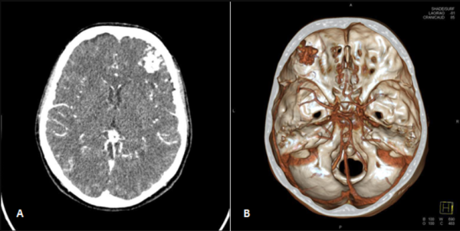
A,B. left frontal dural AVF in CTA
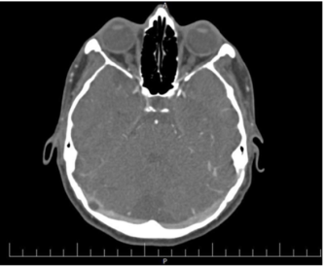
Arachnoid granulations of right transverse sinus in CTA

Recent Publications

1. Alimohamad Asghari, Mohammad Mohseni, Ahmad Daneshi, Yasser Nasoori, Sara Rostami, and Maryam Balali, “Randomized Clinical Trial Comparing Bucket Handle and Cartilage Tympanoplasty Techniques for the Reconstruction of Subtotal or Anterior Tympanic Membrane Perforation,” International Journal of Otolaryngology, vol. 2018, Article ID 2431023, 7 pages, 2018. https://doi.org/10.1155/2018/2431023.

2. Mohseni, Mohammad, Alimohamad Asghari, Ahmad Daneshi, Maryam Jalessi, Sara Rostami, and Yasser Nasoori. 2018. “Comparison of Brain CT Angiography/Venography and Temporal Bone HRCT Scan Findings in Patients With Subjective Pulsatile Tinnitus in Affected Side and Unaffected Side”. Biomedical Research and Therapy 5 (7), 2455-65. https://doi.org/10.15419/bmrat.v5i7.454.
3. Hesam Jahandideh, Yasser Nasoori, Sara Rostami, and Mahdi Safdarian, “Laryngeal Langerhans Cell Histiocytosis Presenting with Neck Mass in an Adult Woman,” Case Reports in Otolaryngology, vol. 2016, Article ID 2175856, 4 pages, 2016. https://doi.org/10.1155/2016/2175856.
4. Rabiee SM, Alijanpour E, Jabbari A, Rostami S. Benefits of using intrathecal buprenorphine. Caspian J Intern Med. 2014;5(3):143-7.

BIOGRAPHY
Sara Rostami is specialized in ear,nose & throat and head&neck surgery. interested in Otology.working at Imam Ali Hospital as ENT surgeon.
