Nasal obstruction: a modern view of the problem
Budkovaia Marina, M.D., scientific. employee of the department of
development and implementation of high-tech methods of treatment of the St. Petersburg
Research Institute of Ear, Throat and Speech, Saint Petersburg, Russia

Artemyeva Elena, resident at the St. Petersburg Research Institute of Ear, Throat
and Speech.

Nasal breathing disorder leads to the complex formation of pathological conditions and reduces significantly the quality of patients’ life. Particular difficulties arise when patients’ complaints of nasal breathing difficulty do not correspond with the results of rhinoscopic picture of the nasal cavity, as well as when patient is dissatisfied with the results of surgical treatment in relation to the restoration of respiratory function of the nose. In order to solve this problem, we conducted an objective diagnosis of nasal breathing disorders with the calculation of the main aerodynamic parameters of the nasal flow and a differential analysis of the causes of nasal obstruction formation, followed by a comparison of the identified changes to the results of multispiral computed tomography(CT) of the paranasal sinuses and nasal endoscopy examination of the nasal cavity and motor activity evaluation of the nasal cavity shimmering epithelium. This diagnostic complex is used in the examination of patients with subjective nasal breathing disorders before the planned surgical treatment and in long term after surgical correction of the external nose, intra-nasal structures and in the selection of patients with allergic rhinitis for allergic - specific immunotherapy. Simultaneous analysis of the parameters of anterior active rhinomanometry (AARM), rhinoresistometry and acoustic rhinometry before and after the test with decongestant allows to identify objectively or exclude the presence of nasal obstruction, to differentiate the causes of nasal breathing disorders into functional, structural and combined. The registered changes in the proposed method are compared with the results of nasal endoscopy and CT of the sinuses of the nose and are used to determine conservative or surgical management of patients to achieve good functional result and objective control of the effectiveness of nasal breathing restoration.
1.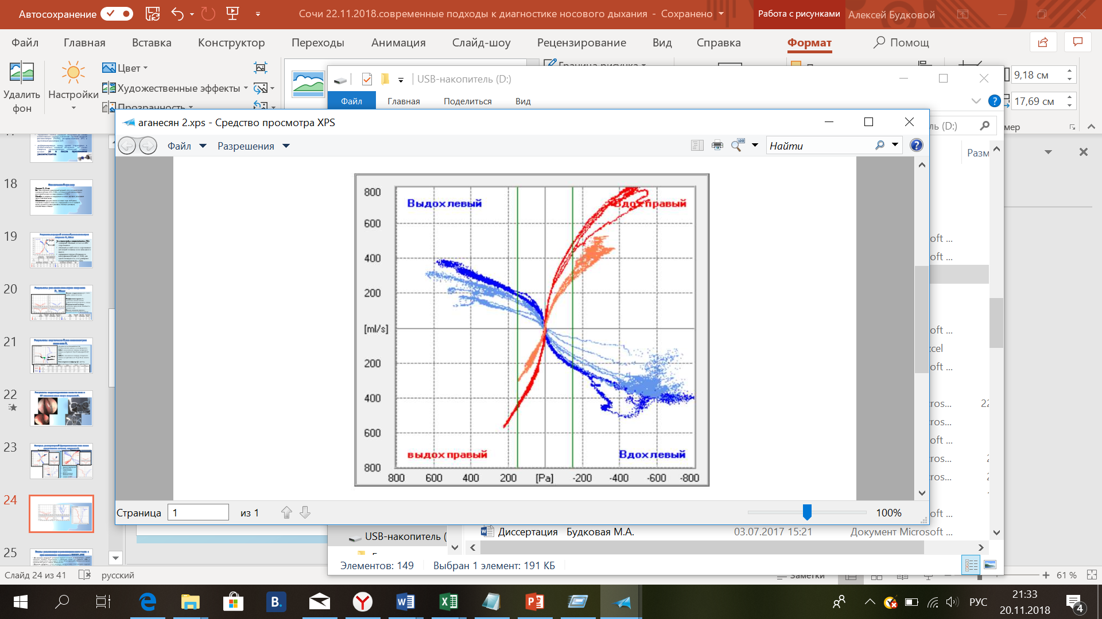2. 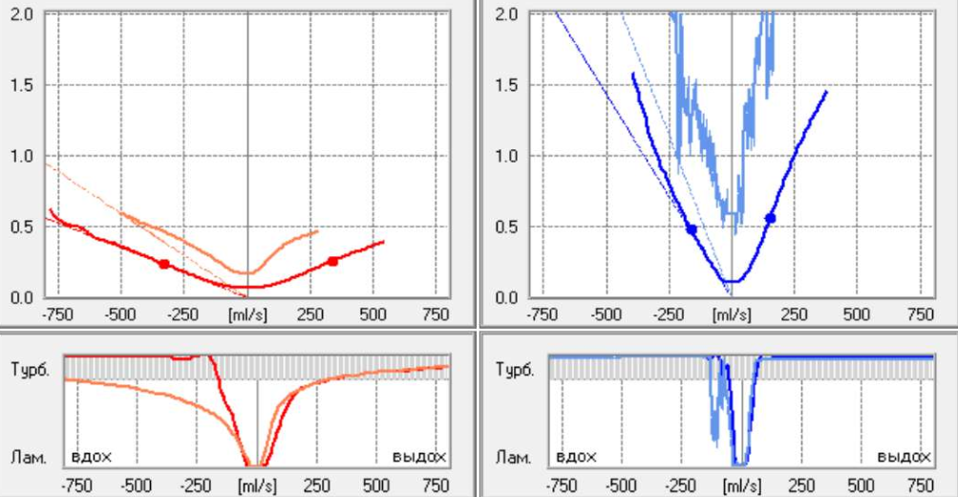 3.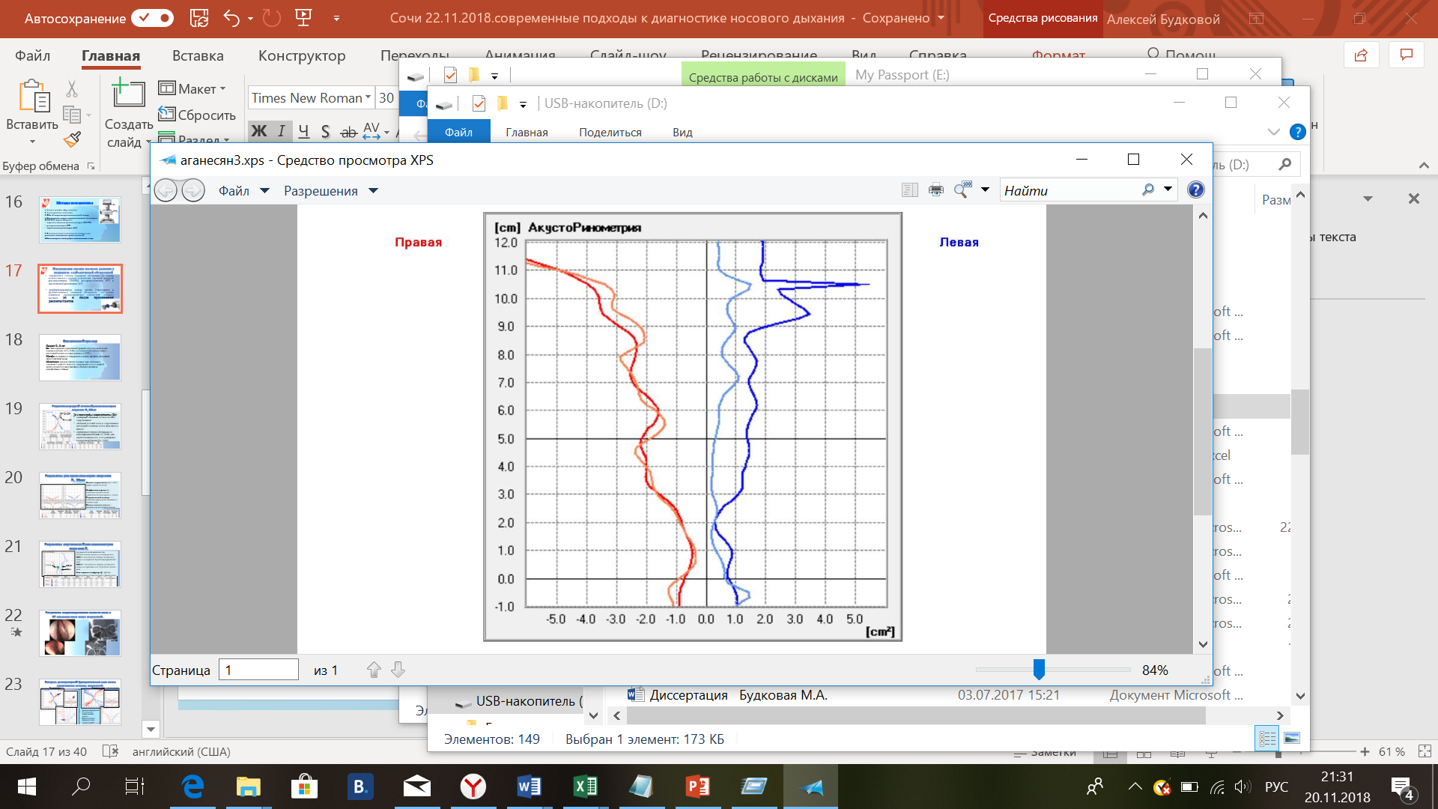
4.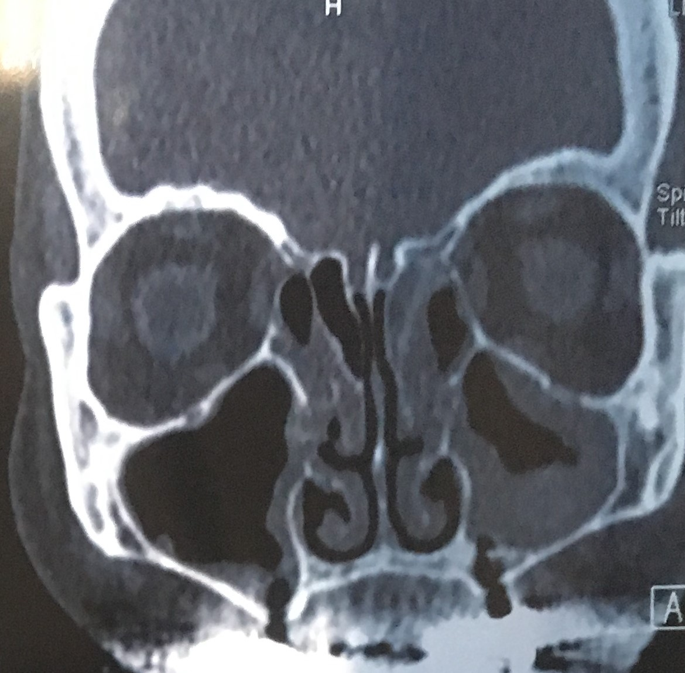5. 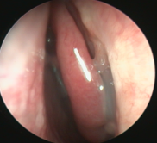 Fig. A: The results of an objective study in a patient with mixed structural-functional component: 1.- AARM; 2.- resistometry.3.- acoustic rhinometry. 4.- CT scan.5.- nasal endoscopy.

Recent Publications:
- Budkovaia MA, Artemeva ES. Objective assessment of the function of nasal breathing in patients after rhinosurgical interventions // Russian otorhinolaryngology. 2018;1(92):25-34. http://entru.org/files/j_rus_LOR_1_2018_uv.pdf
- Budkovaia MA, The Place of topical corticosteroids in the treatment of allergic rhinitis/ Medical advice. 2018. No. 8. P. 72-76.
- Budkovaia M. A., Artemieva E. S. Peculiarities of nasal breathing in patients with nasal obstruction // Russian otorhinolaryngology. - 2019.
- Budkovaia MA, Rebrova AS, Artemieva ES. Clinical aspects of the comprehensive evaluation of disorders of nasal breathing/II all-Russian Congress of the National medical Association of ENT. Russia .21-23 November 2018, Sochi: p.30-31.
- Ryazantsev SV, Budkovaia M.A, Current view of the treatment of chronic rhinosinusitis with nasal polyps// Russian rhinology. - 2017. - Vol. 25. - № 1. - P. 54-59.
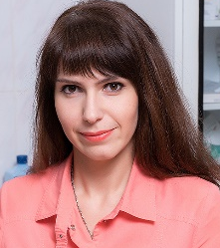 Biography
Budkovaia Marina Aleksandrovna is specialized in otorhinolaryngology. She deals with the diagnosis, conservative and surgical treatment of patients with pathology of the upper respiratory tract. She is now working in the department of development and implementation of high-tech methods of treatment of the St. Petersburg Research Institute of Ear, Throat and Speech.

