https://ent.conferenceseries.com/abstract-submission.php

RHINOPLASTY IN HISPANIC NOSE

Terreros Belén Dr. Otorhinolaryngologist, Hospital de Clinicas, Argentina

Abstract

Rhinoplasty is one of the most common facial plastic surgeries in the world.
Civilizations of all ethnic groups have always had an interest in facial beauty over time.
At present the pure races are less frequent and therefore, facial plastic surgeons around the world we face groups of different cultural and ethnic groups who want to improve their appearance.

Ethnic rhinoplasty is often considered a procedure to reshape the nose of a black or Asian patient, few rhinoplasty has been described in mestizo or Hispanic patients. The mestizo race is a combination of Caucasians, descendants of Africans and local Indian tribes. The proportion of each one depends on the area where the patient comes from.

There has been a large increase in the Hispanic population of the United States and Europe. This has made facial plastic surgeons see a concomitant increase in requests for rhinoplasty among this population.

The goal of rhinoplasty is to correct the nose to have an appearance consistent with your race after the surgery-
It would not be pleasant or harmonious for a Caucsian person with a thick nose and large nostrils, or a person with the face of people with a very thin nose and high back.

Below, we show some cases of Hispanic nose and the result of rhinoplasty according to the physical characteristics of each patient.

Each patient must be handled individually

PRE SURGERY
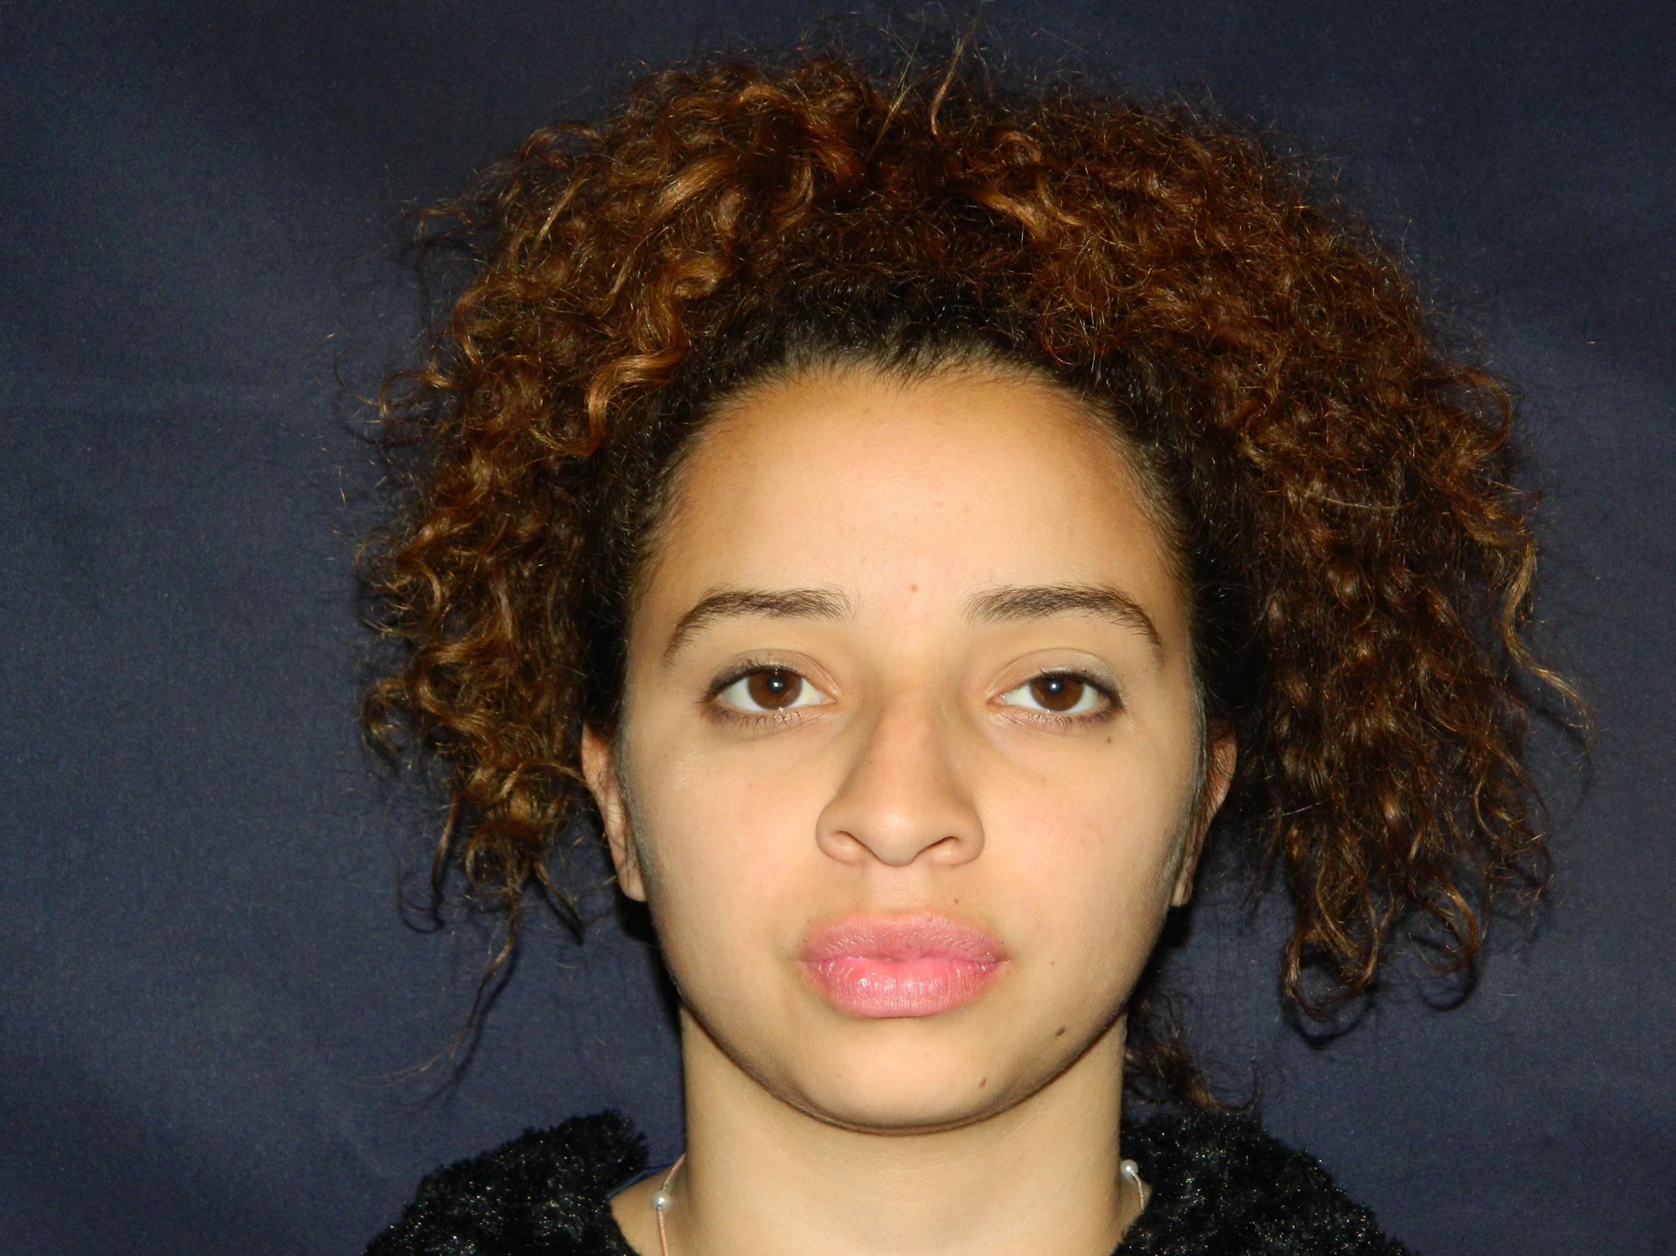

POST SURGERY
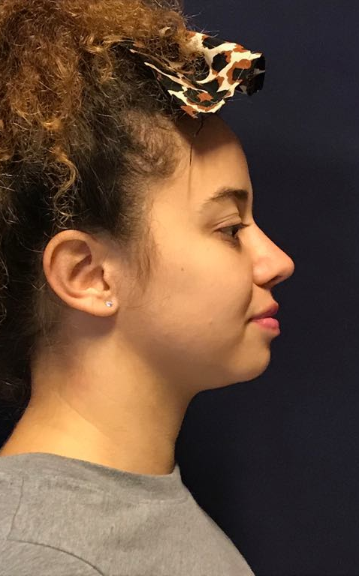

PRE SURGERY

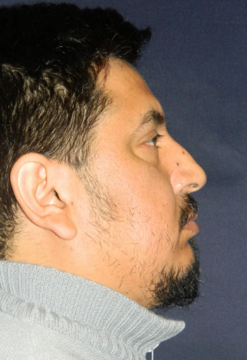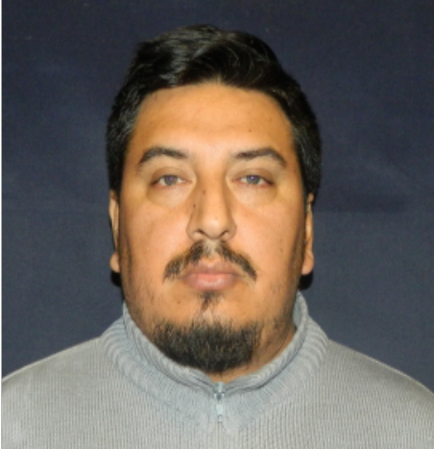

POST SURGERY

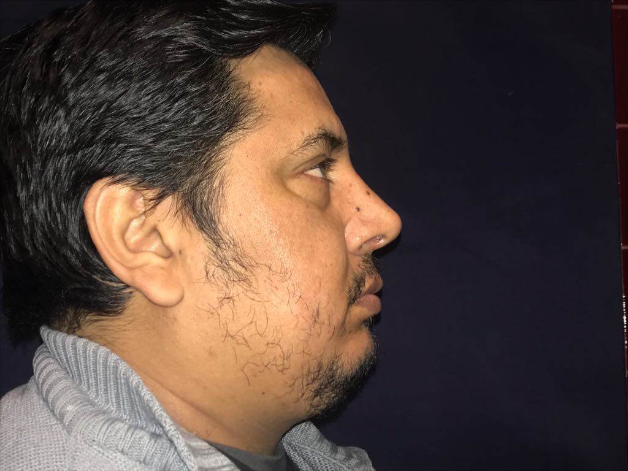

Recent Publications

- 71 CONGRESS AT OTORHINOLARYNGOLOGY F.A.S.O. NOVEMBER 2018
FREE THEME: IDEAL NOSE IN ALL CASES?

- UPDATE CONGRESS AT OTORHINOLARYNGOLOGY F.A.S.O. AUGUST 2017
FREE THEME: URGENT TRACHEOSTOMY: PRINCIPLES, SURGICAL TECHNIQUE AND COMPLICATIONS: OUR EXPERIENCE

- X MANUAL OF THE ARGENTINE ASSOCIATION OF OTORHINOLARYNGOLOGY AND PEDIATRIC PHONOAUDIOLOGY: AMIGDALECTOMY. ADENOIDECTOMY IN PEDIATRIC ORL.
CHAPTER : CHRONIC FARINGOAMIGDALITIS WHEN IS IT SURGICAL? APRIL 2017 PAG 89-92

- •XVIII ARGENTINE CONGRESS OF PEDIATRIC ENT AND PHONO AUDIOLOGY MAY
FREE THEME: IMPACT OF THE TURBINOPLASTY ON THE QUALITY OF LIFE OF PEDIATRIC PATIENTS BETWEEN 9 AND 14 YEARS OF THE CHILDREN'S ENT SECTOR OF JOSÉ SAN MARTIN CLINICAL HOSPITAL: OUR EXPERIENCE (speaker)

- •XVIII ARGENTINE CONGRESS OF PEDIATRIC ENT AND PHONO AUDIOLOGY MAY
FREE THEME: TRACHEOSTOMY FOR THE MANAGEMENT OF CHILDREN IN PROLONGED HOSPITALIZATION IN UTI (speaker)

Biography

Belén Terreros, otorhinolaryngologist, with diploma in sleep medicine and roncopathy. Member of GELPO “Latin American study group olfactory pathology” Fellowship of one year in Rhinology and facial plastic at the Hospital de Clínicas (with Drs. Luis Chinski & Hernan Chinski- ARGENTINA).

