ENDOSCOPE-ASSISTED APPROACH TO INFRA-TEMPORAL FOSSA CLEARANCE IN HEAD AND NECK CANCER – TECHNIQUE AND ONCOLOGICAL OUTCOMES

BACKGROUND:
Traditionally, Infratemporal fossa clearance in head and neck cancer surgery necessitates a lip-split/facial incision and Posterior segmental mandibulectomy/mandibulotomy (angle/para-median) approach for adequate exposure. This is because the pterygoid base cut is near-impossible with an intact mandible, and if blindly done, middle cranial fossa may be breached. This approach also has inherent risks of significant morbidity to the patient (unsightly facial scar, infection/exposure of plate at osteotomy site, osteo-radio necrosis, loss of sensation over mentum, facial deformity). Our aim is to describe the utility of transnasal endoscopic assisted approach to infra-temporal fossa clearance in patients with head and neck cancer.

MATERIALS AND METHODS:
Patients with head and neck cancer with infratemporal fossa involvement (medial pterygoid/ masseter) with adequate mouth opening (>30mm) were selected for this technique. Patients with restricted mouth opening, involvement of lateral pterygoid/temporalis muscle and pterygoid base were excluded. We perform total endoscopic medial maxillectomy to reach the pterygoid plates and infratemporal fossa. Endoscopically, lower fibres of temporalis and medial pterygoid muscle along with the pterygoid base are cut. The attachment of the medial pterygoid to the mandible is released through the neck incision along with resection of the masseter. The mucosal cuts are given per orally and the specimen is delivered intoto.

RESULTS:
Thirty patients underwent anterior infra-temporal fossa clearance by this approach. 22 patients had squamous cell carcinoma involving the upper gingivo-buccal complex. 6 had squamous cell carcinoma in the maxilla and 2 of them were diagnosed with adenoid cystic carcinoma of maxilla. All eight were clinically staged to be T4b (7th edition AJCC). 10 patient had pT4a disease and 20 patients had pT4b disease. The deep soft tissue margins were negative in all the patients. The mean operating time by this approach was 113 minutes. None of the patients developed epiphora or paraesthesia along the infra-orbital nerve post-operatively.

CONCLUSION:
We thus present a novel technique to access infra-temporal fossa which permits significantly expanded exposure, allowing oncologically safe resection of infratemporal fossa by cutting the pterygoid base under direct vision. Avoidance of inherent neurological and cosmetic morbidities are added advantages.

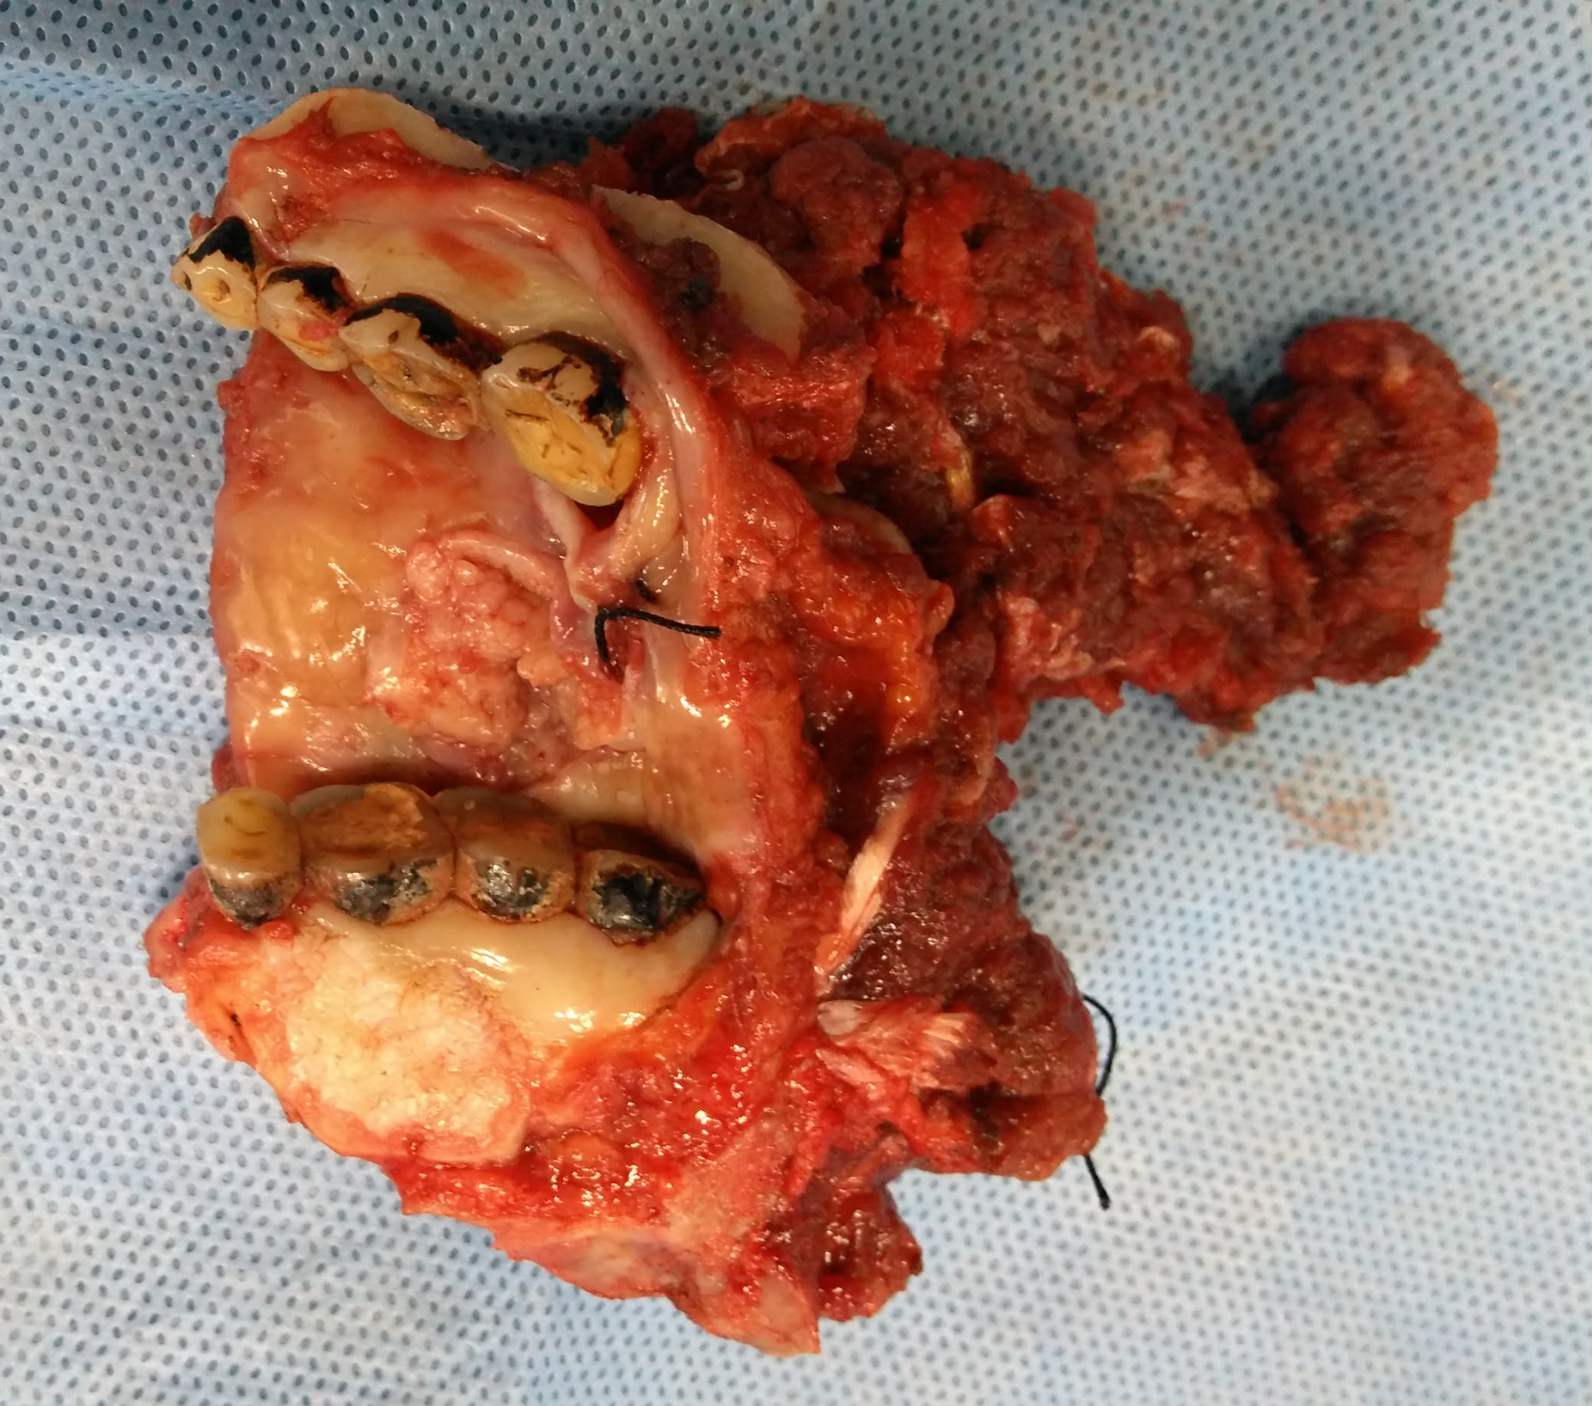
Tumor in left buccal mucosa
Marginal mandibulectomy
Infrastructure maxilla
Specimen delivered per orally.

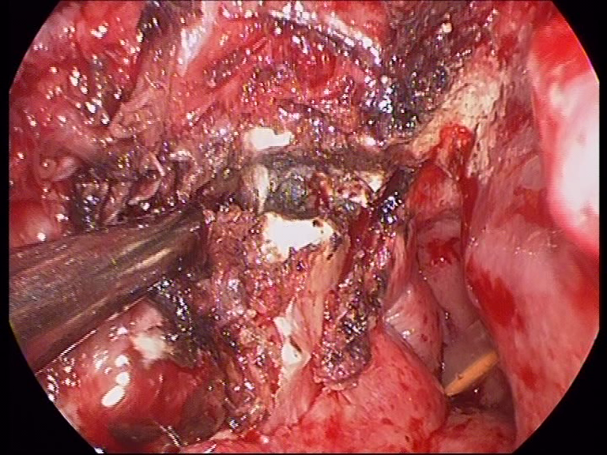
Lateral Pterygoid plate
Medial Pterygoid plate
Drilling of pterygoid plates

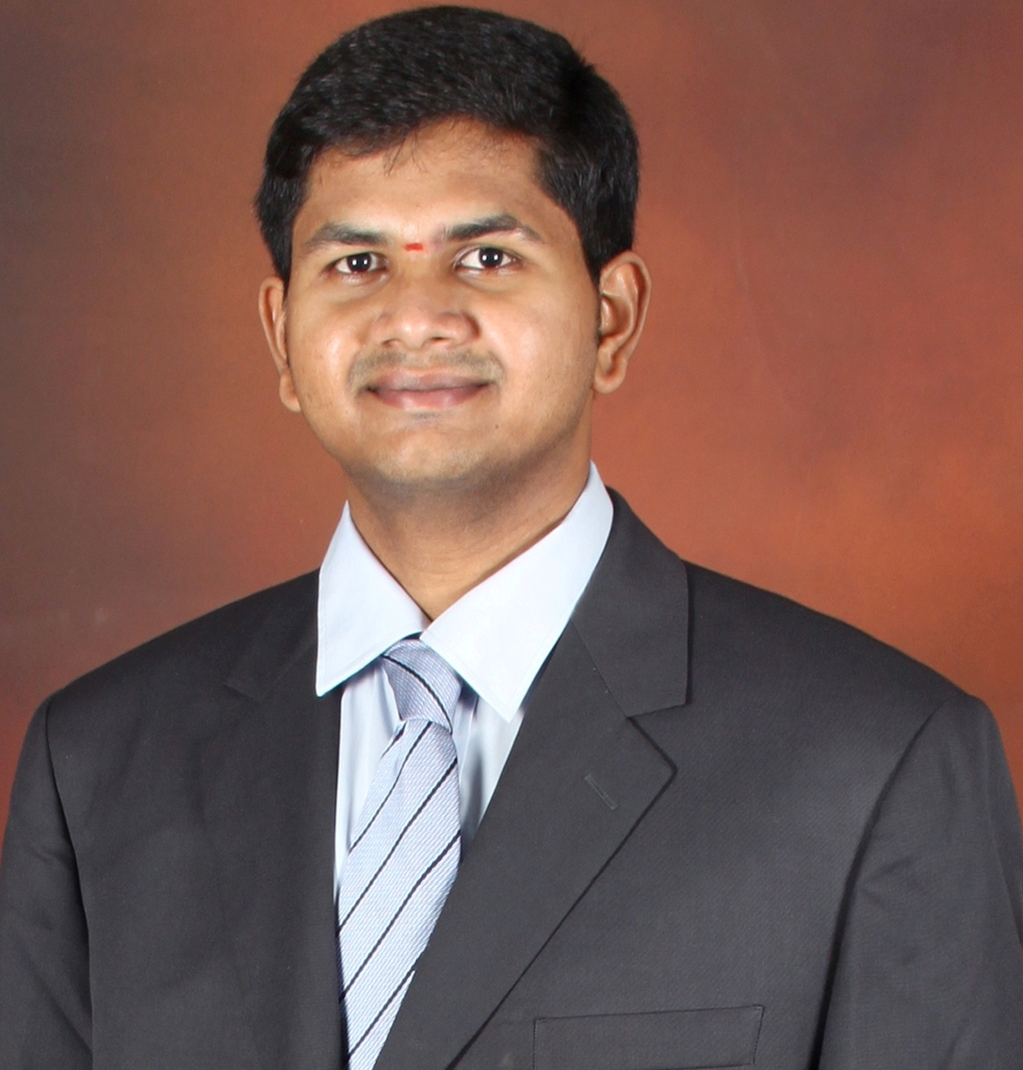

Dr Vidya Bhushan R finished his MBBS and MS – ENT, Head and Neck Surgery from St. Johns Medical College, Bangalore India in 2014. With his keen interest in Head and Neck Oncology, he pursued Fellowship in Head and Neck Surgical Oncology in Mazumdar Shaw cancer Centre. Thereafter, he was trained in Endoscopic Skull base surgery from Christian medical college, Vellore. Presently he is practicing as consultant in Mazumdar Shaw cancer Centre, Bangalore India. His area of specialization is Endoscopic Skull Base OncoSurgery.

Awarded Prestigious FHNO National travel fellowship award for the year 2015 – 2016.

Awarded UICC (Union for International Cancer Control) ICRETT (International rapid transfer of cancer control knowledge and technology) in the year 2017.

Email: drbhushanhns@gmail.com

Publications
- R.V.Bhushan, Pratibha CB, Balasubramanya AM, Nandakumar R, Rose Reynold. Endoscopic management of nasal encephalocoele in a 4 month old baby. International Journal of Pediatric Otorhinolaryngology extra 2014;9(2):67-69
- Bhushan vidya et al. Radio-guided minimally invasive parathyroidectomy: A descriptive report of the experience from tertiary center in Bangalore.2017;32(3):184 - 187
- Rangappa VB, Suresh R, Manikantan K, Balasubramanya AM. Pleomorphic lipoma. A rare tumor in the retropharyngeal space. International journal of otorhinolaryngol clinics 2013;5(3):187-189
- Prabhu M, Samson S, Reddy A, Venkataramanarao SH, Chandrasekhar NH, Pillai V, Bhushan Vidya. Role of preablative stimulated thyroglobulin in prediction of nodal and distant metastasis on iodine whole-body scan. Indian J Nucl Med 2018;33:93-8.
- Rangappa VB, Ramakrishnan A, Balasubramanya AM, Rajaram. Bilateral adductor palsy: A rare complication during routine surgery. World Journal of Endocrine Surgery 2013;5(3):76-78

