Thyroglossal duct cyst excision with hyoid bone preservation
Ahmed Nofal , MD, Zagazig University, Egypt Mohammed El-Anwar, MD, Zagazig University, Egypt

Abstract (300 word limit)
The objective of this study is to assess complete removal of the thyroglossal duct cyst (TGDC) and its tract(s) to the base of the tongue with sparing of the hyoid bone.
It is a prospective cohort study in a tertiary hospital (Zagazig university hospital).
This prospective study was carried out on 21 patients who had been diagnosed preoperatively as TGDC or fistula.
All patients were managed by dissection and removal of the TGDC and its tract(s) to the base of the tongue with sparing of the hyoid bone. The study was conducted on 12 males (57.14 %) and 9 females (42.85 %) with mean age 6.8 years (4–20 years).
After histopathological examination; 16 patients (9 male and 7 female) were proved to have TGDC and 5 patients (3 male and 2 female) were proved to have dermoid cyst. The hyoid bone could be preserved in all cases except in two cases for whom the middle third of the hyoid bone was removed with the specimen. Multiple tracts were found in three cases and could be identified and dissected successfully with sparing of the hyoid bone.
Identification, dissection, and complete excision of the TGDC with its attaching tract(s) could be performed without hyoid bone resection with no recurrence and minimal minor complication. The impacts of this hyoid bone preservation versus removal on the pattern of swallowing and retroglossal space need to be studied.

Image

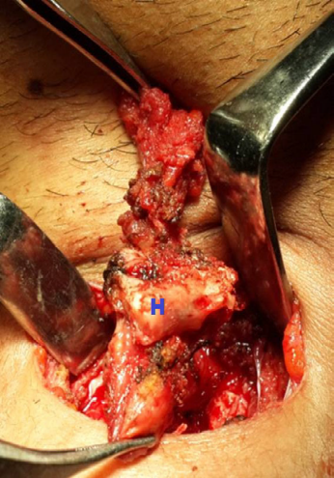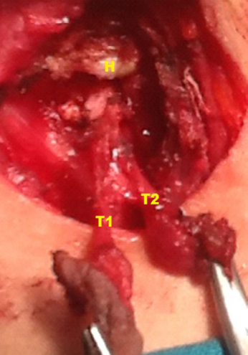
Recent Publications (minimum 5)
- Nofal A A F, El‐Anwar MW. Recurrent Laryngeal Nerve Identification in Thyroidectomy by Intra‐operative Staining with Methylene Blue in Forty Six Patients. Clinical Otolaryngology. 2015
- El-Anwar M W, Nofal A A F. Thyroglossal duct cyst excision with hyoid bone preservation. European Archives of Oto-Rhino-Laryngology 2015;
- Nofal A A F, Mohamed M. Sternocleidomastoid Muscle Flap after Parotidectomy. International Archives of Otorhinolaryngology 2015.
- El-Anwar M W, Nofal A A F, Khazbak A O, El Sayed A E, Hassan M R. The Efficacy of Nasal Steroids in Treatment of Otitis Media with Effusion: A Comparative Study. International Archives of Otorhinolaryngology 2015.

- Nofal A A F, El‐Anwar MW. Intraparotid Neurofibroma of the Facial Nerve: A Case Report. Iranian Journal of Otorhinolaryngology. 2015

- El-Anwar M W, Hamed A A, Mohamed A E S, Nofal A A F, Mohamed M A, Abdel-Aziz H R. Surfactant Protein A Expression in Chronic Rhinosinusitis and Atrophic Rhinitis. International archives of otorhinolaryngology 2015; 19(2), 130-134.
- El-Anwar M W, Nofal A A F, Khalifa M, Quriba A S. Use of Autologous Platelet Rich Plasma in Complete Cleft Palate Repair. Laryngoscope 2016. (Accepted and under publication)
- El-Anwar M W, Nofal A A F, El-Ahl M A. Endoscopic Repair of Bilateral Choanal Atresia Starting with Vomer Resection; Evaluation Study. The American Journal of Rhinology and Allergy. 2016. (Accepted and under publication)
- El-Anwar M W, Nofal A A F, El Malt A. Surgicel Use in Control of Primary Post-adenoidectomy Bleeding. Ear Nose Throat Journal 2016. (Accepted and under publication)
- El-Anwar MW, Nofal AA, El Shawadfy MA, Maaty A, Khazbak AO. Tracheostomy in the Intensive Care Unit: a University Hospital in a Developing Country Study. International Archives of Otorhinolaryngology. 2016 Jul 26.
- El-Anwar MW, Nofal AA, El-Ahl MA. Endoscopic repair of bilateral choanal atresia, starting with vomer resection: Evaluation study. American Journal of Rhinology & Allergy. 2016 May 1;30(3):e95-9.

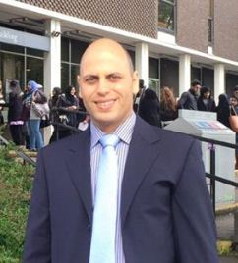 Biography (150 word limit)

Ahmed A F B Nofal is lecturer of Otolaryngology - Head and Neck Surgery at The Faculty of medicine Zagazig University. He was qualified in (2002) Faculty of medicin - Zagazig University, Msc in 2007, M D. 2013. He also has DO-HNS (2010) and MRCS ENT (2015) from The Royal College of Surgeons of Edinburgh (United Kingdom). He has experience in management of Otolaryngology - Head and Neck Surgery with many international publications highly ranked Q1 otolaryngology journals.

Email: nofal_9999@hotmail.com

Notes/Comments:

