Solution Synthesized Metal Oxide Nanoparticles for Organic Photovoltaics
Julia W. P. Hsu, PhD, University of Texas at Dallas, USA

Abstract (300 word limit)
Organic photovoltaic (OPV) devices represent promising technology for low cost, lightweight solar energy harvesting. The inexpensive, large-area manufacturing methods, e.g. roll-to-roll printing, favor solution deposition techniques. Due to the blended nature of the organic active layer in an OPV device, carrier transport layers at the active layer/electrode interface are necessary to set up the electric field across the device to extract photogenerated electrons and holes efficiently. In addition to appropriate work function, ideal transport layer materials should also have a large band gap, be reasonably conductive and carrier selective. Furthermore, to facilitate forming a uniform film on top of the organic active layer, solvent compatibility and low (room)-temperature processing requirements need to be considered. Metal oxides offer a wide range of electrical and optoelectronic properties and can be synthesized in nanoparticles for solution processing. I will discuss solution synthesis of ZnO, MoO_{x}, WO_{x}, NiO_{x}, CoO_{x}, CuGaO₂ and CuCrO₂ nanoparticles for charge transport layer applications in OPVs. Ionization energy and work function of the nanoparticle films determine whether the HTL would efficiently collect holes for a given active layer system, and are measured using photoelectron spectroscopy in air and Kelvin probe, respectively. Separating material synthesis and film formation opens up possibilities to optimize the materials properties (e.g. crystalline phase, particle size, composition) independently from the temperature restriction, substrate property dependence of device processing. In the presentation, details in nanoparticle synthesis, film preparation, optoelectrical property characterization, and OPV device characteristic will be discussed.
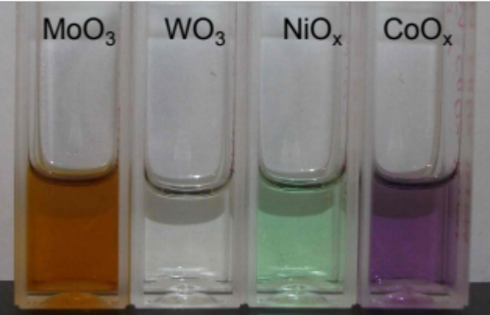
Solution synthesis of various metal oxide nanoparticles in n-butanol.

Image

Recent Publications (minimum 5)
- Lee YJ, Yi J, Gao GF, Koerner H, Park K, Wang J, Luo K, Vaia RA, Hsu JWP (2012) Low-temperature Solution Processed Molybdenum Oxide Nanoparticle Hole Transport Layers for Organic Photovoltaic Devices. Adv Energy Mater 2:1193-1197.
- Wang J, Lee YJ, Hsu JWP (2014) One-step Synthesis of ZnO Nanocrystals in n-butanol with Bandgap Control: Applications in Hybrid and Organic Photovoltaic Devices. J Phys Chem C 118: 18417-18423.
- Wang J, Ibarra V, Barrera D, Xu L, Lee YJ, Hsu JWP (2015) Solution Synthesized p-Type Copper Gallium Oxide Nanoplates as Hole Transport Layer for Organic Photovoltaic Devices. J Phys Chem Lett 6: 1071-1075.
- Lee YJ, Barrera D, Wang J, Hsu JWP (2015) General Method to Synthesize Ultrasmall Metal Oxide Nanoparticle Suspensions for Hole Contact Layers in Organic Photovoltaic Devices. MRS Comm 5: 45-50.
5. Wang J, Lee YJ, and Hsu JWP (2016) Sub-10 nm Copper Chromium Oxide Nanocrystals as Solution Processed p-Type Hole Transport Layer for Organic Solar Cells. J Mater Chem C 4: 3607-3613.

 Biography (150 word limit)
Julia W. P. Hsu is a Professor of Materials Science and Engineering in the Erik Jonsson School of Engineering and Computer Science of the University of Texas at Dallas (UTD) and holds a Texas Instruments Distinguished Chair in Nanoelectronics. She MS received her BSE degree in Chemical Engineering from Princeton University and MS and PhD degrees in Physics from Stanford University. Before UTD, she has worked at University of Virginia, Bell Laboratories, and Sandia Laboratories. Prof. Hsu’s research focuses on nanoscale materials physics, in particular nanomaterials for optoelectronic and energy applications. Prof. Hsu is a Fellow of American Physical Society, American Association for the Advancement of Science, and Materials Research Society (MRS). She has published over 200 referred journal articles, holds 5 patents, served as Treasurer and on the Board of Directors for MRS, and has given invited talks worldwide.

Email: jwhsu@utdallas.edu

Notes/Comments:

