Ileo-cecal intussusception against metastasis of melanoma in the ileum: clinical case and literature review.
Danilov Mikhail, senior researcher
Moscow Clinical Scientific Center named after A.S.Loginov, department of colorectal surgery.

Intestinal intussusception is a very rare pathology, especially in adults. The causes of intestinal intussusception can be both benign and malignant neoplasms. Often, intestinal intussusception is an occasional diagnostic finding, but cases of clinically significant invaginations that lead to disruption of the intestinal passage are described. Significant diagnostic contribution is made by ultrasound and endoscopy, but sometimes one has to resort to such diagnostic methods as CT and MRI. The tactics of surgical treatment of intestinal intussusception are different, and can vary from conservative intussusception to an expanded resection of the intestine site. In this clinical example, the case of ileo-cecal intussusception is described on the background of metastasis of melanoma in the ileum.
Сolonoscopy - in the ascending colon, the invaginated small intestine, occupying 2/3 of the lumen (15 cm in length), is defined in the terminal part of the small intestine with a diameter of about 4 cm.
CT of abdomen - intussusception of the terminal part of the ileum into the cecum and ascending colon, the blood flow at the level of the invaginate is traced.
Operation - right-sided hemicolectomy with D-3 lymphadenectomy (taking into account the absence of morphological verification of the tumor and the impossibility of excluding malignant lesions).
Histological examination - pigment-free metastasis of melanoma, there are no metastases in 29 lymph nodes, expression of S100, CD117, HMB45 Melan A is determined in tumor cells.

Image.
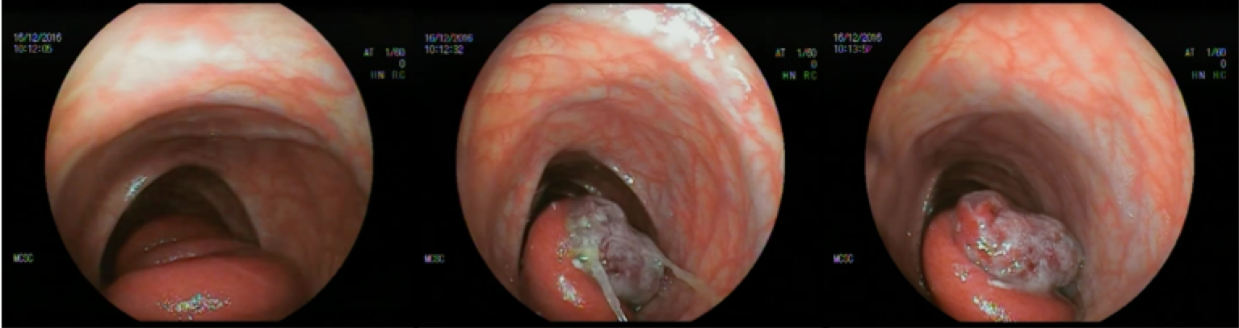
Image 1: Endoscopic finding.
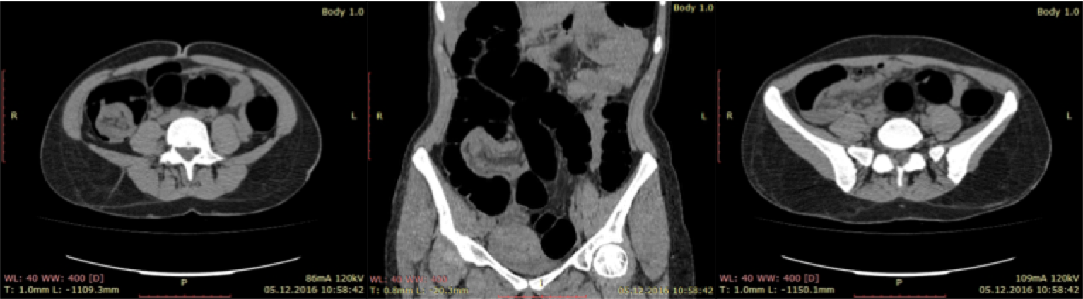
Image 2: CT scan of intussusception.
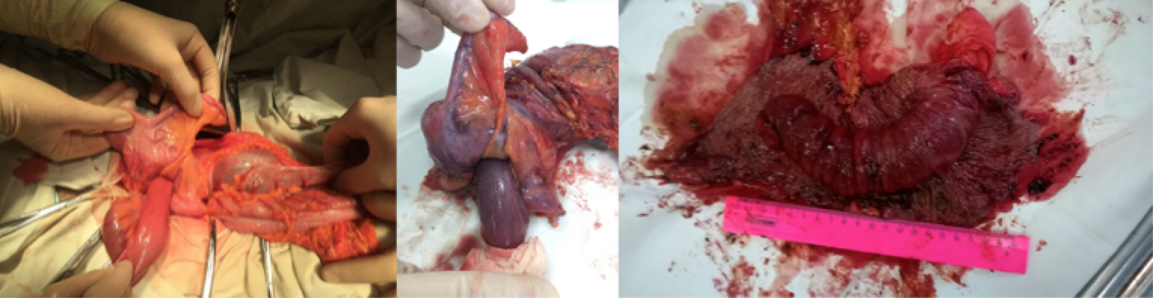
Image 3: Intraoperative view.
Biography
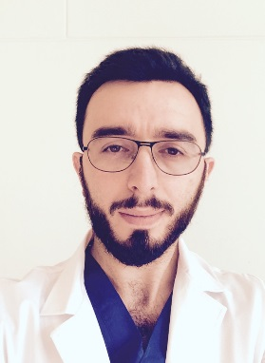
Danilov Mikhail has completed his PhD at the age of 28 years from Center of Surgery named after acad. B.V.Petrovsky, and postdoctoral studies from Sechenov University. He is the senior researcher of department of colorectal surgery. He has published more than 70 papers in reputed journals. Presenting author details Full name: Mikhail Danilov Contact number: +79671367687 Category: Poster presentation. Email: dma23rus@mail.ru

