She was trapped in a man’s body: a case of Virilizing Adrenocortical carcinoma
Ralph Jefferon Ramos, MD, JBLMRH, Philippines
Maria Luisa Cecilia Arkoncel, MD, JBLMRH, Philippines
Ryan Joe Dungca, MD, JBLMRH, Philippines
Francis Raymond Arkoncel, MD, JBLMRH, Philippines

Abstract (300 word limit)

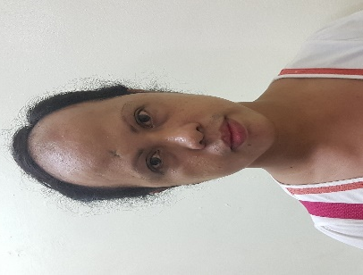
BACKDROUND: Adrenocortical carcinoma is a rare malignancy with an annual incidence of 1-2 per million population. Adrenal tumors exclusively secreting androgens are extraordinarily rare most commonly presenting with hirsutism, acne, and clitoromegaly.

CASE: A 33 year old female came at the IM-OPD due to amenorrhea for 1 year, accompanied by receeding hairline, mustache, hirsutism more on the hypogastric area and lower extremities, right-sided abdominal pain and deepening of voice, hence, consulted. Prior to onset of symptoms, she was admitted for UTI where KUB ultrasound was requested however, was not done. She was discharged with advice to consult at the OPD, however, was lost to follow up. Upon this consultation, she brought the result with an impression of adrenal mass. Whole Abdominal CT scan was requested and revealed right adrenal mass, 5.6x6.5cm, with downward displacement of the ipsilateral kidney. DHEA-S and TESTOSTERONE were done with elevated results. She was referred to Urosurgery for surgical intervention. She underwent laparoscopic adrenelectomy, right, with finding of right adrenal mass, 8.0x7.0x5.0cm, 80 grams, well circumscribed. On follow up, repeat DHEA-S and TESTOSTERONE were normal. Biopsy showed adrenocortical carcinoma with extracapsular invasion. Three months post-operation, the patient followed up with amenorrhea. She was referred to OB confirming her pregnancy. She has no regular prenatal check-up and is expected to deliver a baby boy on July 17, 2018.

DISCUSSION AND CONCLUSION: Majority of adrenal tumors are metastatic, hence, identification of the origin is important in the diagnosis and managent. History, physical examination, imaging, DHEA-s and Testosterone are the cornerstones in the diagnosis.

Image
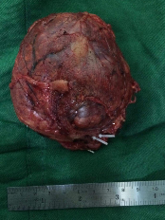
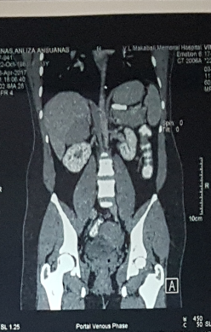

Recent Publications (minimum 5)
- Harrison’s Principles of Internal Medicine 19th edition.
- Adrenocortical carcinoma (ACC): diagnosis, prognosis, and treatment. Front Cell Dev Biol. 2015; 3: 45. Published online 2015 Jul 3. doi: 10.3389/fcell.2015.00045. Else T, Kim AC, Sabolch A, et. al. Endocr Rev. 2014 Apr; 35(2):282-326.
- Integrated genomic characterization of adrenocortical carcinoma.Assié G, Letouzé E, et.al. Nat Genet. 2014 Jun; 46(6):607-12.
- Risk assessment in 457 adrenal cortical carcinomas: how much does tumor size predict the likelihood of malignancy? Sturgeon C, Shen WT, Clark OH, Duh QY, Kebebew E. J Am Coll Surg. 2006 Mar; 202(3):423-30.
- The optimal imaging of adrenal tumours: a comparison of different methods. Ilias I, Sahdev A, Reznek RH, Grossman AB, Pacak K. Endocr Relat Cancer. 2007 Sep; 14(3):587-99.

Biography (150 word limit)
Ralph Jefferson Ramos is currently on his 3rd year Internal Medicine training. He is compassionate in terms of patient care and their well being.
Email: rjramos1987@yahoo.com

Notes/Comments:

