Better diabetes control through individualized ‘Continuous Care’
Noble Zachariah MD, Dar Al Shifa Hospital , Kuwait
Introduction: In spite of having more than 75 medicines and combinations approved for diabetes treatment, the number of people achieving good control is low. It is about 28.7 % (1) to 60% (2) in studies. Uncontrolled diabetes increases the risk of complications which decrease the quality of life, life expectancy and increase the cost of care. Researchers have shown that patients with more frequent clinic visits achieve better control in a shorter time.(3) Many patients find it difficult to visit doctors frequently due to logistic and economic reasons. It has been shown that remote monitoring of diabetes control without frequent clinic visits have yielded equal or better HbA1c results than obtained by clinic visits alone. (4, 5). Methodology: This is an analysis of the outcome of 250 patients referred to us for uncontrolled diabetes. The HbA1c at first visit varied from 7.9% to 14.5%. We use the ‘Continuous Care’ health portal and app. The main components of ‘Continuous Care’ are (a) electronic Personal Health Record (PHR) containing all clinical data, investigations, medicines and (b) Remote monitoring of trackers like blood sugar and weight. In the remote monitoring, the patient enters the fasting and post prandial blood glucose readings, along with a note regarding the food, exercise and stress in the app. The information is read by his doctor remotely and he counsels the patient. Results: 195 out of the 250 patients (78%) achieved HbA1c of 7 or less in 6 months. Many with Type 2 diabetes could be taken off insulin and managed with oral medicines alone. Conclusion: Diabetes control improved significantly with proper health education regarding low glycemic Medical Nutrition Therapy, healthy life style, individualized medical therapy and regular remote monitoring of blood glucose with feedback guidance.

.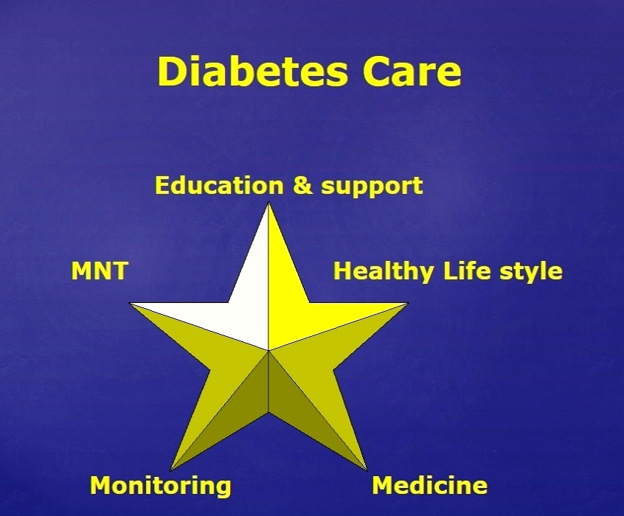
Figure 1. The individualized diabetes care for achieving targets at the earliest.

Recent Publications

1. Cynthia M. Pérez, PhD, Isaedmarie Febo-Vázquez, BS, Manuel Guzmán, MD, Ana Patricia Ortiz, PhD, and Erick Suárez, PhD ( 2012)
Are Adults Diagnosed with Diabetes achieving the American Diabetes Association Clinical Practice Recommendations?
P R Health Sci J. 2012 Mar; 31(1): 18–23.

2. Susan S. Garfield, Jason J. Xenakis, Alex Bastian, and Mary McBride (2015)
Experiences of People with Diabetes by Payer Type: An Analysis of the Roper Diabetes Data Set
Diabetes Therapy. 2015 Jun; 6(2): 113–125

3. Fritha Morrison, MPH; Maria Shubina, ScD; Alexander Turchin, MD, MS (2011)
Encounter Frequency and Serum Glucose Level, Blood Pressure, and Cholesterol Level Control in Patients With Diabetes Mellitus
Arch Intern Med. 2011;171(17):1542-1550.

4. Katalenich B, Shi L Liu S, Shao H, McDuffie R, Carpio G, Thethi T, Fonseca V (2015)
Evaluation of a Remote Monitoring System for Diabetes Control.
Clinical Therapeutics. 2015 Jun 1;37(6):1216-25.
.

5 Health Quality Ontario (2009)
Home telemonitoring for type 2 diabetes: an evidence-based analysis.
Ont Health Technol Assess Ser. 2009;9(24):1-38.

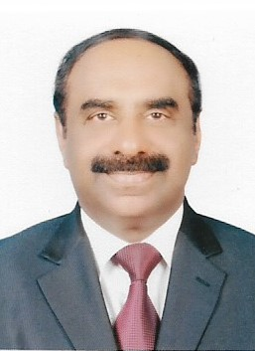
Biography
Dr Noble Zachariah has more than 35 years of experience in treating diabetes, after completing his postgraduate studies at the internationally known Christian Medical College, Vellore, India. His method of diabetes management is through empowering his patients. He educates his patients regarding the type of diabetes each one of them has, the aggravating factors, the type of low Glycemic Index food to eat, the healthy life style with exercise, stress management and no smoking. His ‘Continuous Care’ program monitors his patients’ blood sugars remotely and he counsels them individually. His patients achieve amazing results. Many Type 2 patients who were inadequately controlled even with high doses of insulin could be controlled on oral medication without the use of insulin. He is a co-founder of Indian Doctors Forum recognized by the Governments of Kuwait and India for its health care activities and edited its health guide on Diabetes.
Email: nzachariah@daralshifa.com , drnoblez@gmail.com

.

