Changes in adiposity, insulin secretion and sensitivity, glucose homeostasis and diabetes control following Roux-en-Y gastric bypass: A prospective cohort study in Chinese patients
Hongkai Gao,MD, Hui Han,The General Hospital of Chinese People's Armed Police Forces, Beijing 100039, China

Abstract
Background: Obesity is a major public health problem worldwide. Roux-en-Y gastric bypass (RYGB) is the most effective bariatric surgery approach that has been shown to induce considerable weight loss and improve metabolic parameters in obese patients. In view of the increasing adoption of metabolic surgery, post-surgical follow-ups are important to assess long-term effects and efficacy.
Objective: To report on time changes on nonmorbid patients in adiposity, insulin secretion and sensitivity, glucose homeostasis and improvement in diabetes in the after Roux-en-Y gastric bypass (RYGB) surgery Chinese ethnicity.
Methods: This prospective cohort study involved 177 patients who met the indications of bariatric surgery for obesity. Markers of adiposity, insulin secretion and sensitivity, glucose homeostasis and diabetes control were monitored from baseline to 12 months in all participants and up to five years in a subset of participants. Mixed-linear and logistic regression models were used for follow up.
Results: Mean body mass index (BMI) decreased by 15.5% from 30.31±5.21 kg/m2 at baseline to 25.33±2.57 kg/m2 at 12 months, 24.47±4.93 kg/m2 at 5 years(p<0.001). Indices of insulin secretion and c-peptide (both fasting and at various time-points during oral glucose tolerance test) improved during follow-up, translating into improved insulin sensitivity and glucose homeostasis. Improved diabetes control (HbA1c<6.5%) among those with diabetes was 64% at six months and 67.2% at 12 months, then the percentage of diabetes control dropped smoothly since 3 years (62.7%) after surgery to 5 years (60.5%). Findings were mostly similar in men and women
Conclusions: The favorable effects of RYGB over time on total adiposity in this population were paralleled by significant improvement in insulin secretion and sensitivity, and glucose tolerance.

Image
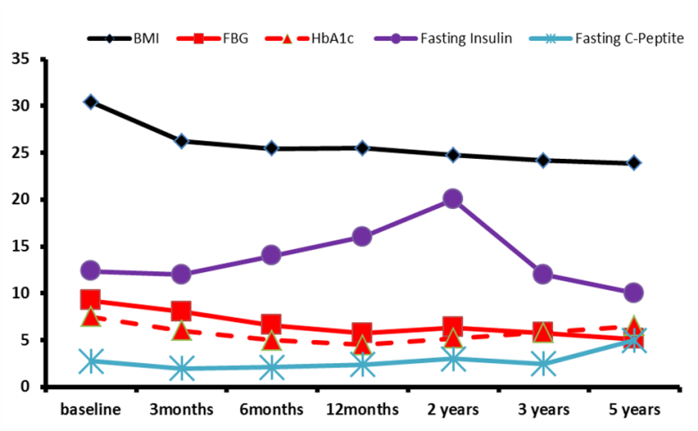
Figure 1 Glucose homeostasis after five year follow up
BMI: kg/m2; FBG:mmol/L; HbA1c:%; Fasting Insulin:mU/L; Fasting C-peptide: nmol/L

Recent Publications
- Mazidi M, Gao HK (2017). Changes in adiposity and other cardiometabolic risk factors following Roux-en-Y gastric bypass: A 12-month prospective cohort study in Chinese patients. Indian J Gastroenterol. 2017;36(4):258-262.
- Mazidi M, Gao HK (2017).Inflammatory Markers Are Positively Associated with Serum trans-Fatty Acids in an Adult American Population. J Nutr Metab. 2017;2017:3848201.
- Mazidi M, Gao HK (2017). The relationship of plasma Trans fatty acids with dietary inflammatory index among US adults. Lipids Health Dis. 2017 4;16(1):147.
- Mazidi M, Gao HK (2017). Effect of Sodium-Glucose Cotransport-2 Inhibitors on Blood Pressure in People With Type 2 Diabetes Mellitus: A Systematic Review and Meta-Analysis of 43 Randomized Control Trials With 22 528 Patients. J Am Heart Assoc. 2017 25;6(6)

Biography
Hongkai Gao, M.D. is Associate Professor of Surgery and Vice chief of General Surgery. He served as Director of Beijing Diabetes Prevention Association. He performed the first 3 years follow-up study that provided the direct evidence of the effect of gastric bypass surgery on type 2 diabetes in China in 2011. His research interests include studying the surgical mechanisms on diabetes and obesity and the role of gastrointestinal hormones in the physiology and pathophysiology of glucose homeostasis. Dr. Gao authored the translated book in 2013, “Bariatric and Metabolic Surgery”. He serves as invited Reviewers to Chinese Journal of Diabetes.
Email: wjgaohk@163.com

Notes/Comments:

