Medical Nutrition Therapy (MNT) In Gestational Diabetes Mellitus (GDM) Management: A Healthcare Professional Centric Survey
Hitesh Punyani, MD, Chaitanya Cardio-Diabetes Centre, Delhi
Neelam Pandey, DM, Pinnacle Super Specialty Clinic, Gurugram
Bharti Kalra, MD, Bharti Hospital, Karnal
Priya Sindhwani, MS, New Delhi
Chetan Mehndiratta, MD, New Delhi
Tanmay Agrawal, M Pharm, New Delhi

Abstract
Background: GDM is defined as any degree of dysglycemia with onset or first recognition during pregnancy. Prevalence of GDM in Asia (11.5%) is higher than European countries (5.4%). Women with GDM are at increased risk of developing gestational hypertension, preeclampsia and caesarean section. Approximately 50% women with GDM develop type 2 diabetes within five year of pregnancy. Children born to mothers with GDM are up to 8-times more likely to develop type 2 diabetes and obesity in their teens or early adulthood.
MNT is defined as “nutritional diagnostic, therapy, and counselling services for the purpose of disease management, furnished by a registered dietitian or nutrition professional. The challenge is to stabilize the nutrient requirements during pregnancy along with maintaining glucose levels.
Methodology: Keeping in view the direct correlation between diet and GDM, we undertook a survey on the MNT in GDM management across India. A total of 492 Gynecologist/Diabetologist completed 15-item survey by rating on 5 point Likert scale: 1=strongly disagree, 2=disagree, 3=neutral, 4=agree, 5=strongly agree. The questionnaire is about management of GDM, identifying trends of MNT in GDM, its importance and management of nutritional deficiencies, recommendation pattern, benefits of MNT, importance of low GI and practice trends of doctors across India.
Results: More than 85% of doctors agreed or strongly agreed that for GDM management, prevention, timely screening and diagnosis is extremely crucial and if not adequately managed, could lead to number of maternal and fetal complications. Total 83% doctors were of opinion that MNT is a central aspect in treatment of GDM, however they believe that MNT should be individualized based on the requirement. The most common pattern of prescription was either as snack replacement or snack supplement.
Conclusion: Doctors strongly recommend MNT to be an integral part of GDM management under the guidance from a registered dietician.

Image
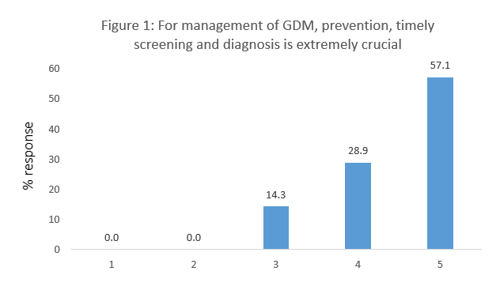
Recent Publications
- Viswanathan V, Krishnan D, Kalra S et.al. Insights on Medical Nutrition Therapy for Type 2 Diabetes Mellitus: An Indian Perspective. Adv Ther. 2019 Mar;36(3):520-547.
- Group HSCR. Hyperglycemia and adverse pregnancy outcomes. N Engl J Med. 2008;358(19):1991–2002.
- Anna V, van der Ploeg HP, Cheung NW, Huxley RR, Bauman AE. Socio-demographic correlates of the increasing trend in prevalence of gestational diabetes mellitus in a large population of women between 1995 and 2005. Diabetes Care. 2008;31:(12)2288–2293.
- Mwanri AW, Kinabo J, Ramaiya K, Feskens EJ. Gestational diabetes mellitus in sub-Saharan Africa: systematic review and meta regression on prevalence and risk factors. Tropical Med Int Health. 2015;20(8):983–1002.
- Kim C, Newton KM, Knopp RH. Gestational Diabetes and the Incidence of Type 2 Diabetes: A Systematic Review, Diabetes Care 25, 2002.

 Biography
Dr. Hitesh Punyani is a practicing Cardio Diabetologist with an experience of 24 years. He is Director of Chaitanya Cardio-Diabetes Centre in Ramesh Nagar, Delhi. He completed MBBS from Pt BD SHARMA PGIMS Rohtak in 1995 and MD - Medicine from Pt BD Sharma PGIMS Rohtak in 2001. He is a member of Research Society for the Study of Diabetes in India (RSSDI) and has a lot of publications to his credit. Some of the services provided by the doctor are: comprehensive management of Type1 and Type 2 Diabetes Mellitus including diet counselling, thyroid disorders, hypertension and various other cardiovascular diseases and infections.

Email: hiteshpunyani@gmail.com

Notes/Comments:

