Effect of Five Weeks of High-Intensity Interval Training on the Expression of miR-23a and Atrogin-1 in Gastrocnemius Muscles of Diabetic Male Rats

Shiva khoramshahi, Phd student

University of Tehran, Iran

Mohammadreza Kordi, Assist prof Dr

University of Tehran, Iran

Statement of the Problem: Diabetes is the most common metabolic disorder and in a sense is the most common endocrine disease(1). Muscular atrophy is one of the complications of this disease during this action in muscle atrophy factors such as Atragin-1 increases which leads to changes in protein synthesis and breakdown(2).miR-23a has anti-atrophy and through the suppression of target gene Atragin-1 to help reduce atrophy agents(3). The aim of this study was to evaluate the effect of five weeks of intense interval training (HIIT) on miR-23a expression and Atrogin-1 in Gastrocnemius muscle of diabetic male rats. Methodology & Theoretical Orientation 14 Wistar rats with an average weight of 260±10g by injection of Streptozotocin(50mg/kg) were randomly divided into two groups . Exercise protocol included five minutes of warm-up and cool-down(30-40% VO2max),four three minutes sets (85-90% VO2max and one minute recovery between each set 30- 35% VO2max).24 hours after the last training session, gastrocnemius muscles were removed and the miR-23a and Atrogin-1 gene were measured by RT-PCR to check the compatibility of the implementation of HIIT. Data analysis was preformed using K-S test and independent t-test. Conclusion & Significance: miR-23a expression had tripled increased. As well as gene expression Atrogin-1 was about 49 percent decreased. The average weight of the rats in the exercise group increased also the average weight of the rats in the control group decreased. plasma glucose concentration training group compared to the control group was significantly decreased. The research evidence shows that, high-intensity exercise, the possibility of better and more effective in controlling blood glucose in diabetic patients. Due to less weight the experimental group than the control group and reduce hypoglycemia the experimental group than the control group appeared, high intensity interval training this path have a positive impact to prevent further damage and muscle tissue diabetes.
Image
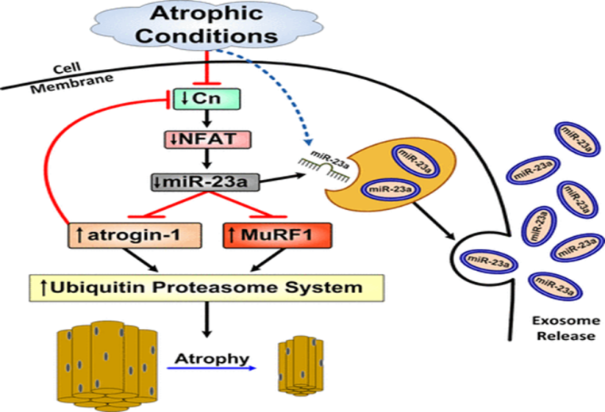
Figure 1: Atrophic pathway

 Biography

Shiva khoramshahi phd student at university of Tehran. she is former member of Iran national archery team. She interested to connection between physical training and science to improving healthcare for diabetics. This approach control complications of diabetes.

Email: shiva_khoramshahi@yahoo.com

