DIABETIC FOOT IN ALGERIA
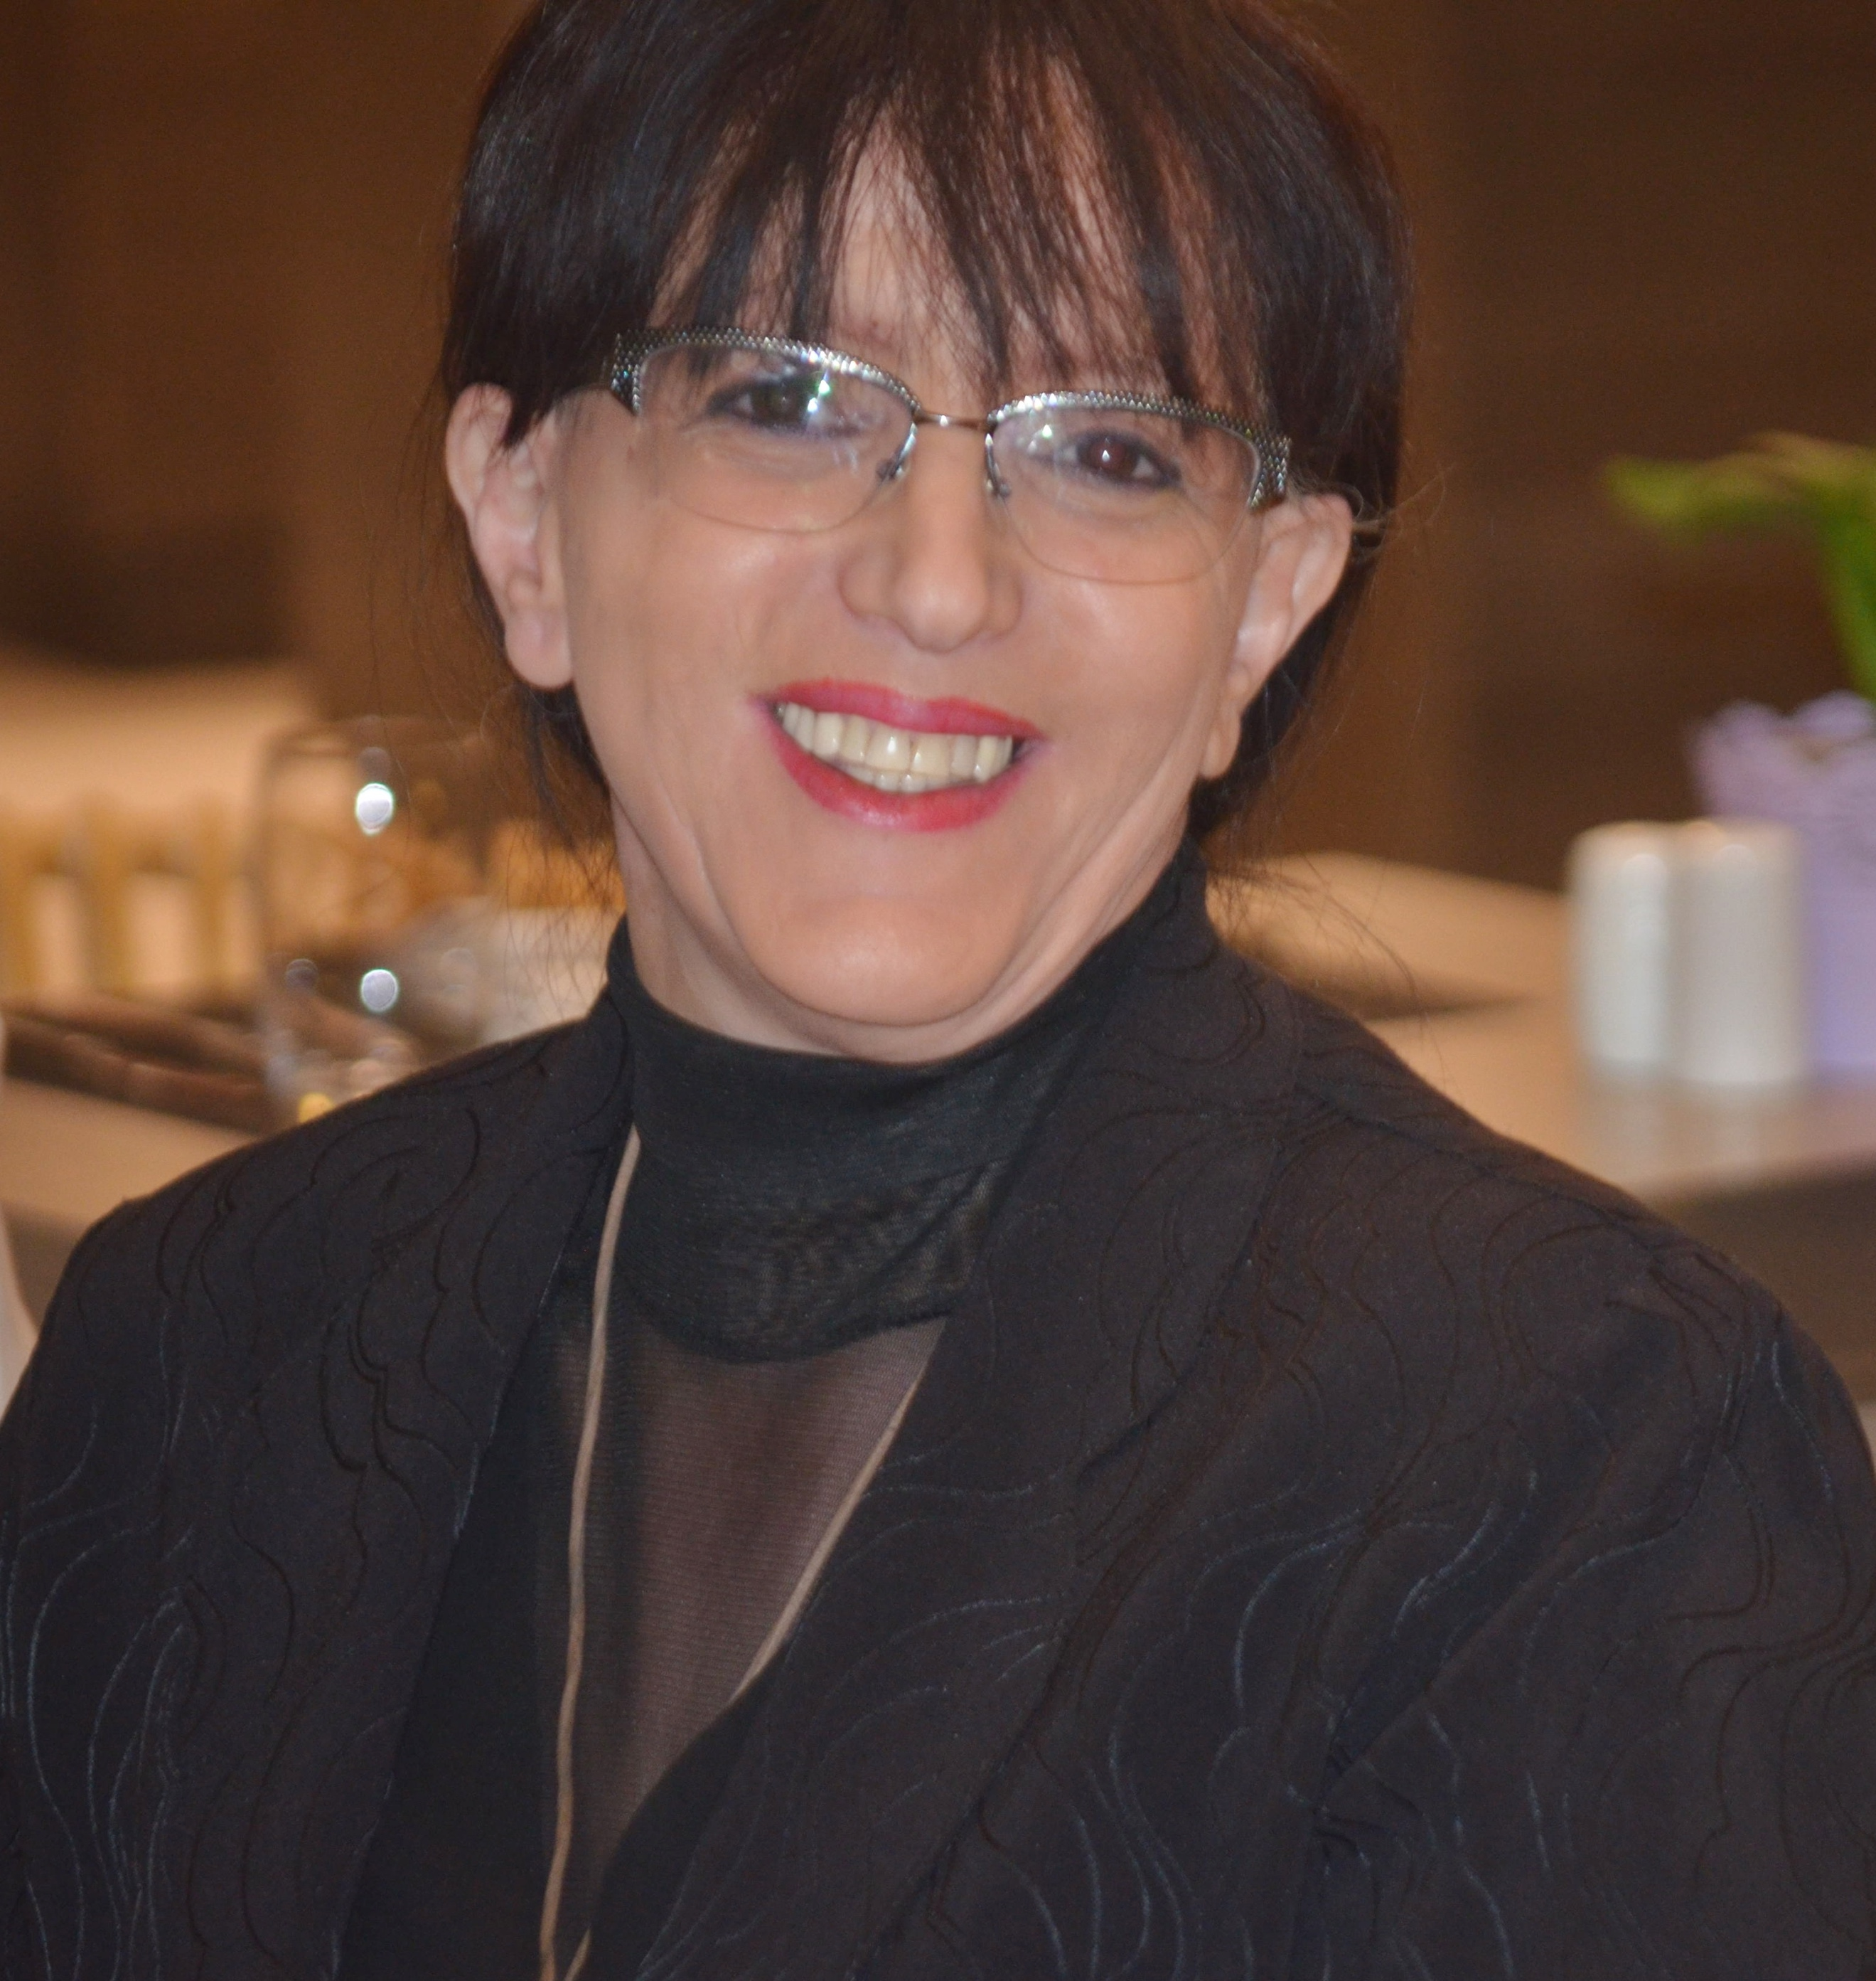

(CARBOMEDTHERAPY)

Dr. NADIA BOUDJENAH
39 Boulevard Marius Vivier Merle
Lyon 69003, France
Phone: +33 681 59 98 00
------------
132 route Ouled Fayet, Amara
Chéraga, Alger 16003, Algeria
Phone: +213 661 89 00 17
+213 555 03 89 88
Email: drboudjenah@yahoo.fr
drboudjenah@pieds-diabetique.com

- Based on our experience, after having taken care of more than 80.000 patients over 12 years, we were able to define specific particularities as well as strong points of our therapeutic strategy:
- Therapeutic: carbon dioxide therapy.
- Economic: outpatient practice, our patients have no access to any insurance benefits.
- Results: less than 0,5 % of major amputations.

All the assessments that we request are conventional: different tests - Blood, Bacteriological, Arterial and venous echo-doppler, Radiology, microcirculation / macrocirculation tests and ENMGs.

As treatment:
We use a very specific device which delivers heated carbon dioxide during the transcutaneous injections through disposable accessories. We also use targeted antibiotic treatments as well as anticoagulants. Full discharge of the wound is mandatory. It is accompanied by a specific physical activity that has for goal not to lose muscles and joints, and fight against the development of pressure sores.
For local treatment, we recommend foot baths with a mixture of water and hydrogen peroxide. Every day, we cover the wounds with a cream (Belcic), and complete with a light dressing which is made by compresses and gauze bands. The rehydration of the feet is ensured by (coconut), a locally made cream. For mycoses, we use Belmyc drops and spray.

Maggot therapy is part of our therapeutic arsenal. This natural microsurgery helps remove dead tissue, and leads to a granulation stimulation, leaving behind healthy tissue that can heal.

About CDT
The Carbon Dioxide Therapy is called Carbomedtherapy for diseases, and carboxytherapy for aesthetics.
Carbomedtherapy significantly improves vascularity. It repels ischemia and distinguishes necrotic from viable areas. In post-surgery, the contribution of CDT to wound healing is as important.

- The second part of our presentation will develop our prospective study that began January 01, 2021 for a period of six months. Our main objective is to highlight the effectiveness of CDT in the management of patients without having to resort to vascular surgery which is not within our reach. We usually provide an Average of 1000 consultations per month. January 2021 activity saw a decline due to the pandemic.

Conclusions
The safety and efficiency of Carbomedtherapy make this simple technique an appreciable tool, especially since: a) It is performed on an outpatient practice reducing the cost of the treatment; b) Wound prevention by treating the neuropathy allowing a better comfort for our patients; c) Reducing amputation rates to 0.5%.

BIOGRAPHY:
Dr. Nadia Boudjenah is General Surgeon who specializes in a diabetic Foot and its complications. With 40 years of experience, she specializes in the practice of the Carbon Dioxide Therapy, a technique she practices for more 15 years now.
For 8 years, as an assistant professor at the University Hospital, Zéralda, Algiers West, she was the Head of Surgical Unit.
For 12 years, in France, she was a Hospital Practitioner specializing in general and endocrinology surgery.
For the last 15 years, she has her own diabetic foot center, first in France, and for the last 12 years in Algeria.

