Unleashing the power of controlling hepatic Thioredoxin-interacting protein (TXNIP) by quercetin in diabetes

Salma M Eraky, Department of Biochemistry, Faculty of Pharmacy, Mansoura University, Mansoura, Egypt
Nehal M Ramadan, Clinical Pharmacology Department, Faculty of Medicine, Mansoura University, Mansoura, Egypt
Nada F Abo El-Magd, Department of Biochemistry, Faculty of Pharmacy, Mansoura University, Mansoura, Egypt

Abstract
TXNIP, one of the α-arrestins that has been named so due to its function as an inhibitor of the antioxidant protein, thioredoxin. By inhibiting the activity of thioredoxin, TXNIP disrupts the intracellular redox balance, and promotes the occurrence of oxidative stress. That is why, inhibiting or lowering TXNIP expression has shown obvious cellular protective effects across many cell types.
Dating back to 2002, the first clue to the involvement of TXNIP in diabetes pathogenesis was reported, when a gene expression microarray has described TXNIP as the highest glucose-induced gene in human pancreatic islets. Via launching beta cell apoptotic signals, promoting inflammatory and autoimmune responses and lowering insulin production, TXNIP was centrally suited in the development and progression of diabetes. Indeed, lowering beta cell TXNIP expression has been described with metformin, dipeptidyl peptidase-4 inhibitors, as well as, Glucagon like peptide-1 analogues.
Recently, another role of TXNIP as a key regulator of hepatic glucose production was highlighted, and gene suppression of hepatic TXNIP in the livers of diabetic animals was sufficient to normalize expression of hepatic gluconeogenic genes, and to control hyperglycaemia.

Apart from its antioxidant properties, molecular docking has revealed that quercetin (Q, 3,30,40,5,7-pentahydroxyflavone) represents a potent bioactive TXNIP inhibitors. Our recently available online publication, Cell Biochem Funct. 2021 Dec 2. doi: 10.1002/cbf.3678. Epub ahead of print. PMID: 34855213, highlights the efficacy of quercetin alone or in combination with Liraglutide in lowering TXNIP protein expression in the diabetic rat livers. Such effect was linked to improved hepatic insulin signalling and reduction in insulin receptor substrate (IRS-1) serine phosphorylation, along with increased PI3K expression.
Image
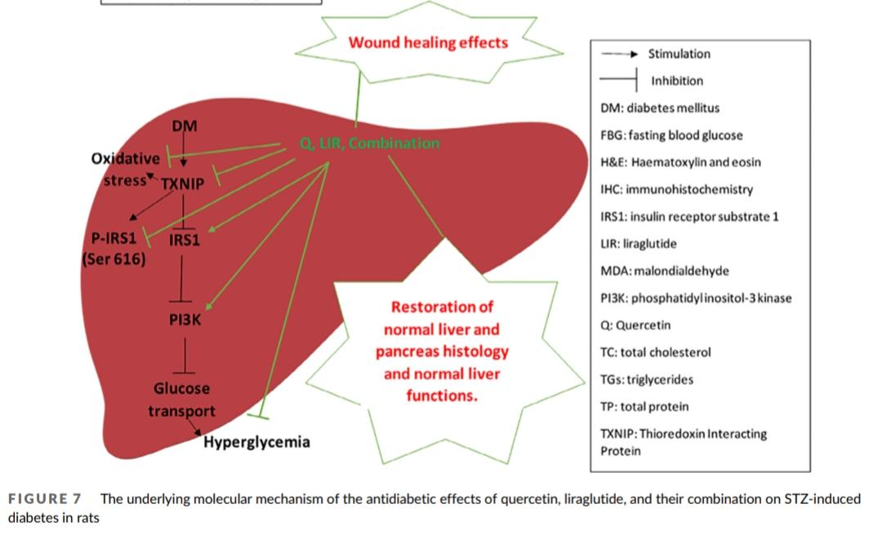
Recent Publications (minimum 5)
- El-Beltagi HM, Fouda AM, Abdel-Ghany SA, Ramadan NM, Daba MH, Abd-Elaziz MA. Students’ perception for objective structured practical examination versus traditional examination in clinical pharmacology department, Mansoura faculty of medicine, Egypt. International journal of Biology, Pharmacy AND Allied Science (IJBPAS), 2018, 7(4): 421-427.
- Eraky SM, Ramadan NM. Effects of omega-3 fatty acids and metformin combination on diabetic cardiomyopathy in rats through autophagic pathway: Effects of omega-3 fatty acids and metformin combination on diabetic cardiomyopathy: Role of autophagy. J Nutr Biochem. 2021; 5:108798. https://doi.org/10.1016/j.jnutbio.2021.108798.
- Abo El-Magd NF, Ramadan NM, Eraky SM. The ameliorative effect of bromelain on STZ-induced type 1 diabetes in rats through Oxi-LDL/LPA/LPAR1 pathway. Life Sci. 2021 Nov 15;285:119982. doi: 10.1016/j.lfs.2021.119982. Epub 2021 Sep 27. PMID: 34592232.
- Ramadan NM, Malek HA, Rahman KA, El-Kholy E, Shaalan D, Elkashef W. Liraglutide Effect on Ventricular Transient Outward K + Channel and Connexin-43 Protein Expression. Exp Clin Endocrinol Diabetes. 2021 Dec;129(12):899-907. doi: 10.1055/a-1162-8196. Epub 2020 Jun 19. PMID: 32559789.
- Eraky SM, Ramadan NM, Abo El-Magd NF. Antidiabetic effects of quercetin and liraglutide combination through modulation of TXNIP/IRS-1/PI3K pathway. Cell Biochem Funct. 2021 Dec 2. doi: 10.1002/cbf.3678. Epub ahead of print. PMID: 34855213.



Biography

Nehal M. Ramadan has her research expertise in experimental and clinical pharmacology. Her research focus mainly on assessing the potential therapeutic efficacy of natural and/or synthetic drugs against diabetic metabolic phenotype and its related complications. She had earned her MSc and PhD degree in clinical pharmacology from Mansoura faculty of medicine, Egypt in 2017. With special emphasis on the molecular mechanisms of drug/herb action, her publications targeted mainly drug's effect on the diabetic heart electrophysiology and autophagy pathways, and also on the diabetic liver insulin signaling and resistance.
Email: Nehalpharma@mans.edu.eg

Notes/Comments:

Presenting author details
Full name: Nehal Mohamed Ramadan
Contact number: +2 01113397935
Twitter account:
Linked In account: https://www.linkedin.com/in/nehal-ramadan-06a563a6
Session name/ number:
Category: (Oral presentation/ Poster presentation)

