EDC-ABS-119

The effects of professional continuous glucose monitoring as an adjuvant educational tool for improving glycemic control in patients with type 2 diabetes: A pilot study in Mexico
Dulce Adelaida Rivera-Ávila. MD. Especialista en Medicina Familiar. Clínica de Medicina Familiar Oriente. ISSSTE. México City
E-mail: dradulcedul@gmail.com *
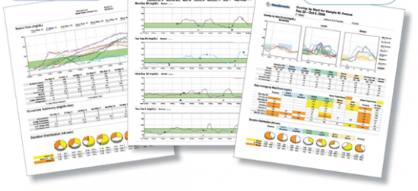
Alejandro Iván Esquivel-Lu. MD. ISSSTE. México City
Carlos Rafael Salazar-Lozano. MD. Especialista en Cirugía General. México City
Kyla Jones. México City
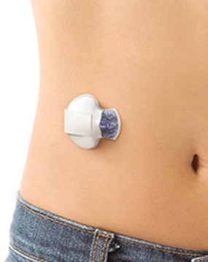
Svetlana V. Doubova, M.D., M.Sc., D.Sc. IMSS. Mexico City.

Abstract
Statement of the Problem: It is important to analyze the benefits of the use of health technologies. Particularly, continuous glucose monitoring (CGM) could represent an educational intervention that is expected to be useful for the glycemic control of patients with Type 2 Diabetes Mellitus (T2D). The improvements in patient glycemic control would help to avoid the development of micro and macro-vascular complications, and therefore reduce the total costs for society derived from the care of patients with diabetes. Methodology & Theoretical Orientation: We conducted a three-month quasi-experimental study with an intervention and control group and ex-ante and ex-post evaluations in one family medicine clinic in Mexico City. Participants were T2D patients with HbA1c>8 mg/dL attending a comprehensive diabetes care program. In addition to the program, the intervention group wore a professional CGM sensor (iPro™2) during the first six days of the study. Following this period, intervention group participants had a medical consultation for the CGM results and treatment adjustments. Additionally, they received an educational session and personalized diet plan from a dietitian. Findings: This pilot study showed an improving glycemic control of patients with T2D, as reflected in the additional 0.481 points decrease of HbA1c levels in the intervention group compared with the control group in the three-month follow-up. The intervention group reached a significant increase in the time in range measurement and decreases in the time in hyperglycemic range, glucose variability, and total caloric intake. Conclusion & Significance: Primary care services deliver most of the care for patients with T2D. Care for these patients is complex and requires interprofessional collaboration. Our results indicate that in the context of Latin American countries, the professional CGM may be a useful tool for accurate data that can guide the therapeutic and educational decisions of health providers treating patients with T2D.
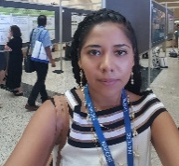

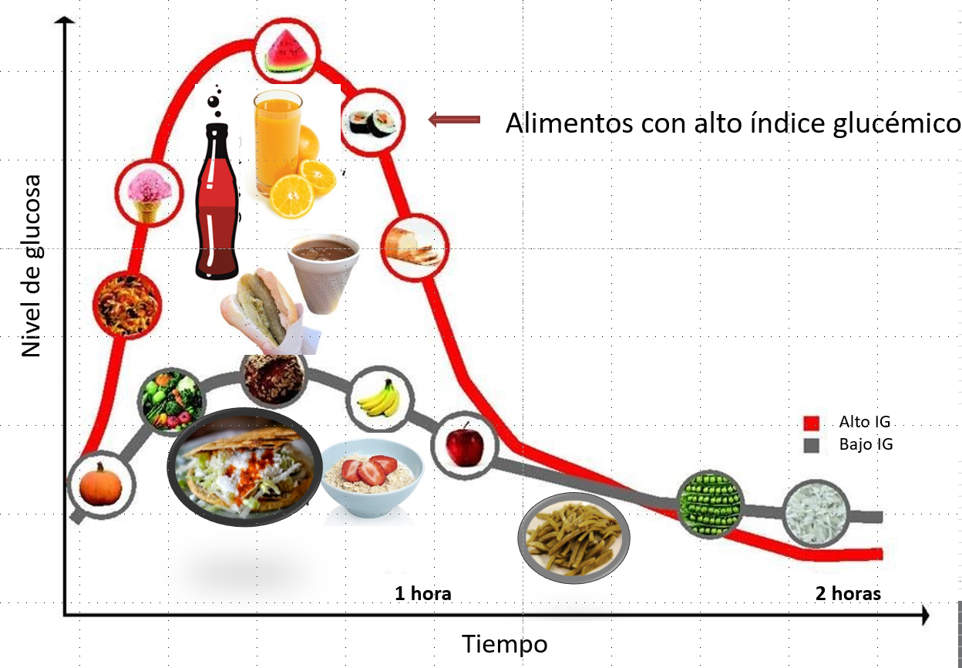

Recent Publications
- Rivera-Ávila, D.A., Esquivel-Lu, A.I., Salazar-Lozano, C.R. et al. The effects of professional continuous glucose monitoring as an adjuvant educational tool for improving glycemic control in patients with type 2 diabetes. BMC Endocr Disord 21, 79 (2021). https://doi.org/10.1186/s12902-021-00742-5
- Aleppo G. Approaches for Successful Outcomes with Continuous Glucose Monitoring. 2018 Aug. In: Role of Continuous Glucose Monitoring in Diabetes Treatment. Arlington (VA): American Diabetes Association; 2018 Aug. Available from: https://www.ncbi.nlm.nih.gov/books/NBK538974/ doi: 10.2337/db20181-13
- Carlson AL, Mullen DM, Bergenstal RM. Clinical Use of Continuous Glucose Monitoring in Adults with Type 2 Diabetes. Diabetes Technol Ther. 2017;19(S2):S4-S11. doi:10.1089/dia.2017.0024
- Park C, Le QA. The Effectiveness of Continuous Glucose Monitoring in Patients with Type 2 Diabetes: A Systematic Review of Literature and Meta-analysis. Diabetes Technol Ther. 2018;20(9):613-621. doi:10.1089/dia.2018.0177
- Rodbard D. Continuous Glucose Monitoring: A Review of Recent Studies Demonstrating Improved Glycemic Outcomes. Diabetes Technol Ther. 2017;19(S3):S25-S37. doi:10.1089/dia.2017.0035
- Sierra JA, Shah M, Gill MS, Flores Z, Chawla H, Kaufman FR, Vigersky R. Clinical and economic benefits of professional CGM among people with type 2 diabetes in the United States: analysis of claims and lab data. J Med Econ. 2018;21(3):225-230.

Dulce Rivera is a Mexican academic in primary health care and trained as a GP, Professor of Therapeutics of Pharmacology at National Autonomous Mexican University. Master of Health Sciences. She joined de Education Department at the Mexican Civil Service Social Security and Services Institute (ISSSTE). Founder and active member of the Mexican Network of Researchers in Family Medicine AC. She has expertise in evaluation and treatment of heterogeneity patient response and passion in improving the medical education and help clinicians and patients to make more informed decisions about diabetes care; increasing adherence to pharmacological treatment and motivating patients to make changes in their lifestyle.
Email: dradulcedul@gmail.com
Notes/Comments:

