Effects of Calorie Restriction on Insulin Resistance: A Potential Diabesity Prevention

Ana Napoleão, Medical Student, Portugal
Lívia Fernandes, CN, Nutritionist, Portugal
Cátia Miranda, CN, Nutritionist, Portugal
Ana Paula Marum, MD, Medical Doctor, Portugal

Abstract
The present abstract is based on the article “Effects of Calorie Restriction on Health Span and Insulin Resistance: Classic Calorie Restriction Diet vs. Ketosis-inducing Diet” (2021). Nevertheless, as this subject is in continued investigation, further results and conclusions will be added to the existing evidences.
Diabesity, the coexistence of diabetes and obesity, has become a recent pandemic, implying a rising need for preventive approaches.
Calorie restriction (CR) is the most robust nutritional intervention known to increase health span. CR improves cardiometabolic risk parameters, boosts exercise insulin sensitivity response, and may have long term benefits on healthy young and middle-aged individuals. Moderate CR can prevent and reverse the harmful effects of the accumulation of excessive body fat and obesity, diabetes, dyslipidemia, and hypertension. Insulin resistance is one of the most significant factors implicated in these results. Metabolic pathways and pathophysiological mechanisms are well known (figure 1).
In the CALERIE 2 trial CR resulted in a significant improvement in glucose tolerance, insulin sensitivity index, and metabolic syndrome score. BIOSPHERE 2 and CRON studies showed similar results.
Ketosis-inducing diets represent a group of diets that induce the production of ketone bodies, comprising: diets with low carbohydrate content, normoproteic content and high-fat content, such as classic ketogenic diet, fasting mimicking diet, very-low-calorie ketogenic diet and Spanish ketogenic Mediterranean diet; and diets in which the individual restricts the eating period, having intermittent ketosis, such as intermittent fasting. Ketosis-inducing diets have shown promising results on the improvement of insulin sensitivity and fasting glucose, and on the reduction of perceived hunger with weight loss. A consensus paper by the American Diabetes Association concluded that diets with low carbohydrate content (including those leading to physiological ketosis) “have been shown to reduce glycated hemoglobin and the need for anti-hyperglycemic drugs”.
In summary, CR, including ketosis-inducing diets, may play a role in diabesity prevention. Yet, most studies are designed for obese or diabetic individuals, in which dietary approaches have a secondary prevention and treatment goal. Nonetheless, primary prevention is pivotal, and so we must understand how different dietary approaches reduce the long-term incidence of diabesity.
Image

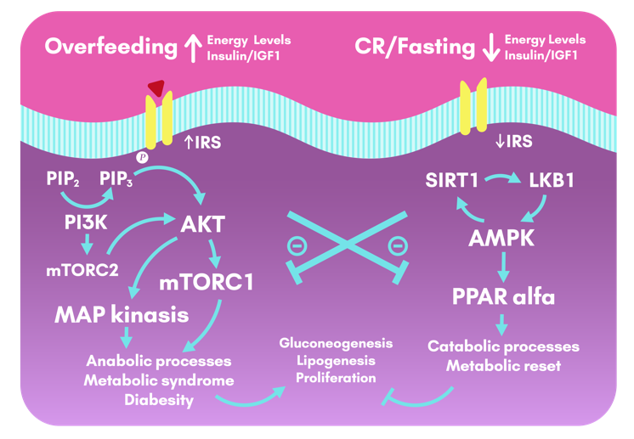

Figure 1: Cellular metabolic pathways activated during overfeeding and calorie restriction and fasting: insulin and IGF1 lead to the activation of the insulin-pAKT-mTOR pathway, that drives downstream gene activities that promote anabolic processes, glycolysis, gluconeogenesis, lipogenesis, and so, the physiopathology pathways that promote the metabolic syndrome and diabesity.
In contrast, CR or fasting periods activate AMPK/ SIRT1 pathway, counteracting the insulin and IGF1 pathways. AMPK triggers repair and catabolic processes, and metabolic reset.
AKT: Protein Kinase B; AMPK: Adenosin-mono-phosphate-activated protein kinase; CR: Calorie Restriction; IGF1: Insulin-like Growth Factor 1; IRS: Insulin Receptor Substrates; LKB1: Liver Kinase B1; MAP: Mitogen-Activated Protein; mTOR: mechanistic Target OF Rapamycin; PI3K: Phosphoinositide 3-Kinase; PIP2: Phosphatidylinositol biphosphate; PIP3: Phosphatidylinositol triphosphate; PPAR alfa: Peroxisome proliferator-activated receptor gamma; SIRT1: Sirtuin 1.

Recent Publications
- Caprio, M.; Infante, M.; Moriconi, E.; Armani, A.; Fabbri, A.; Mantovani, G.; Mariani, S.; Lubrano, C.; Poggiogalle, E.; Migliaccio, S.; et al. Very-low-calorie ketogenic diet (VLCKD) in the management of metabolic diseases: Systematic review and consensus statement from the Italian Society of Endocrinology (SIE). J. Endocrinol. Investig. 2019, 42, 1365–1386.
- Cox, N.; Gibas, S.; Salisbury, M.; Gomer, J.; Gibas, K. Ketogenic diets potentially reverse Type II diabetes and ameliorate clinical depression: A case study. Diabetes Metab. Syndr. Clin. Res. Rev. 2019, 13, 1475–1479.
- Gabel, K.; Kroeger,C.M.; Trepanowski,J.F.; Hoddy,K.K.; Cienfuegos,S.; Kalam,F.; Varady,K.A. Differential Effects of Alternate-Day Fasting Versus Daily Calorie Restriction on Insulin Resistance. Obesity 2019.
- Hutchison, A.T.; Liu, B.; Wood, R.E.; Vincent, A.D.; Thompson, C.H.; O’Callaghan, N.J.; Wittert, G.A.; Heilbronn, L.K. Effects of Intermittent Versus Continuous Energy Intakes on Insulin Sensitivity and Metabolic Risk in Women with Overweight. Obesity 2019, 27, 50–58.
- Kraus, W.E.; Bhapkar, M.; Huffman, K.M.; Pieper, C.F.; Krupa Das, S.; Redman, L.M.; Villareal, D.T.; Rochon, J.; Roberts, S.B.; Ravussin, E.; et al. 2 years of calorie restriction and cardiometabolic risk (CALERIE): Exploratory outcomes of a multicentre, phase 2, randomised controlled trial. Lancet Diabetes Endocrinol. 2019, 7, 673–683.
- Malinowski, B.; Zalewska, K.; We ̨sierska, A.; Sokołowska, M.M.; Socha, M.; Liczner, G.; Pawlak-Osin ́ska, K.; Wicin ́ski, M. Intermittent Fasting in Cardiovascular Disorders—An Overview. Nutrients 2019, 11, 673.
- Paoli, A.; Tinsley, G.; Bianco, A.; Moro, T. The Influence of Meal Frequency and Timing on Health in Humans: The Role of Fasting. Nutrients 2019, 11, 719.
- Pignatti, C.; D’Adamo, S.; Stefanelli, C.; Flamigni, F.; Cetrullo, S. Nutrients and Pathways that Regulate Health Span and Life Span. Geriatrics 2020, 5, 95.
- Romano, L.; Marchetti, M.; Gualtieri, P.; Di Renzo, L.; Belcastro, M.; Lou De Santis, G.; Perrone, M.A.; De Lorenzo, A. Effects of a Personalized VLCKD on Body Composition and Resting Energy Expenditure in the Reversal of Diabetes to Prevent Complications. Nutrients 2019, 11, 1526.
- Stekovic, S. Alternate Day Fasting Improves Physiological and Molecular Markers of Aging in Healthy, Non-obese Humans. Cell Metab. 2019, 21, 462–476.e6.
- Tappia, P.S.; Blewett, H. Nutrition and Cardiovascular Health. Int. J. Mol. Sci. 2020, 21, 2284.
- Yuan, X.; Wang, J.; Yang, S.; Gao, M.; Cao, L.; Li, X.; Hong, D.; Tian, S.; Sun, C. Effect of the ketogenic diet on glycemic control, insulin resistance, and lipid metabolism in patients with T2DM: A systematic review and meta-analysis. Nutr. Diabetes 2020, 10, 38.

________________________________________________

Biography

Ana Napoleão (speaker) is a Medical Student at the University of Lisbon. She is also doing a Master on orthomolecular medicine at the Spanish Society of Precision Health, and recently published about calorie restriction and ketosis inducing diets.

Lívia Fernandes is Graduated in Nutrition from the Federal University of Minas Gerais (Brazil)and has a Master in Gastronomic Sciences from Universidade Nova de Lisboa (Portugal). She has experience in research along the lines involving obesity, eating behaviour and intervention strategies. Currently works with Clinical Nutrition.

Cátia Miranda has a Master’s in Clinical Nutrition, a Degree in Nutrition Sciences and Food Engineering, and an Advanced Course in Functional Nutrition. She is currently a certified trainer in the field of Nutrition Sciences and works in Clinical Functional and Integrative Nutrition.

Ana Paula is a Medical Doctor with a Master’s in Clinical Nutrition. She is an Integrated Clinical Director, leading a multidisciplinary clinical team. Specialist in orthomolecular medicine, functional and integrative medicine, and Lecturer at a higher school of health. Has conducted clinical trials on Low FODMAPs diet.

email: direcaoclinicacemint@gmail.com

________________________________________________

Notes/Comments
This abstract was prepared based on the article Effects of calorie restriction on health span and insulin resistance: classic calorie restriction diet vs ketosis-inducing diet, published on Nutrients on April 2021, https://doi.org/10.3390/nu13041302.

