Costs associated with depression and obesity among cardiovascular patients: medical expenditure panel survey analysis
Felipe S. Tápias, MD, MSc, University of Medical Sciences of Santa Casa de São Paulo, Brazil
Victor H. O. Otani, MD, MSc, University of Medical Sciences of Santa Casa de São Paulo, Brazil
Daniel A. C. Vasques, MD, MSc, University of Medical Sciences of Santa Casa de São Paulo, Brazil
Thais Z. S. Otani, MD, MSc, University of Medical Sciences of Santa Casa de São Paulo, Brazil
Ricardo R. Uchida, MD, PhD, University of Medical Sciences of Santa Casa de São Paulo, Brazil

Abstract
Statement of the problem: The financial burden of depression accounted for $ 210.5 billion in 2010 in the US alone. While depression-associated comorbidities contribute over 60% to this amount, the cost of cardiovascular disease treatment attributed to metabolic syndrome and depression are scarce in the literature. To fill this gap, we evaluated the interplay between depression and obesity on total expenses with cardiovascular conditions using data from the US Medical Expenditure Panel Survey (MEPS) database in the 1996-2017 period. Methodology & Theoretical Orientation: We categorized adult cardiovascular subjects from the MEPS database using the International Classification of Diseases ICD-9-CM and ICD-10 codes and the Patient Health Questionnaire-2 (PHQ-2) depression screening tool. Our sample encompassed 96,697 cardiovascular patients aged 18 years and older, with a body mass index (BMI) between 18.5 and 60, from a weighted sample of 938,835,031 individuals. The total annual healthcare expenditures evaluated included dental, emergency room, hospital outpatient, hospital inpatient, office-based, prescription, and home health care expenses. The outcomes were correlated with four response categories: no depression, unrecognized depression, asymptomatic depression, and symptomatic depression. Findings: Obese individuals were more affected by asymptomatic and symptomatic depression (p < 0.001). Total expenditure was highest among symptomatic depression individuals (17,536) and obese (9871) with cardiovascular disease. Expenditures were significantly higher among symptomatic depression individuals than those without depression (p < 0.001), except for dental costs (p = 0.899). All healthcare expenditures associated with obesity were higher compared to individuals with normal BMI with p < 0.001, except for emergency and home healthcare costs. Conclusion & Significance: Obesity and depression raised expenses with cardiovascular disease. As we used a nationally representative sample, we conclude that investments in screening and management of depression and obesity can help reduce the economic burden with cardiovascular disease treatment in the US.

Image

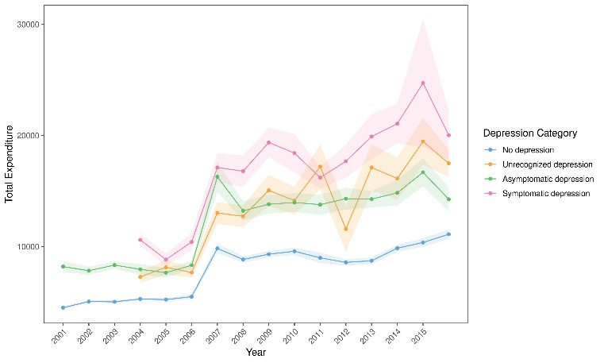
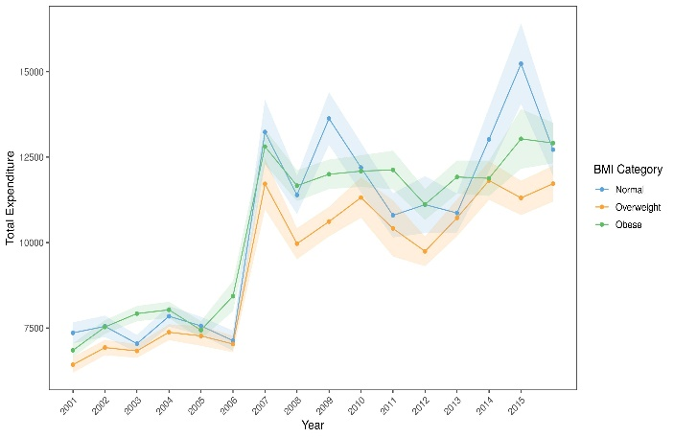
Figure 1: Total expenditure (in USD) among individuals with cardiovascular conditions from 2001 to 2015 stratified by (a) depression category and (b) BMI category.
Recent Publications
- Greenberg PE, Fournier A-A, Sisitsky T, Pike CT, Kessler RC (2015) The economic burden of adults with major depressive disorder in the United States (2005 and 2010). Journal of Clinical Psychiatry 76(2):155-162.
- Elderon L, Whooley MA (2013) Depression and cardiovascular disease. Progress in Cardiovascular Diseases 55(6):511-523.
- MEPS – Medical Expenditure Panel Survey (2015) Available at: https://meps.a hrq.gov/mepsweb/. Accessed 21 Sept 2020.
- Kroenke K, Spitzer RL, Williams JBW (2003) The patient health questionnaire-2: validity of a two-item depression screener. Medical Care 41(11):1284-1292.
5. Patten SB, Williams JVA, Lavorato DH, Fiest KM, Bulloch AGM, Wang J (2015) The prevalence of major depression is not changing. The Canadian Journal of Psychiatry 60(1):31-34.



Biography
Felipe Saia Tápias is a medical doctor with a Master’s degree in Health Sciences from the University of Medical Sciences of Santa Casa de São Paulo, Brazil. He is currently the Mental Health Coordinator of the municipality of Osasco, in the state of São Paulo.

Email: felipetapias89@gmail.com

Notes/Comments:

