Effective methods to improve electrical conductivity and Seebeck coefficient of thermoelectric PEDOT:PSS films
Jianwei Xu, Institute of Materials Research and Engineering (IMRE), the Agency for Science, Technology and Research (A*STAR), Singapore

Thermoelectric energy conversion that converts waste heat into electricity has attracted much attention as a potential clean energy technology. The performance of thermoelectric materials is determined by the dimensionless figure of merit (ZT), which is equal to σS2T/κ where the κ is the thermal conductivity, the S is the Seebeck coefficient and the σ is the electrical conductivity. The σS² stands the power factor. Even though a low k and a high-PF are needed to reach high ZT values, the conflicting relationship between the S and the σ limits the further modulation of ZT of thermoelectric materials. Conducting polymers are promising to be the next generation of thermoelectric materials. They have intrinsically low κ and potentially high σ, cost-effectiveness, large area processing and facile synthesis. Conductive polymers have been widely investigated as thermoelectric materials. Among the polymer TE materials studied, poly(3,4-ethylenedioxythiophene):poly(styrenesulfonate) (PEDOT:PSS), is particularly of interest. It is thermally stable, water processable and can be highly electrically conductive upon post-treatment. It was reported that the σ of PEDOT:PSS films can be greatly enhanced by various post-treatment methods to increase the charge carrier concentration. However, this high doping level results in a small S value because of the extra charge carrier and hence appropriate methods that enhance the S value are required. Moreover, earlier studies have already shown that the power factor could be improved by regulating the redox level through electrochemical or chemical methods optimizing thermoelectric properties through the control of charge carrier concentration. On the other hand, chemicals used in the enhancement of thermoelectric properties are mostly toxic, and its large-scale use should be avoided because of safety and environmental issues. This work will report several chemicals to tune the oxidation level of PEDOT:PSS films and enhance their electrical conductivity, Seebeck coefficient and environmental stability.

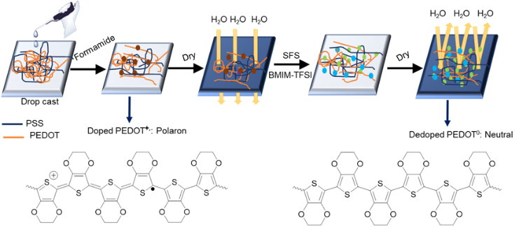
- Tam TLD, Ng CK, Lim SL, Yildirim E, Ko JU, Leong WL, Yang SW, Xu, JW (2019) Pro-Quinoidal Conjugated Polymer as an Effective Strategy for the Enhancement of Electrical Conductivity and Thermoelectric Properties. Chem. Mater. 31:8543-8550
- Kyaw AKK, Wong GDH, Yemata TA, Xu JW (2019) Effective ionic Seebeck component suppression in mixed ion-electron conductor via chemical treatment. Org. Electron. 69:7-12
- Tam TLD, Xu JW (2019) The role of fluoride in anion–π interaction with naphthalene diimide. Chem. Commun. 55:6225-6228.
- Yemata TA, Zheng Y, Kyaw AKK, Wang X, Song J, Chin WS, Xu JW* (2019) Improved thermoelectric properties and environmental stability of conducting PEDOT: PSS films post-treated with imidazolium ionic liquids Front. Chem. 7:870
5. Zheng Y, Zeng H, Qiang Z, Xu JW (2018) Recent advances of conducting poly (3, 4-ethylenedioxythiophene) polystyrene sulfonate hybrids for thermoelectric applications. J. Mater. Chem. C 6: 8858-8873.

Biography
Dr. Xu received his PhD from the National University of Singapore (NUS). His current research areas are mainly focused on polyhedral oligomeric silsesquioxanes (POSS)-based functional hybrid materials, electrochromic conjugated polymers, aggregation-induced emission-based materials and hybrid thermoelectric materials. He has published more than 160 papers and filed more than 30 patents, some of which has been licensed to companies. He contributed 10 chapters to polymer materials related books and also compiled a book on smart electrochromic materials and device. Now, he is a Principal Scientist in IMRE and a Strategic Research Councilor, A*STAR, Republic of Singapore. He also holds the appointments of Adjunct Associate Professor in NUS.
Email: jw-xu@imre.a-star.edu.sg

