Fabrication of topologically anisotropic microparticles and their surface
modification with pH responsive polymer brush
Ifra, S. Saha*, Department of Materials Science and Engineering, Indian Institute of Technology Delhi

Abstract
The performance of particles is highly influenced by particle size, shape, surface chemistry, elasticity and permeability¹. Electrohydrodynamic jetting technique has proven to be a versatile technique to fabricate particles with different shapes and sizes. In this work, we have fabricated topologically anisotropic cup shaped made from polylactide (PLA)/ poly[methylmethacrylate-co-2-(2-bromopropionyloxy) ethyl methacrylate] (75/25) of ~6 μm size using electrojetting technique. Solution and processing parameters were changed to understand the mechanism of cup shape formation and to control particle’s shape from cups to discoids. Surface initiated atom transfer radical polymerization (ATRP) of stimuli responsive DMAEMA (2-dimethylamino ethyl methacrylate) was subsequently carried out for 1 h onto the surface of cup shaped particles to observe pH responsiveness of the modified anisotropic particles. An interesting change in the morphology of cup shaped particles was observed which changed to elongated cup and showed significant swelling under acidic pH (swelling ratio:~1.6), also enhanced dye adsorption at specific pH was observed by optical microscope and confocal laser scanning microscope implying that DMAEMA polymerization happened onto the surface of the composite microparticles. The Raman microscopy and FTIR spectra obtained from the particles after polymerization further confirmed the immobilization of pH responsive poly(DMAEMA) brushes onto the cup shaped particles which may potentially function as triggered/targeted drug delivery vehicles. Moreover, the brush modified cup shaped particles were found to be two times more efficient in adsorbing dye compared to disc shaped one indicating a clear advantage of using cup shaped particles over other shapes for immobilizing/adsorbing charged species e.g. sensitive biomolecules.

Image

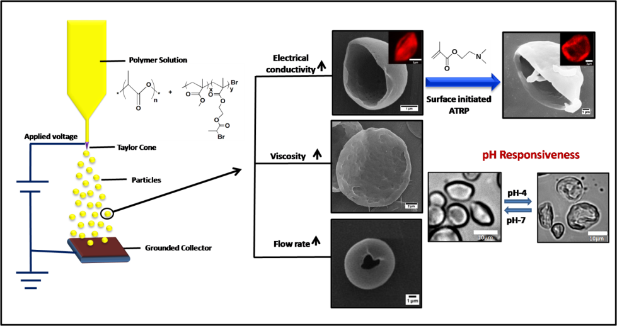

References
- Mirza, Ifra, and Sampa Saha. "Fabrication of topologically anisotropic microparticles and their surface modification with pH responsive polymer brush." Materials Science and Engineering: C (2019): 109894.
- Liu, Hang, Dejian Huang, and Jie Sun. "Microscale scaffolds with diverse morphology via electrohydrodynamic jetting for in vitro cell culture application." Biomedical Physics & Engineering Express (2019
- Wang, Dazhi, et al. "Fabrication of micro/nano-structures by electrohydrodynamic jet technique." Frontiers of Mechanical Engineering 12.4 (2017): 477-489.
- Yang, Lijiao, et al. "Anisotropic nanomaterials for shape-dependent physicochemical and biomedical applications." Chemical Society Reviews 48.19 (2019): 5140-5176.
- Ankamwar, Balaprasad. "Size and shape effect on biomedical applications of nanomaterials." Biomedical Engineering-Technical Applications in Medicine (2012): 93-114.

Biography


Ifra is a research scholar at Indian Institute of Technology, Delhi. She has expertise in particle’s fabrication via electrohydrodynamic jetting technique (modification of electrospinning) and surface modification.
Email: iframirza333@gmail.com, *ssaha@polymers.iitd.ac.in

