Synthesis and properties of MAl(XO4)2 crystals (M= Li, K or Na and X= W or Mo)

A.KHELFANE^{1,2}; I. T. E BOUDJELLAL² ; M. DERBAL² ; M. TABLAOUI¹

⁽¹⁾ Massive Semiconductors Growth laboratory, CRTSE, Algiers, Algeria.
⁽²⁾LASICOM laboratory. Blida1 university. Blida, Algeria.

Abstract
Much attention has been given in recent years to the study of tungstates and molybdates, especially those containing rare earth elements. In the last years, there has been a much interest to study the properties of monovalent (Li-Cs) and trivalent (Al, Ga, In, Cr, Bi, Y, La or lanthanide Ln=Ce-Lu) double tungstates or double molybdates crystals. These Crystal tungstates were shown to be promising for of variety of laser, scintillator and phosphor applications.
In this study, many tungstate and molybdate crystals were synthesized using the solid state reaction. Different conditions of preparation where used to obtain the MAl (XO4)2, (M= Li, Na and K ; X= W and Mo). The crystal structural, morphological structure, optical absorption experiments and quantum efficiency of the samples were analysed by X-ray diffraction (XRD), scanning electron microscope (SEM + EDS), UV-VIS-NIR scan spectrophotometer and Fourier transform infrared spectrometer (FT-IR) respectively. The synthesis protocols choosen where in good agreements to obtain double tungstates or molybdates such as NaAl(MoO4)2, KAl(MoO4)2, LiAl(MoO4)2 and LiAl(WO4)2. Other structural results have indicate mono phases apparition like Na2W4O13 and KAl0.33W1.67O6. The SEM analysis indicated that the particle size ranging from 0.3 to 4.47 µm. Optical analysis reveals band gap values (direct and indirect transitions) of obtained phases: double molybdates ranging from 3.20 eV to 3.41 eV for direct gap and from 2.93 eV to 3.16 eV for indirect gap (Figure.1) and for double tungstates LiAl(WO4)2, the band gap is 3.13 eV for indirect transition and 3.38 eV for direct transition.

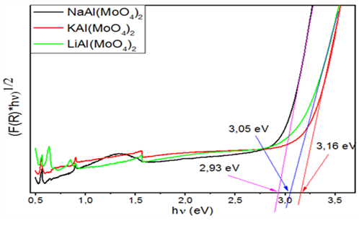

Figure.1. The indirect gap of different alkali Aluminium double molybdate.

References
- Greetham G.M., Donaldson P.M., Nation C., Sazanovich I.V., Clark I.P., Shaw D.J., Parker A.W., Towrie M., Appl. Spectrosc. 70 (2016) 645-653.
- Akbari R., Fedorova K.A., Rafailov E.U., Major A., Appl. Phys. B 123 (2017) 123-126.
- Lecoq P., Nucl. Instrum. Methods Phys. Res., Sect. A 809 (2016) 130-139.
- Guzik M., Tomaszewicz E., Kaczmarek S.M., Cybi_nska J., Fuks H., J. Non-Cryst. Sol. 356 (2010) 1902-1907.
- Zhou L.J., Wang W.X., Yu S.C., Nan B., Zhu Y.G., Shi Y., Shi H.H., Zhao X.Z., Lu Z.G., Mater. Res. Bull. 84 (2016) 429-436.

Biography

KHELFANE Amar was born on 18/03/1979 in Bouira, Algeria. He graduated from magister in 2012, a physical option for materials and components at the USTHB University in Algiers. He worked as a physics teacher in high school for two and a half years and temporary teacher inMohandAkliOulhaj University of Bouira, before joining the CRTSE Research Center in Algiers in December 2014 where he worked as a researcher in Bulk Semiconductors Crystal Growth team (CSM) working in photovoltaic materials of 3rd generation Cu2Zn(Ge)SnS4. In 2016, I enrolled in PhD at the Saad Dahlab University of Blida1, Algeria. he has more than 13 publications (oral conferences, posters, magister thesis, articles). His H index is 1 on Scopus.

Email : Khelfane.ammar@crtse.dz

