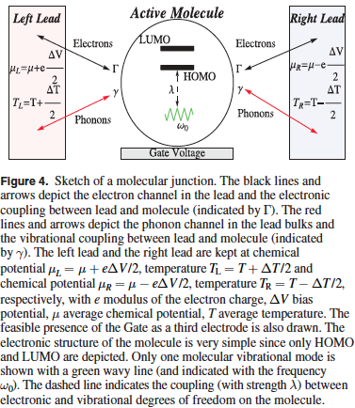
Thermoelectric efficiency of molecular junctions


Paste your Logo here
Carmine Antonio Perroni, CNR-SPIN and Physics Department “E. Pancini”, University “Federico II”, Napoli, Italia

Abstract (300 word limit)
Theoretical results in the coherent regime are discussed considering in particular a reference simple model with one electronic level and one vibrational mode in order to provide the relevant orders of magnitude for the thermoelectric properties. Moreover, we analyze the effects of molecular many-body interactions, such as electron-vibration couplings, which typically tend to reduce the efficiency [1,2,3]. Indeed, the electron–vibration interaction can enhance both phonon and electron thermal conductance, and it can reduce not only the charge conductance, but also the thermopower. For prototype fullerene junctions, we focus on the results obtained within a non-equilibrium adiabatic approach which includes a strong Coulomb repulsion and applies to the self-consistent calculation of electron and phonon transport properties of massive molecules within the Coulomb blockade regime [3]. In particular, the effect of the strong electron–electron interactions provides a peculiar double-peak structure to the thermopower versus charge conductance curve.
Within the regime of weak to intermediate electron–vibration and vibration–lead phonon coupling, the peak values of the thermoelectric figure of merit are slightly less than unity, and the maximal efficiency of the junction can reach values slightly less than half of the Carnot limit for large temperature differences between the leads. Since a fine tuning of many parameters and coupling strengths is required to optimize the thermoelectric conversion in molecular junctions, new theoretically proposed set-ups are mentioned providing the new research directions in the field of molecular thermoelectricity [4].

Recent Publications (minimum 5)
- A. Nocera, C.A. Perroni, V. Marigliano Ramaglia, and V. Cataudella (2016) Beilstein J. Nanotechnol., 7 439.
- C.A. Perroni, D. Ninno, and V. Cataudella (2014) Phys. Rev. B, 90 125421.
- C.A. Perroni, D. Ninno, and V. Cataudella (2015) New J. Phys., 17 083050.
- C.A. Perroni, D. Ninno, and V. Cataudella (2016) invited Topical Review “Thermoelectric efficiency of molecular junctions”, J. Phys. : Condens. Matter., 28 373001.

 Biography (150 word limit)
Carmine Antonio Perroni has expertise in many-body physics, linear and non-linear transport properties, quantum, topological and correlated states of matter.
Email: perroni@fisica.unina.it
Contact no: +39081676855
Track name:

Notes/Comments:

