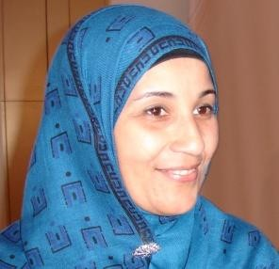
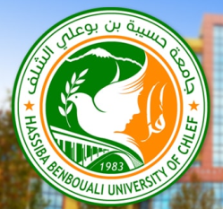

Title : Elaboration of a nanocomposite with Zinc oxide and zeolite: influence of the concentration.

Fatima Belhadj ¹, liela djahnit¹

¹Département de Chimie, Faculté des Sciences et Informatique, Université Hassiba Ben Bouali, Chlef, Algeria.

There is a limited literature on the encapsulation of a semiconductor ZnO within pores of zeolite. Some of the recent works made the object of an manufacturing investigation of nanoparticles of ZnO supported by the zeolite and their performance in terms of cathodic luminescence so effective as photocatalysts, and resistant circles in ultraviolet rays with antimicrobial properties. ZnO nanoparticles deposited on the zeolite HY by electrochemical method was estimated for the photodiscoloration of blue methylene. In this work, a semiconductor of ZnO nanoparticles with deferent concentrations inside EMT nano-zeolite (polymorph of the zeolite Y) was prepared in soft conditions and rich sodium medium. In a first step, we synthesized the nano-zeolite EMT by hydrothermal method. In a second step, the Zn ²⁺ ions were fixed on the zeolite by ion exchange process, then the precipitation of zinc with sodium hydroxide are perforned and finally a calcination at 500°C. As a result, ZnO @ EMT nanoparticles are obtained and characterized by (FTIR, DRX). After ion exchange and calcination,. The FT-IR spectra show a new bands which could be attributed to the vibrations of the Zn-O and Zn-O-T groups. However the X-ray diffraction indicates the formation of ZnO nanoparticles of hexagonal structure (würtzite). These results suggest that ZnO crystallites are formed in hexagonal EMT nano-zeolite.

Biography

Educational background:
-Secondary School - A-Level in Mathematics- 1990
-Bsc in chemistry from Oran University Es- Sénia -1994
-Magister degree in chemistry of materials Passed with distinction from Oran University Es- Sénia -1999.
-PhD in materials engineering passed at University Mohamed Boudiaf Oran -2011.

Professional experience
-Associate professor: department of chemistry, Hassiba Ben Bouali University, Algeria. April 2011- present
-Associate teacher: department of sciences and technologies, Hassiba Ben Bouali, Algeria, dec 2002 – April 2011.

Visiting researcher:
Laboratoire de génie chimique (Chemical Engineering Laboratory), Toulouse, France- January 2006
Laboratory of Infrared and Raman spectroscopy (LAZIR), University of sciences and technologies Lille 1, France -Sept 2007- July 2008
Laboratoire de Catalyse et Spectrochimie (laboratory of Catalysis and Spectrochemistry) (LCS), Caen, France, June –July 2012.
Institut de catalyse et pétrochimie ICP-Madrid, Espagne, Janvier 2014.
Institut de catalyse et pétrochimie ICP-Madrid, Espagne, Avril 2015.
Institut de catalyse et pétrochimie ICP-Madrid, Espagne, Avril 2016.

Presenting author details
Full name: Fatima Belhadj
Contact number:+213 796 274 000
Twitter account:/
Linked In account:/
Session name/ number:/
Category .Poster presentation

