Carbon nanocoils: synthesis, properties and applications
Lujun Pan, Department of Physics, Dalian University of Technology, Dalian, China
Zhenlin Wu, Department of Physics, Dalian University of Technology, Dalian, China

Abstract
Due to their specular 3D helical morphology, carbon nanocoils (CNCs) have excellent electromechanical properties, which show potential applications in super capacitors, field-emission devices, microwave absorption materials, near-infrared detectors, elastic composites, and strain sensors. This report focuses on the application of flexible strain sensors using CNCs as sensing medium.
The electrical conductivity of a single CNC is investigated over a wide temperature range from 4 to 300 K. It is found that the smaller the line diameter of the CNC, the bigger the size of the crystalline grain, which results in the better crystallinity and conductivity. Moreover, the temperature behavior of ρ(T) reveals that the intrinsic electric-transport mechanisms through a single helical CNC are mainly due to a combination conduction processes of the thermal activation, the nearest-neighbor hopping, and variable range hopping.
A straightforward method for measuring Young’s modulus of single CNCs is proposed. Acting as a 1D nano-oscillator, a CNC cantilever was stimulated to vibrate under an alternating electric field. Using a classical continuum model, a formula that accounts for the frequency response of vibration was deduced, and this formula was used to accurately determine the resonance frequency of the CNC. Young’s modulus was calculated from the resonance frequency using a theory based on material mechanics. It was found that Young’s modulus is depend on graphitization of the CNCs.
Based on the electromechanical properties, CNCs for the electrodes of super capacitors, surface enhanced Raman spectroscopy and microwave absorbers, single CNC units for near-infrared detectors, surface tension detectors, strain sensors and the CNC networks for wearable devices and micro-electro-mechanical systems have been studied.

Acknowledgement
This work was supported by the National Natural Science Foundation of China (No. 51661145025, 61520106013).

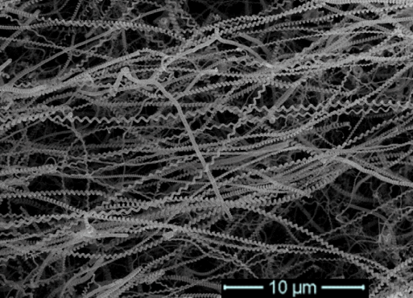
Figure 1: Carbon nanocoils synthesized by CVD method.
Recent Publications
- Deng C, Pan L (2017) A super stretchable and sensitive strain sensor based on carbon nanocoil network fabricated by a simple peeling off approach. Nanoscale 9: 16404-16411.
- Li C, Pan L (2017) A flexible, ultra-sensitive strain sensor based on carbon nanocoil network fabricated by an electrophoretic method. Nanoscale 9: 9872-9878.
- Deng C, Pan L (2016) Thermal Diffusivity of Single Carbon Nanocoil: Uncovering the correlation with temperature and domain size, ACS Nano, 10: 9710-9719.
- Sun Y, Pan L (2016) Electrical conductivity of single polycrystalline-amorphous carbon nanocoils, Carbon, 98: 285-290.
- Fu x, Pan L (2016) Controlled synthesis of carbon nanocoils on monolayered silica spheres, Carbon, 99: 43-48.
- Su D, Pan L (2015) Facile synthesis of CNC-MnO2 hybrid as a supercapacitor electrode, Applied Surface Science, 324: 349-354.

 Biography
Lujun Pan received his doctoral degree at Osaka Prefecture University in 2000, and became an assistant professor at the same university. In 2007, he returned back to China and worked in Dalian University of Technology as a professor. He is directing the research center of nanomaterials and optoelectronic technology. His research interesting is in carbon nanomaterials, including the synthesis of carbon nanotubes, carbon nanocoils and graphenes, their physical properties and potential applications in field emission devices, MEMS and NEMS, super capacitors and strain sensors. He has managed or participated many research projects in Japan and China and international collaborations, and published over 100 papers in the relative international journals, and also edited or took part in the writing of 5 books.
Email: lpan@dlut.edu.cn

