A redox active self-assembled monolayer both a sensor and actuator.

Divya Balakrishnan ^{a,b}, , Wouter Olthuis ^{b}, César Pascual-García ª

a. Luxembourg Institute of Science and Technology (LIST), 41 Rue du Brill, L-4422 Belvaux, Luxembourg
b. MESA+ Institute, University of Twente, Drienerlolaan 5, 7522 NB Enschede, Netherlands

Abstract

Redox active self-assembled monolayers (SAMs) are emerging materials in the design of key devices like sensors, batteries, or chemical switches¹. Amino thiol phenol (APT) is a very well studied molecule with a low redox potential, which is able to form SAMs in noble metals thanks to the affinity of its mercapto group and the interactions among the benzene rings ^{2, 3}. The dissociation constant (pK_{a}) of the amino-group and its interaction with protons has been used to fabricate plasmonic pH sensors associating the molecule to metal nanoparticles which enhance the vibrionic signals that reveal the protonation state of the molecule ^{4, 5}. Recently, the corresponding concept, namely the modification of the pH through the proton release was proposed by the group of Itamar Willmer ⁶. The electrochemical change of the pH was allowed by a composite material which used Au Nanoparticles to increase the surface area to a point where the proton release induced by electrochemical action on the APT was sufficient to achieve a significant modification of the pH. Though, the system showed some signs of electrode degradation, the article proposed a new route to control electrochemical reactions. We studied an alternative to the concept of a nanoparticle concept, by keeping the self-assembled monolayers, which exhibited a better behavior in terms of quasi-reversibility of the proton exchange reactions ⁷. We studied different methods of functionalization including the traditional electrochemical polymerization and less common ones like photo- polymerization and plasma polymerization. In addition, we showed that the SAM in addition of sensing it can be used as an effective actuator to control the pH in microfluidic devices ⁸. We will propose microfluidic configurations of how use these monolayers and applications to take advantage of the miniaturization possibilities and electrochemical control.

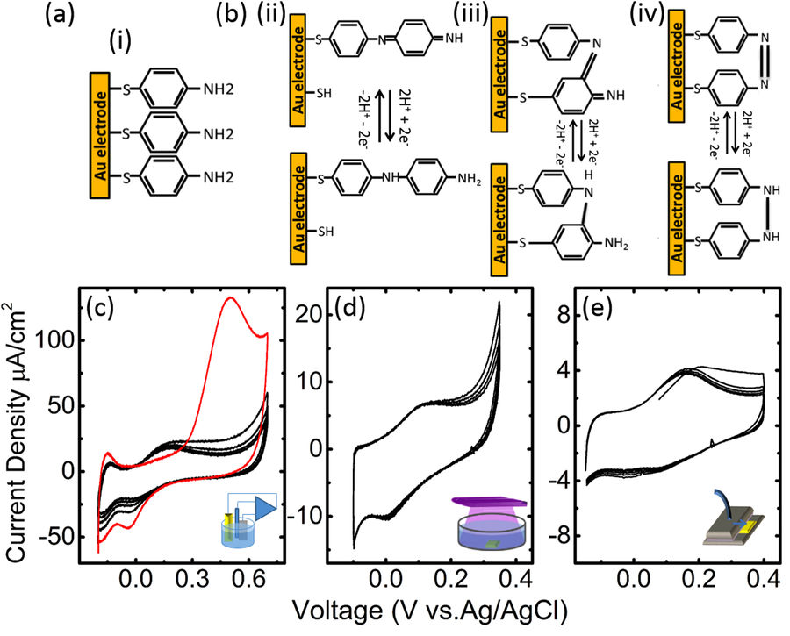

Figure 1: Schematic representation of the PATP monolayers adsorbed on gold (a) and most common products of polymerisation (b) (in a structural formula representation). Representative cyclic voltammograms corresponding to the electropolymerisation of PATP(c) with the first and subsequent cycles (in red and black respectively) and UV (d) and plasma polymerised (e) samples respectively. (Figure and caption from ref. 7).

Recent Publications
- Eckermann, A. L., Feld, D. J., Shaw, J. A. & Meade, T. J. Electrochemistry of redox-active self-assembled monolayers. Coord.Chem. Rev. 254, 1769–1802 (2010)..
- Cho, S. H., Kim, D. & Park, S. M. Electrochemistry of conductive polymers. Effects of self-assembled monolayers of aminothiolphenols on polyaniline films Electrochimica Acta 53, 3820–3827 (2008).
- Ahao, L. B., Zhang, M., Ren, B., Tian, Z. Q. & Wu, D. Y. Theoretical study on thermodynamic and spectroscopic properties of electro-oxidation of p-Aminothiolphenol on Gold electrode surfaces. J. Phys. Chem. C 118, 27113–27122 (2014).
- Zong, S., Wang, Z., Yang, J. & Cui, Y. Intracellular pH Sensing Using p-Aminothiophenol Functionalized Gold Nanorods with Low Cytotoxicity. Anal. Chem. 83(11), 4178–4183 (2011).
- Bishnoi, S. W. et al. All-Optical Nanoscale pH Meter. Nano Lett. 6(8), 1687–1692 (2006).
- Frasconi, M., Tel-Vered, R., Elbaz, J. & Willner, I. Electrochemically Stimulated pH Changes: A Route To Control Chemical Reactivity. J. AM. CHEM. SOC. 132, 2029–2036 (2010).
- D. Balakrishnan , G. Lamblin , J.-S. Thomann , J. Guillot , D. Duday , A.van den Berg , W. Olthuis C. Pascual-Garcia “Influence of polymerisation on the reversibility of low-energy proton exchange reactions by Para-Aminothiolphenol” Scientific Reports in press. DOI: 10.1038/s41598-017-13589-5 (2017)
- Balakrishnan, D.; Lamblin, G.; Thomann, J.-S.; van den Berg, A.; Olthuis, W.; Pascual Garcia, C. “Electrochemical control of pH in nano-litre volumes.” Nano Lett., submitted for publication, 2017.

Biography

César Pascual-García graduated in Solid State Physics at the Universidad Autónoma of Madrid in Spain with a dissertation of Electronic optical transitions in III-V semiconductors. He obtained his PhD in Condensed Matter Physics in 2007 at the Scuola Normale Superiore of Pisa in Italy with the Thesis “Low lying excitations of few electrons quantum dots”. At the beginning of his career he collaborated in fundamental topics centered on the electron correlations of semi- and super- conductor materials, but then his interest shifted to biology-applied topics as he started working as Scientific Officer at the Institute for Health and Consumer Protection of the European Commission. Currently he is an ATTRACT fellow and Lead Research Scientist at the Luxembourgish Institute of Science and Technology where he is leads the activities for electrochemical sensors and actuators for medicine applications at the Materials Research and Technology department. His current research focus are semiconductor nanowires for bio-sensing and the miniaturized control of chemical reactions.

Email: cesar.pascual@list.lu

