Functionalization of nanodiamond (ND) and silica nanoparticles; challenges, applications and development in preparation of efficient nanocomposite membrane in water purification and reclamation processes
Reza Yegani, Membrane Technology Research Center, Faculty of Chemical Engineering, Sahand University of Technology, Tabriz, Iran
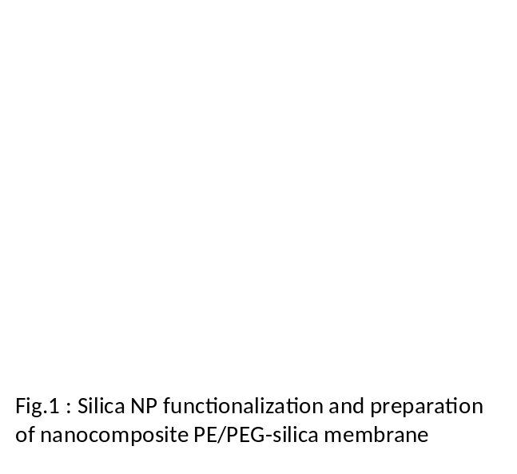 Elham Mohammad Gholinia, IFA Pazhohesh, Knowledge Based Co., Tehran, Iran

Abstract
Water recycling and re-use from unconventional resources is usually carried out by membrane based technologies, however, membrane fouling and material price are still considered as the main obstacles against further development of membrane technologies. Therefore, preparation of less-fouling and cheap membrane material are essential for many industries. Recent reports and successful achievements regarding the Nanotecnology, encouraged us to start very unique series of research, entitled “nanocomposite membrane”. Among various nanoparticles (NPs), silica NPs and nanodiamond (ND) enjoy with straightforward one-pot one-step preparation methods and less price, respectively. Hence, it was speculated that preparation of nanocomposite membrane would be beneficial, if we could successfully combine the advantages of functionalized NPs with interesting filtration abilities of microporous polymer materials.
In this research, we identified various aspects of utilization of neat and functionalized ND and silica NPs in preparation of less-fouling, easy cleanable, and protein repellent nancomposite polymer membrane. Several challenges including, protein-membrane interaction, protein repellent surface, membrane surfaces biocompatibility, NPs size/size distribution, NPs aggregation, dispersion and distribution in polymeric matrix and membrane hydrophilicity were fully evaluated. Obtained results revealed that presence of vinyl moieties in the PEG modified silica NPs, significantly improved protein repellency in poly ethylene (PE) microporous membranes. This membrane was promising, when anti-fouling property, material price and chemical resistance were the main targets. However, Humic acid (HA) removal from surface water was not possible, without pre-treatment using coagulation agent. In other hand, cellulose acetate (CA) nanocompsoite membrane, prepared by embedding amino functionalized nanodiamond (ND-NH2) as well as PEG grafted ND (ND-PEG) NPs, completely removed the HA from surface water without any extra pre-treatment (pre-coagulation) step. Membrane performance was excellent and very little membrane fouling was observed, however, in comparison with PE, less chemical and bacterial resistance as well as relatively higher price of CA, was still challenging step.

Image

. 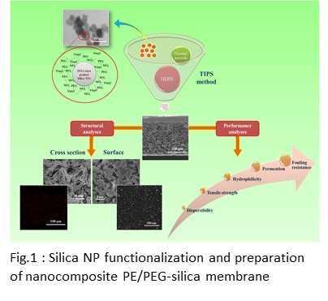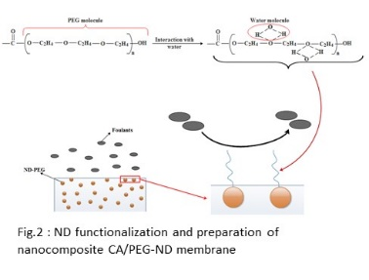

Recent Publications
- W. Stober, A. Fink, E. Bohn (1968), “Controlled growth of monodisperse silica spheres in the micron size range, J. Colloid Interf. Sci. 26 (1) 62–69.
- Habib Etemadi, Reza Yegani, Mahdi Seyfollahi, (2017), “The effect of amino functionalized and polyethylene glycol grafted nanodiamond on anti-biofouling properties of cellulose acetate membrane in membrane bioreactor (MBR) systems”, Separation and Purification Technology, 177, 350-362.
- Ali Akbari, Reza Yegani, Behzad Pourabas, Ali Behboudi, (2016), “Fabrication and study of fouling characteristics of HDPE/PEG grafted silica nanoparticles composite membrane for filtration of Humic acid”, Chem. Eng. Res. & Des.109, 282-296.
- Ali Akbari, Reza Yegani, Behzad Pourabbas, (2015) “Synthesis of poly (ethylene glycol) (PEG) Grafted Silica Nanoparticles with a Minimum Adhesion of Proteins via One-Pot One-Step Method”, Colloids Surf., A., Physicochem. & Eng. Aspec. Vol.484, 206-215
- Ali Akbari, Reza Yegani, Behzad Pourabbas, (2016), “Synthesis of high dispersible hydrophilic poly (ethylene glycol)/vinyl silane grafted silica nanoparticles to fabricate protein repellent polyethylene nanocomposite, European Polymer Journal, 81, 86-97

 Biography (150 word limit)
Reza Yegani, Professor of Chemical Engineering, has established the first membrane technology research center (MTRC) in Sahand University of Technology of Iran on 2009. The main goal behind this achievement was based on the localization of membrane related researches, sciences and industries in Iran.
Middle East and North African (MENA) countries suffer from water scarcity, therefore it is vital to recycle and reuse the water obtained from unconventional resources such as waste streams, rivers and sea, which are usually carried out by membrane based technologies including membrane bioreactor or membrane filtration processes. Membrane fouling however, is the main obstacle against the development of membrane based technologies. Recent reports and achievements regarding anti-fouling properties of nanocomposite membranes are promising. Therefore it is essential to identify the impact of influential parameters on the nanoparticle functionalization.
Email: ryegani@sut.ac.ir

