Development of Supramolecular Cyclodextrin Gel for Selective Separation of Sugars in Water
¹Tewodros Getachew BEKELE,
JETRO, Ethiopia
²Takashi Hayashita, Sophia University, Tokyo, Japan

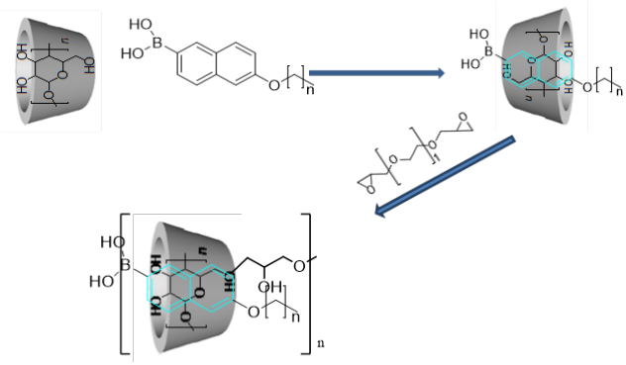
Abstract
Simple sugars play vital role in biological functions in living cells. The three commonly known monosaccharides glucose, galactose and fructose used as energy source by organisms. Glucose, exclusively brain fuel has to be regulated in human body to prevent our brain from any potential fuel shortage. Significant drop in blood sugar level can cause lack of concentration, dizziness and headache. Due to this reason it is very critical to develop a chemical sensor that is cheap, simple to use, rapid and efficient to measure and monitor blood glucose level.
Supramolecular cyclodextrin polymeric gel is synthesized for the separation of monosacchrides in aqueous solution. A nanometric hollow molecule i.e. cyclodextrin is polymerized by using polymerizing agent and form inclusion complexation with naphthalene probe. Boronic acid is used as sugar recognition terminal, naphthalene as reporter site and alkyl chain as a tail to maximize inclusion complexation. The adsorption phenomenon was investigated by using HPLC, UV-VIS spectrometer and Fluorescence spectrometer. The equilibrium adsorption isotherm was analyzed by using Langmuir modeling. Boronic Naphthalene (B-Nap-Cn) probe was synthesized for selective binding by reacting with cis-1,2-diol and cis-1,3-diols to form reversible covalent complexes. Probes with alkyl chain length of C-4, C-8 and C-12 were synthesized to analyze chain length effect. Results showed that, fructose and glucose showed high amount of adsorption towards B-Nap-C4/β-CyD gels and increase in alkyl chain resulted decrease in amount of adsorption for glucose, fructose and galactose. In B-Nap-C4/γ-CyD gel adsorption analysis, all three sugars had showed increase in adsorption amount with increasing concentration. This is probably the larger cavity γ-CD could enable probes to freely adjust their active side to bind the sugar.
In Summary, B-Nap-Cn incorporated supramolecular cyclodextrin polymeric gel is promising chemical sensor that can be utilized to examine blood sugar level.
c)

Fig. 1 Synthesis of B-Nap-Cn /β-CyD/γ-CyD gel
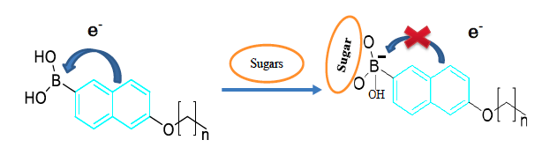
Fig 2: ICT mechanism of B-Nap-Cn


Fig. 3 Adsorption amount of sugar by B-Nap-C4/ β-CyD gel

Tewodros Getachew is a young project manager at JETRO. He has earned his undergraduate degree from Bahir Dar University in Chemical Engineering and has three(3) years of experience in the manufacturing industry (Sugarcane industry) as a shift supervisor. In 2014, he got a scholarship from Government of japan and studied M.Sc in Green Science and Engineering at Sophia University, Tokyo, Japan. His research interest is to study about molecular assembly and gel synthesis using supramolecular natural interaction.
¹Email: tedy99star@gmail.com
²Email: ta-hayas@sophia.ac.jp
Contact no: +25191218519

