New Bone Formation & Fusion Relevant to Timing of Cranioplasty via Frozen Autologous Bone Flaps in Rabbits: A Preliminary Report using Micro-CT Scans & Tissue Staining Analysis
Deok-Won Lee, DMD, PhD, Dept. of Oral and Maxillofacial Surgery, Kyung Hee University Dental Hospital at Gangdong, School of Dentistry, Kyung-Hee University, Seoul, South Korea
Sung ok Hong,DMD, MSD, Dept. of Dentistry, Catholic Kwandong University International St. Mary’s Hospital

Abstract
Introduction: The timing of cranioplasty and method of bone flap storage are known risk factors of non-union and resorption of bone flaps. In this ani¬mal experimental study, we evaluated the efficacy of cranioplasty using frozen autologous bone flap, and examined whether the timing of cranio¬plasty after craniectomy affects bone fusion and new bone formation.
Method and materials: Total 8 rabbits (male, older than 16 weeks) were divided into two groups of early cranioplasty group (EG, 4 rabbits) and delayed cranioplasty group (DG, 4 rabbits). The rabbits of each group were performed cranioplasty via frozen autologous bone flaps 4 weeks (EG) and 8 weeks (DG) after craniectomy. In order to obtain control data, the cranioplasty immediate after craniectomy were made on the contralateral cranial bone of the rabbits (control group, CG).The bone fusion and new bone formation were evaluated by micro-CT scan and histological examination 8 weeks after cranioplasty on both groups.
Results: In the micro-CT scans, the mean values of the volume and the surface of new bone were 50.13±7.18 mm3 and 706.23±77.26 mm2 in EG, 53.78±10.86 mm3 and 726.60±170.99 mm2 in DG, and 31.51±12.84 mm3 and 436.65±132.24 mm2 in CG. In the statistical results, significant differences were shown between EG and CG and between DG and CG (volume: p=0.028 and surface: p=0.008). The histological results confirmed new bone formation in all rabbits.
Conclusion: We observed new bone formation on all the frozen autologous bone flaps that was stored within 8 weeks. The timing of cranioplasty showed no difference of degree of new bone formation. Not only the healing period after cranioplasty but the time interval from craniectomy to cranioplasty could affect the new bone formation.

This study was supported by a grant from the National Research Foundation of Korea (NRF-2014R1A1A1002630 and NRF-2016R1A2B4014600)

Image
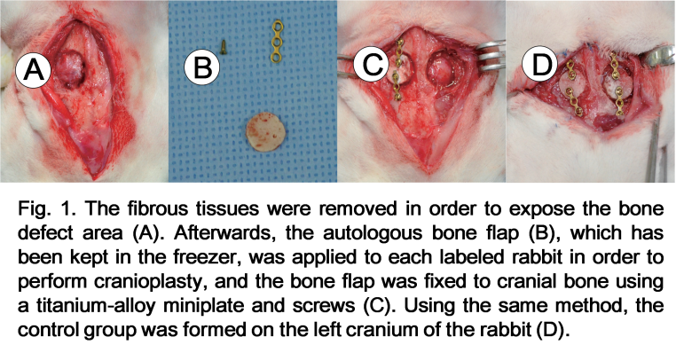
Recent Publications
- Yang DH, Moon SW, Lee DW. (2017) Surface Modification of Titanium with BMP-2/GDF-5 by a Heparin Linker and Its Efficacy as a Dental Implant. International Journal of Molecular Sciences. 23;18(1).
- Lee SJ, Bae MS, Lee DW, Heo DN, Lee D, Heo M, Hong SJ, Kim J, Kim WD, Park SA, Kwon IK. (2017) The use of heparin chemistry to improve dental osteogenesis associated with implants. Carbohydrate Polymers 10;157:1750-1758.
- Yun HM, Kang SK, Singh RK, Lee JH, Lee HH, Park KR, Yi JK, Lee DW, Kim HW, Kim EC (2016) Magnetic nanofiber scaffold-induced stimulation of odontogenesis and pro-angiogenesis of human dental pulp cells through Wnt/MAPK/NF-κB pathways. Dental Materials 32(11):1301-1311.
- Yoon SJ, Yang DH, Kim EC, Noh K, Lee DW (2016) In Vitro Osteogenic Differentiation Enhanced by Zirconia Coated with Nano-Layered Growth and Differentiation Factor-5. J of Nanoscience and Nanotechnology 16(1):280-6.
5. Lee JB, Kim JE, Balikov DA, Bae MS, Heo DN, Lee D, Rim HJ, Lee DW, Sung HJ, Kwon IK. (2016) Poly(l-Lactic Acid)/Gelatin Fibrous Scaffold Loaded with Simvastatin/Beta-Cyclodextrin-Modified Hydroxyapatite Inclusion Complex for Bone Tissue Regeneration. Macromolecular Bioscience 16(7):1027-38.

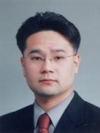Biography
Deok-Won Lee is an oral and maxillofacial surgery specialist and associate professor of Kyung Hee University Schoole of Dentistry. His expertise is in treating and improving the oral and maxillofacial health and wellbeing of people. His research on dental implant materials creates new pathways for improving healthcare. He is continually building and investigating on adequate material for implantation through invivo and invitro models based on years of experience in research, evaluation, teaching and administration both in hospital and education institutions.
Email: verycutebear@hanmail.net

Notes/Comments: This study was supported by a grant from the National Research Foundation of Korea (NRF-2014R1A1A1002630 and NRF-2016R1A2B4014600)

