Number of layer dependent direct optical transition from monolayer to pentalayer in synethesized laerge area MoSe₂
Jae-Hun Jeong, Yoon Ho Choi, Kwang Sik Jeong, Mann-ho cho, Hanbom Park, Dasol Kim Yonsei University, Seoul

Abstract (300 word limit)

Two-dimensional transition metal dichalcogenides (TMDs) have attracted great interest for applications in optoelectronic device. We studied the optical properties of the large area MoSe₂ thin film on c-axis sapphire (0001) substrate grown by molecular beam epitaxy (MBE). Photoluminescence (PL), Raman, X-ray diffraction (XRD), and X-ray photoelectron spectroscopy (XPS) were measured to evaluate the film quality. We obtained the optical absorption spectra of mono-, bi- and tri-layer MoSe₂ and observed optical critical point which is correspond to the direct transition at Г-point of the Brillouin zone (BZ) at ~3 eV. Increasing the number of layer, the intensity of the absorption peak at Г-point was increased and its position was shifted. The changes in peak at Г-point are caused by the band structure depending on the number of layer, resulting in the modulation of the joint density of state (JDOS). Since the geometrical band shape of conduction band and valance band are similar around Г-point for few layer MoSe₂, both van Hove singularities (VHS) and band nesting contribute to strong absorption peak. Using 3eV optical pump, we can selectively excite the MoSe₂ by choosing suitable number of layer. The modulation of band structure and strong photon-electron interaction of 2D material would be widely applied to photonic and optoelectronic devices.

Image
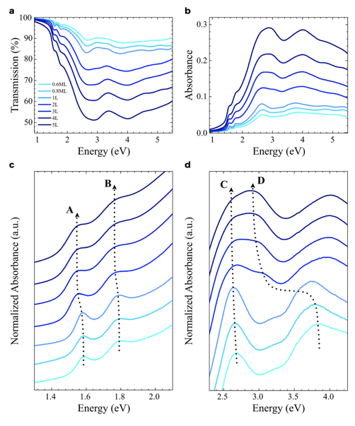
Recent Publications (minimum 5)
- A. Carvalho (2013) Band ndsting and the optical response of two-dimensiona semiconducting transition metal dichalcogenides. Physical review B 88, 115205.
- Yilei Li, Alexey Chernikov (2014) Measurement of the optical dielectric function of monolayer transition-metal dichalcogenides : MoS2, MoSe2, WS2 and WSe2. Physical review B 90, 205422
- Yi Zhang (2013), Direct observation of the transition from indirect to direct bandgap in atomically thin epitaxial MoSe2. Nature nanotechnology 10.1038.
- Anupam Roy (2016), Structural and Electrical Properties of MoTe2 and MoSe2 Grown by Molecular Beam Epitaxy. ACS Applied materials and interface 8, 7396-7402
5. J.E. Padilha (2014) Nature and evolution of the band-edge states in MoS2 : From monolayer to bulk. Physical Review B, 90,205402

Biography (150 word limit)
Jae-Hun Jeong has expertise in the properties of two-dimensional materials such as MoS2 and MoSe2. His large-area growth technology and in-depth research have laid the foundation for 2D materials to be used in next-generation applications. His research approach, which focuses on deep physics, and his large-area growth techniques, are expected to make a valuable contribution to the development of new-level devices.
Email: duanjjh@gmail.com

Notes/Comments:

