Novel self- cross-linking injectable gelatin based material for bone tissue engineering

Al-Namnam NM¹, Kim KH², Chai WL³, Ha KO¹, Siar ^{CH1} and Ngeow WC¹
Department of Oro-Maxillofacial Surgical and Medical Sciences¹,
Department of Diagnostic and Integrated Dental Practice³,
Faculty of Dentistry, University of Malaya, 50603 Kuala Lumpur, Malaysia
Department of Physiology², Faculty of Medicine,
University of Malaya, 50603 Kuala Lumpur, Malaysia

Abstract

An injectable in situ cross-linkable material that is easily implanted into irregularly shaped osseous defects surgery was developed. Previously a biodegradable porous poly(caprolactone)-trifumarate scaffold, made based on salt leaching fabrication technique, was found to be a biocompatible scaffold in vitro. However, there are an issues associated with its mechanical stability and in vivo compatibility when combined with salt. A modified form of the original material named as PCLTF-GMPs was made using new fabrication technique, creating a three-dimensional porous PCLTF based on gelatin microparticles (GMPs). A detailed characterization of the modified scaffold was done by analyzing the scaffold surface, the thermal, physical and mechanical properties, and the in vitro cell compatibility. In vivo behaviour of PCLTF-GMPs was evaluated in a critical-size defect drilled in the cranial bone of New Zealand white rabbits. This PCLTF-GMPs scaffolds showed no significant difference (p > 0.05) in its mechanical properties before and after gelatin leaching as compared to the preexsisting one (p < 0.05) and revealed a higher biodegradability rate of 18 weeks. The alamar blue assay result showed that the PCLTF-GMPs has no critical cytotoxic effect and has a clear cell layer covering the entire outermost surface of scaffolds, as observed in scanning electron microscopy. PCLTF-GMPs demonstrated improved biocompatibility in vivo, while the original PCLTF was associated with local inflammation and necrosis at the site of implantation during the first two weeks post-surgery. Polyfluorochrome tracers detected bone growth occurring in the PCLTF-GMPs filled defects during the entire period of the tracers’ activity with the mean values statistically significant higher than that of the control defects (p< 0.05). Overall, this new fabrication technique produced a biocompatible candidate material with reliable properties that has potential use as a bone filler to treat critical bone defect, periodontal bone defect and alveolar bone augmentation.

Image
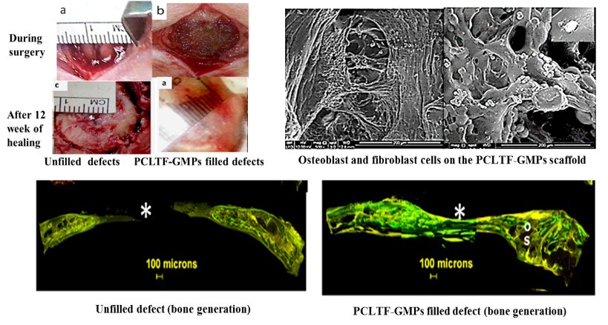
Recent Publications (minimum 5)
- NM Al-Namnam, P. Shanmuhasuntharam, KO. Ha and CH Siar, (2010). Processed Allogenic Dentine as A Scaffold for Bone Healing: An in vivo study. Australian Journal of Basic & Applied Sciences; 4(12):5932.
- NM Al-Namnam, KH Kim, WL Chai, KO Ha, CH Siar, WC Ngeow. (2015). A biocompatibility study of injectable poly(caprolactone-trifumarate) for use as a bone. Frontiers in Life Science; (8): 3.
- NM Al-Namnam, KH Kim, WL Chai, KO Ha, CH Siar, WC Ngeow. (2016). Modified poly(caprolactone trifumarate) with embedded gelatin microparticles as a functional scaffold for bone tissue engineering. Journal of Applied Polymer Science; 133(30): 43711.
- NM Al-Namnam, Nambiar P, Shanmuhasuntharam P, Harris M. Dengue related Osteonecrosis of the Maxillary Dento-Alveolar Bone: case report. Australian Dental Journal, 2016. DOI: 10.1111/adj.12472
- NM Al-Namnam, KH Kim, MG Kutty, WL Chai, KO Ha, CH Siar, WC Ngeow. A modified Poly(caprolactone-trifumarate) scaffold material for bone tissue engineering. Journal of the Material Science and engineering: C. 72,332–340.

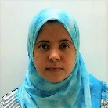 Biography
Nisreen Mohammed Al-Namnam graduated from the faculty of dentistry, University of Sana’a in 2003 and was a lecturer and private practitioner for 4 years befores was offered the postgradute studies. She obtained her Master and Ph.D in Oral and Maxillofacial Surgery from the Faculty of Dentistry, University of Malaya where her work encompassed a multidisciplinary field. She has experience in biomaterials and bone tissue engineering. She is also interested in craniofacial and biomaterial science. Currently, she is a researcher at the Faculty of Dentistry, University of Malaya and working on projects related to syndromic craniosynostosis and gene therapy.
Email: nis_moh2007”yahoo.com

Notes/Comments:

The bone material is present in different and the injectable form is the most preferred because of its easy to work and change to different forms. However, to become solid, the present injectable material need either photo-initiator or heating during inserting which could affect the surrounding tissue. Globally, all the bone materials need open surgery to insert. Given these challenge as researcher we ask if we could make an injectable material that has the characteristics of those bone materials and at the same time can self-harden without any intervention. If we are able to do that, in the future we can inject this material through a gap without the need for open surgery. Thus improved the preexisting material (PCLTF), produced minimally invasive injectable graft material.

