Observation of atypical lymphocytes in post-COVID subjects in the study of the nasal mucosa

Arturo Armone Caruso, MD, Ph D, AIAS di Afragola, Naples, Italy

Abstract (300 word limit)

Coronavirus disease-19 (COVID-19) is now a global pandemic. Fever, cough, muscle aches, dyspnea, and fatigue can be presenting symptoms, as well as smell and taste dysfunction, usually in presence of a patent nasopharyngeal airway. The virus, as it is known, first of all attacks the nasal mucosa by activating the local immune system.

Recent studies report that the cytological effects on the nasal mucosa are characterized by its disorder. The observation under the optical microscope, documents a cell infiltration characterized by neutrophils, lymphocytes and epithelial cells, which have "Ciliocytophthoria" (fig. 1), the main sign of cell damage from viruses. However , there are other aspects that in the future could be an additional element of in-depth diagnostics, as well as prevention and monitoring. This is the study of atypical lymphocytes that can be observed on the nasal mucosa.

To study this aspect, at the AIAS of Afragola, with the favourable opinion of the Scientific Committee, were performed, by scraping, samples of nasal mucosa to patients (30 males and 30 females minimum age 30 maximum age 60 average 45,5) Two weeks in rehab, recovering from COVID. A control group was used. The nasal mucosa was stained with MGG and observed with the 100x optical microscope.

The observation of lymphocytes in all POST-COVID patients documented the presence of atypical lymphocytes. These were grouped, according to the literature, in two groups (fig 2) 1. Plasmacytoid features; 2. Downey II-like cells.

Of these two groups, those belonging to the former are more relevant. This aspect agrees with the literature that detects a greater amount of lymphocytes belonging to the first group. In the light of these results, the cytological methodology could encourage further developments not only for the monitoring of the disease but set a precise therapeutic path
Image

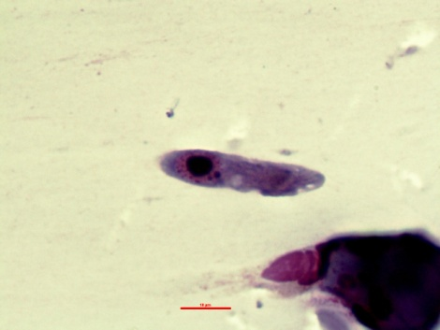
Fig. 1 “Ciliocytophthoria" Observation by optical
microscope. Magnification at 100 x oil immersion. Col. MGG

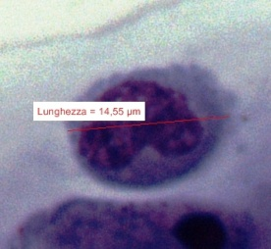 sin | 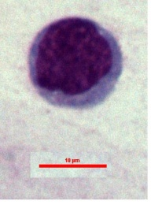 dx
Fig. 2
dx: Atypical lymphocytes showing plasmacytoid features including small size, eccentric nucleus and dark blue cytoplasm.
Magnification at 100 x oil immersion. Col. MGG
Sin: Atypical lymphocytes with Downey II-like cells features showing large size, ample cytoplasm, indented nucleus, and occasional cytoplasmic granules. Magnification at 100 x oil immersion. Col. MGG

Recent Publications (minimum 5)
- Gelardi M, Notargiacomo M, Trecca E, M, C, Cassano M, Ciprandi G(2020): COVID-19 and NasalCytobrushCytology. ActaCytologica, 64:397-398. doi: 10.1159/000508768
- Gelardi M, Notargiacomo M, Trecca EMC, Cassano M (2020). SARS-CoV-2: Naso-bronchialcytologicalcorrelations. Am J Otolaryngol., 41(4):102549. doi:10.1016/j.amjoto.2020.102549
- Chong VCL, Lim KGE, Fan BE, Chan SSW, Ong KH, Kuperan P. (2020) Reactive lymphocytes in patients with COVID-19. Br J Haematol. Jun;189(5):844. doi: 10.1111/bjh.16690. Epub 2020 May 5. PMID: 32297330; PMCID: PMC7262365.
- Weinberg SE, Behdad A, Ji P. (2020), Atypical lymphocytes in peripheral blood of patients with COVID-19. Br J Haematol. Jul;190(1):36-39. doi: 10.1111/bjh.16848. Epub 2020 Jun 2. PMID: 32420613; PMCID: PMC7276903
- HaghjooyJavanmard S, Vaseghi G, Manteghinejad A, Nasirian M. (2020) Neutrophil-to-Lymphocyte ratio as a potential biomarker for disease severity in COVID-19 patients. J Glob Antimicrob Resist. 2020 Sep;22:862-863. doi: 10.1016/j.jgar.2020.07.029. Epub 2020 Aug 15. PMID: 32810639; PMCID: PMC7428697.
- El Jamal, S. M., Salib, C., Stock, A., Uriarte-Haparnas, N. I., Glicksberg, B. S., Teruya-Feldstein, J., Dembitzer, F. R., Nadkarni, G. N., & Firpo-Betancourt, A. (2020). Atypical lymphocyte morphology in SARS-CoV-2 infection. Pathology, research and practice, 216(9), 153063. https://doi.org/10.1016/j.prp.2020.153063



Biography (150 word limit)
Arturo Armone Caruso is an otolaryngologist specialist and is the Health Director of the AIAS (Italian Association of Disadvantaged Assistance) of Afragola. He has also obtained a Phd in "Cytosmetabolism of drugs and applied morphology" For many years he has been interested in the study of nasal mucosa. His research ranges from allergies to some oncological aspects of the upper airways and digestive tract. On the occasion of the COVID pandemic, he carried out a series of studies aimed at both the prevention and implementation of a therapy of this disease. In particular, the study, together with other colleagues, addressed the possibility of using hydrogen peroxide, obtaining encouraging results and still being developed. He is also interested in rehabilitation paths as well as methodological research to improve the quality of life and consequently behavioural emotional health
Email: armocar@libero.it

Notes/Comments

Presenting author details
Full name: Arturo Armone Caruso
Contact number: +393396069421
Mail id: armocar@libero.it
Category: Oral presentation

