A molecular-based experimental study: validation of tick role in the transmission of pathogens
Kashif Hussainª, Farhan Ahmad Atif^{c}, Muhammad Sohail Sajidª, Zafar Iqbalª, Imaad Rasheed^{b}, Maria Kausarª.
Ticks (Arachnida; Arthropoda), the ravening blood-feeding multicellular ectoparasites, are the putative vector for enzootic stability of infectious agents of veterinary and public health concern. Ticks are found worldwide but because of favorable climatic conditions, the highest percentage of ticks is found in tropical and subtropical counties. Ticks transmit bacterial, protozoan, rickettsial, and viral infections in domesticated animals. Babesiosis (hemolytic), theileriosis (lymphoproliferative), and anaplasmosis (intra-erythrocytic) are the most important tick-borne infections (TBIs) as they cause huge losses in the livestock industry. During the current study role of ticks as biological vectors of Babesia, Theileria, Anaplasma was validated cutting-edge modern technique (PCR). Ticks were collected from the pathogen-free region, divided into 3 groups, fed on Babesia, Theileria, and Anaplasma positive animals, again collected and confirmed for positivity of these pathogens via molecular analysis. Disease-free calves (15 in number) were selected and divided into three groups (5 calves/group) and each calf was infested with 10 pathogen positive ticks (5 Hyalomma sp. and 5 Rhipicephalus sp.). After 2 weeks calves were screened based on molecular analysis. Calves infested with Hyalomma sp. were positive for TBIs (Babesia 18.18%, Theileria 45.45%, and Anaplasma 27.27%) and calves infested with Rhipicephalus sp. were positive for TBIs (Babesia 50%, Theileria 12.5%, and Anaplasma 37.5%). The statistical analysis (z-test: p<0.05) validated that tick genera has significant role in transmission of specific pathogen. It can be concluded that ticks are the competent vectors of TBIs and among tick genera, Rhipicephalus is the main vector of Babesia sp. while Hyalomma is the main vector of Theileria sp. The obtained data might be useful for implementation of a genera-specific modern tick control technique viz; RNAi and CRISPR-Cas9.
Keywords: Tick-borne infections, Hyalomma, Rhipicephalus, molecular analysis.
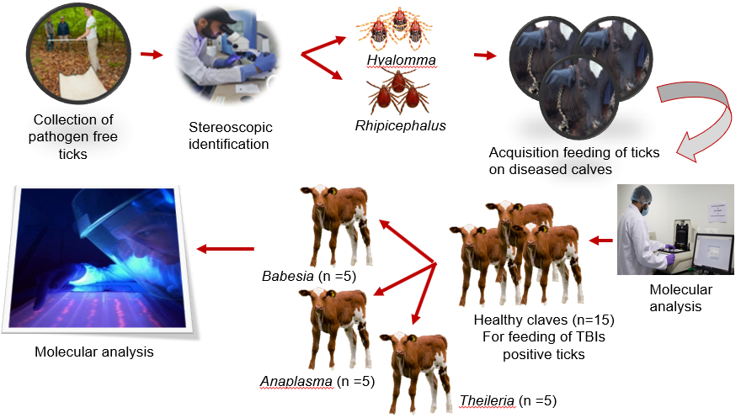
Figure: Elaborating experiment he layout
- Department of Parasitology University of Agriculture, Faisalabad.
- Department of Clinical Medicine, University of Agriculture, Faisalabad.
- Department of Clinical Sciences, CVAS Jhang.
Recent Publication

1. Farhan Ahmad Atif, Muhammad Arfan Zaman, Kashif Hussain, Muhammad Fiaz Qamar, Muhammad Sohail Sajid, Umair Iqbal, Saba Mehnaz (2021). First molecular surveillance and estimation of risk factors of Anaplasma marginale infection among indigenous, crossbred and exotic cattle from Jhang district, Pakistan. Journal of Animal and Plant Sciences, issue 31 (04) 2021.
2. Farhan Ahmad Atif, Kashif Hussain, Muhammad Fiaz Qamar, Muhammad Sohail Sajid, Zafar Iqbal, Muhammad Arfan Zaman, Muhammad Kamran Rafique (2021). First report on the transplacental transmission of Anaplasma marginale in the neonatal dairy calves from district Jhang, Punjab, Pakistan. Int J Agric Biol. ISSN. 1560–8530, (30) 2021.

