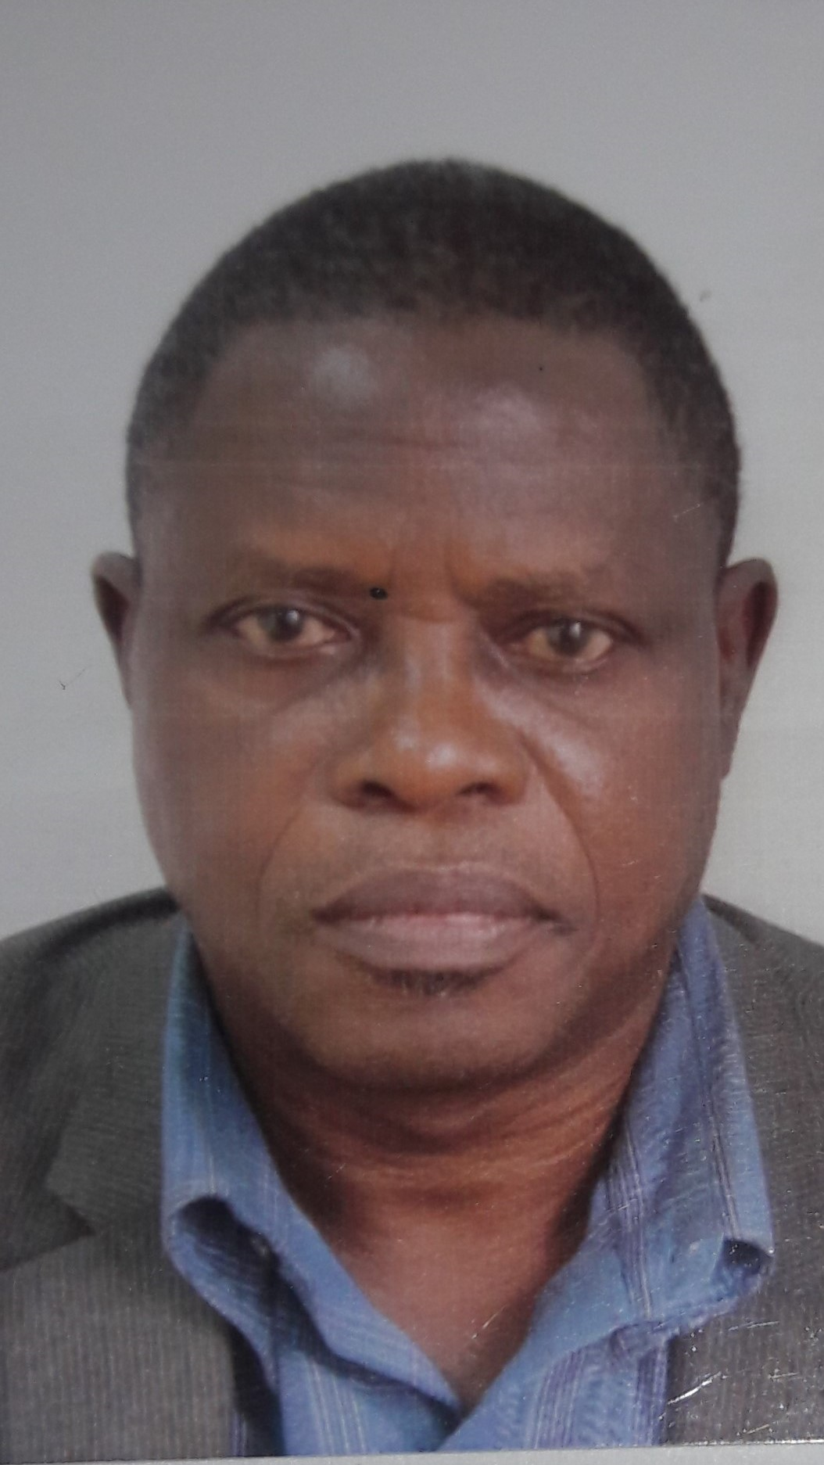

TITLE: Whole genome Amplification of Torque teno virus from Nigeria HIV patients and blood donors.
NAME: Prof Isaac Adeyemi Adeleye.
Department of Microbiology, Faculty of Science, University of Lagos, Nigeria.

Torque teno virus (TTV) is a single stranded DNA virus suspected to be responsible for Hepatitis symptoms in humans. There is no published data on the genomic characterization of TTV in Nigeria. To this end, 260 plasma samples, 130 each from HIV positive patients and healthy voluntary donors, were tested for TTV DNA by PCR and three near complete genome of TTV were isolated and sequenced. Using appropriate primers, genome amplification with the expected product size of 3652bp was achieved. In-silico analysis was done to characterize this virus. The TTV Nigerian isolate FL100 yielded a product size of 3623bp and shares the highest sequence similarity of 93%, E-value 0.0 over a 99% query cover, with a US isolate KT163879 (3748bp). Both isolates clustered with other isolates from group 1 such as AB017610 (TTV prototype reference genome from US) AF298585, a Polish isolate. Isolate FL100 has between 63% - 65% identity with other isolates in genogroup 1. It shares between 52% - 59% identity with isolates from other phylogenetic groups. It has a 45% and 46% identity with TTMV and TTMDV respectively. Its alignment identity with other Nigerian isolates was 56% and 57% for FL08 and BD 67 respectively. FL100 has a pairwise distance value of 0.07 with KT163879and 0.51 with group 1 reference isolate TA278 (AB017610) over the entire sequence. This confirms that the Nigeria isolate FL100 belongs to phylogenetic group one.
Biography
Professor Adeleye is a microbiologist with focus on pathogenic microbes and Bioactive compounds from plants and marine microbes. He has his undergraduate degree B.Sc (Hons) in Biology from the University of Lagos; Masters degree in Microbiology from Obafemi Awolowo University (O.A.U) and a Doctorate degree from the University of Ibadan. He holds a chair of Microbiology at the University of Lagos. He has conducted research in many areas of Microbiology and mentored more than 100 undergraduates, 50 Masters and has supervised more than 10 Ph.D students. He has more than 70 publications to his credit.
Presenting author details
Full name: ADELEYE, ISAAC ADEYEMI
Contact number: +2348066721617
Twitter account:
LinkedIn account:
Session name/ number:
Category: (Oral presentation)

