Molecular Study of Cryptosporidium spp.from rat and mice

Saroj Kumar Yadav MS(fellow), CVASU,Bangladesh
Ferdoshe Akter DVM.Veterinary surgen,Bangladesh

Abstract
Present study contracts with is a zoonotic intestinal protozoan parasite with public health importance. research was aimed to determine the prevalence of Cryptosporidium in rats\mice and to assess the potential role of rodents as a source for human and animal Cryptosporidiosis. A total of 49 fecal samples from field rats, tree rats, house mice and wetland rats were collected from Chittagong, Bangladesh during the period from February to July, 2017. Initial identification of Cryptosporidium spp. was carried out on stool samples by Ziehl-Neelsen (Z-N) acid fast staining method and found prevalence of 4.08%. DNA was extracted from Z-N positive and few other suspected samples using commercially available stool DNA isolation kit. Nested PCR was done to amplify 581 bp of 18srRNA gene with the use of 1% agarose gel electrophoresis for PCR amplified products. Cryptosporidium spp. was confirmed in 3 samples by PCR with prevalence of 6.12%. The results of this research give an idea that rodents may act as reservoirs for zoonotic intestinal protozoan parasites and should be considered important to public health.
Key words: Cryptosporidium, rodents, Z-N techniques, PCR, prevalence


Image
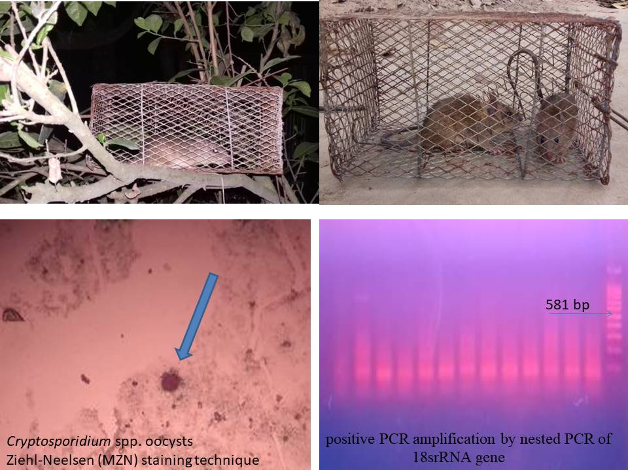
Recent publications
- Sotiriadou I, Pantchev N, Gassmann D, Karanis P 2013. Molecular identification of Giardia and Cryptosporidium from dogs and cats. Parasite 20:1–7.
- Uehlinger FD, Greenwood SJ, McClure JT, Conboy G, O’Handley R, Barkema HW. 2013. Zoonotic potential of Giardia duodenalis andCryptosporidium spp. and prevalence of intestinal parasites in young dogs from different populations on Prince Edword Island, Canada. Veterinary Parasitology. 196: 509–514.
- Tavalla M, Kord, E, Abdizadeh R, & Asgarian, F (2017). Molecular study of Cryptosporidium spp. in dogs from Southwest of Iran. Jundishapur Journal of Microbiology, 10:4
- Gil H, Cano L, de Lucio A, Bailo B, de Mingo M. H, Cardona G. A, & Carmena D (2017). Detection and molecular diversity of Giardia duodenalis and Cryptosporidium spp. in sheltered dogs and cats in Northern Spain. Infection, Genetics and Evolution, 50: 62-69.
- La Sala L.F, Leiboff A, Burgos J.M. and Costamagna S.R., 2015. Spatial distribution of canine zoonotic enteroparasites in Bahia Blanca, Argentina. Revista Argentina de microbiologia, 47:17-24.

Biography
Saroj Kumar Yadav has expertise in evaluation and passion in improving new research. He open and contextual evaluation model creates new pathways for improving veterinary sector. he has built this model after years of experience in research, evaluation, teaching both in hospital and education institutions.he always try to form new technique for better veterinary services.
Email:shirfraaz@gmail.com

Notes/Comments:

