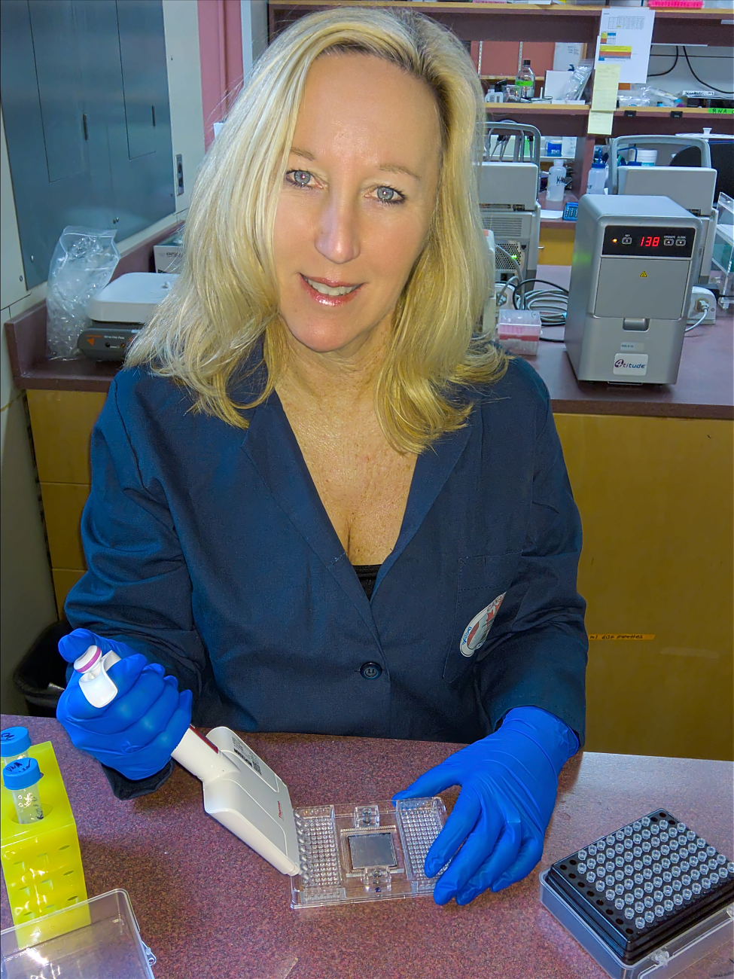
Molecular indices of viral disease development applied to discover emerging disease etiology
Kristina M. Miller¹², Oliver P. Günther³, Shaorong Li¹, Karia H. Kaukinen¹, Tobi J. Ming¹
¹Pacific Biological Station, Fisheries and Oceans Canada, Nanaimo BC Canada
²Department of Forest and Conservation Sciences, University of British Columbia, Vancouver, BC, Canada
³Günther Analytics, Vancouver, BC, Canada
Climate change enhances vulnerability of organisms to stress and disease, which can result in volatility in survival and ultimately population decline for many species. Emerging infectious diseases have been resolved in some cases, but understanding their disease etiology can be difficult in instances where morbidity and mortality are not readily observable. Sensitive technologies to detect early stages of disease development in live-sampled organisms, and the ability to differentiate pathogen carrier states from active disease states are required to demonstrate impacts of infectious diseases in wild populations. We present the discovery and validation of host transcriptional biomarkers capable of distinguishing the presence of an active viral disease state (VDD) from latent viral infections, and viral versus bacterial disease states in salmon. Biomarker discovery was conducted through meta-analysis of published and in-house microarray data, and validation performed on independent datasets including disease challenge studies and farmed diagnoses of various viral, bacterial, and parasitic diseases. We demonstrate that the VDD biomarker panel is predictive of disease development across RNA-viral species, salmon species, and salmon tissues, and can recognize a viral disease state in cultured and wild-migrating salmon. Application of this technology has led to the discovery of eight novel salmon viruses in British Columbia alone. Biomarkers resolved in our study on salmon were highly overlapping with those based on similar human viral influenza research, suggesting a highly conserved suite of host genes associated with viral disease that may be applicable across a broad range of vertebrate taxa.

Biography
Kristina Miller holds a PhD from Stanford University (1992) and is currently the Head of Genetics and Genomics at Fisheries and Oceans Canada. She is also an adjunct professor at UBC. Dr. Miller is on the editorial board for Immunogenetics, Facets and Coastal Marine Fisheries Journal. She has over 120 primary publications in the fields of genetics, genomics, immunogenetics, and disease

Presenting author details
Full name: Kristina M. Miller
Contact number: 250-248-1461
Twitter account:
Linked In account: Kristi Miller-Saunders
Session name/ number: Emerging Infectious Diseases – Modern and Unique Diagnostics
Category: Oral presentation
.

