TITLE: PNEUMOCEPHALUS,ICU MANAGEMENT OF AN UNUSUAL CONDITION ,A TERTIARY CARE EXPERIENCE FROM PAKISTAN
NAME: KULSOOM BANO MEHDI.
AGA KHAN UNIVERSITY HOSPITAL, KARACHI, PAKISTAN.
Pneumocephalus is caused by trauma and instrumentation which involves the sinuses, orbits, nasal passages or intracranial space. It can be managed conservatively but requires urgent neurosurgical intervention if tension pneumocephalus. There are many cases reported worldwide due to multiple causes but very few associated with ophthalmological procedures. We describe a rare case of pneumocephalus developing after dacrorhinostomy for bilateral nasolacrimal duct obstruction, managed in Medicine Intensive Care Unit conservatively.
A 62 year old lady presented with vomiting, drowsiness, respiratory distress and rhinorrhea. She had diabetes and ischemic heart disease and recent history of dacrocystorhinostomy for bilateral nasolacrimal duct obstruction. CT head showed cribriform plate rupture with tension pneumocephalus. She was treated with 100% inspired fraction of oxygen (FiO2) on mechanical ventilation, Fowler’s position, empiric antibiotics in meningitic doses, and complete sedation. Repeat CT Head after 3 days showed complete resolution of pneumocranium. She regained full consciousness and discharged home later.
Pneumocranium can also be caused by traumas after minor ophthalmological surgeries. If managed immediately by giving high flow oxygen, maintaining Fowler’s position, minimal position change and giving antibiotic and analgesics it can be resolved without the need for surgical intervention. To the best of our knowledge there is no case reported after trauma caused after dacrorhinostomy in Pakistan and abroad.
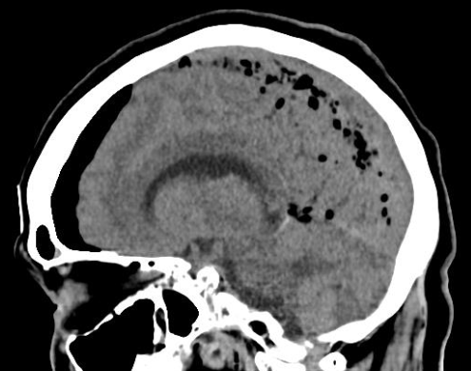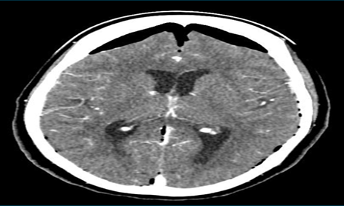

BIOGRAPHY: Dr.Kulsoom Bano Mehdi completed her MBBS in the year 2013 from Dow Medical College, Karachi, Pakistan. After graduation she did her Internship from Aga Khan University Hospital. Shortly after that she joined Department of Community Health Sciences, Aga Khan University as a research medical officer. Currently she is working as a resident, Internal Medicine department, Aga Khan University Hospital.
Presenting author details
Full name: Kulsoom Bano Mehdi.
Contact number: 0332-8266236
Category: Poster presentation

