Rational Design of High-Performance Electrocatalysts Based on Advanced Carbon Nanomaterials
Mohammad Tavakkoli*¹, Tanja Kallio², Kari Laasonen², and Esko I. Kauppinen¹
¹Department of Applied Physics, and ²Department of Chemistry, Aalto University, Espoo, Finland

Abstract

The development of efficient and low-cost electrocatalysts in electrocatalytic reactions plays an essential role because the catalyst determines not only the overall reaction efficiency but also the cost. We have developed a few synthesis methods to synthesize novel and low-cost electrocatalysts developed by carbon nanotubes (CNTs). CNTs are known for their exceptional properties in various applications. Here, I will further show that CNTs can be also utilized to create highly active and durable electrocatalysts [1-6]. In this talk, the focus is to design active catalysts for electrochemical water splitting by which highly pure hydrogen (as a clean energy carrier) and oxygen are produced from water. However, these novel and highly active designed electrocatalysts can be also utilized in other electrochemical energy devices.

We have developed a one-step chemical vapor deposition synthesis process to grow carbon-encapsulated iron nanoparticles (CEINs) supported on CNTs, as efficient electrocatalysts for catalyzing hydrogen production through electrochemical hydrogen evolution reaction [1]. The structure of CEINs can be also electrochemically modified to make them active for catalyzing another half-reaction in water electrolysis devices which is oxygen evolution reaction [2]. I further introduce single-walled CNTs as promising supports to stabilize individual atoms or subnano clusters of Pt in order to produce much cheaper Pt catalysts with almost a similar activity to that of bulk Pt for electrochemical hydrogen production. I show how our recently developed electroplating technique can strongly immobilize Pt atoms on small diameter CNTs, suggesting a facile method to produce single-atom catalysts [3]. I also remark the promising performance of multi-walled CNTs for the covalent functionalization with organometallic compounds [4] and non-covalent modification with nitrogen-enriched polymers [5,6] to produce stable electrocatalysts for catalyzing reactions occurring under harsh oxidizing conditions.

Finally, I also mention some of our other recent achievements in the design of advanced porous carbon nanomaterials which show promising performance for catalyzing various electrocatalytic reactions of importance for fuel cells and hydrogen production.
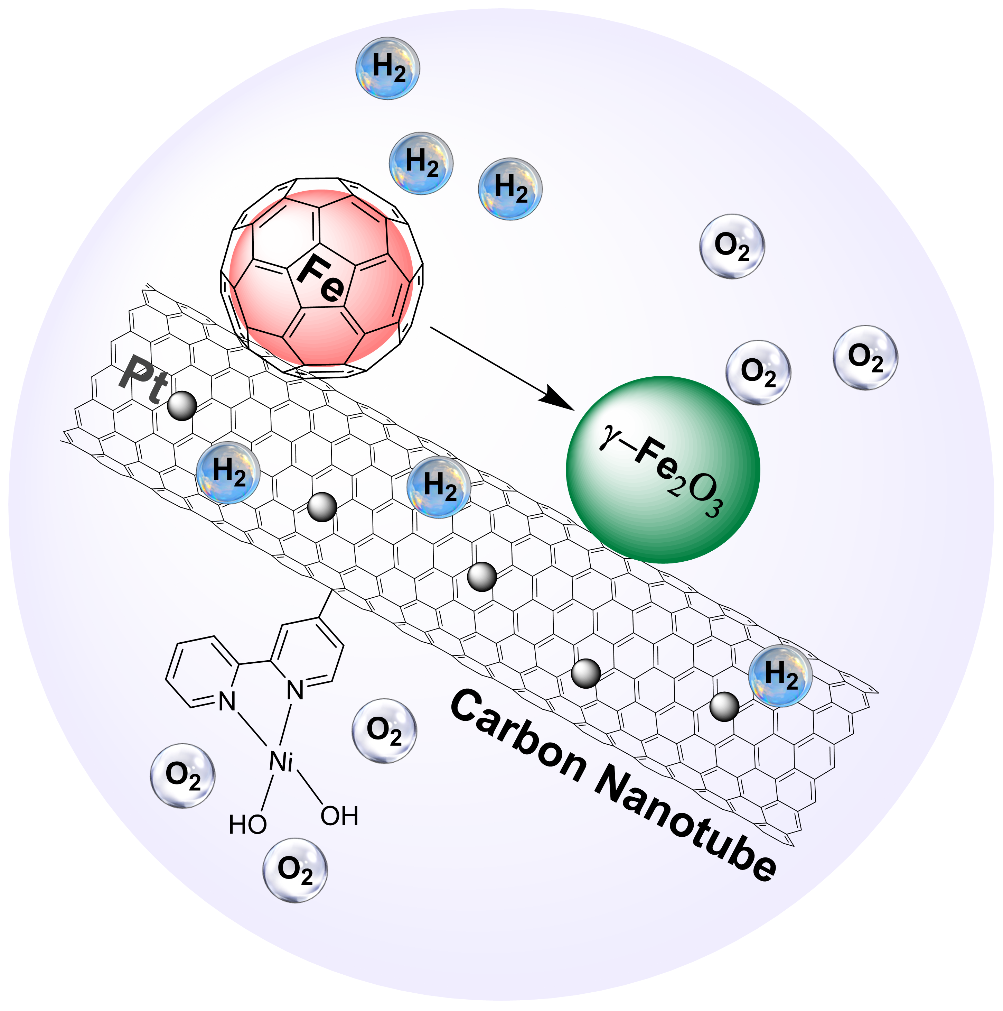
Recent Publications
[1] M. Tavakkoli, T. Kallio, O. Reynaud, A.G. Nasibulin, C. Johans, J. Sainio, H. Jiang, E.I. Kauppinen, K. Laasonen, Angewandte Chemie International Edition, 54 (2015) 4535-4538.
[2] M. Tavakkoli, T. Kallio, O. Reynaud, A.G. Nasibulin, J. Sainio, H. Jiang, E.I. Kauppinen, K. Laasonen, Journal of Materials Chemistry A, 4 (2016) 5216-5222.
[3] M. Tavakkoli, N. Holmberg, R. Kronberg, H. Jiang, J. Sainio, E.I. Kauppinen, T. Kallio, K. Laasonen, ACS Catalysis, 7 (2017) 3121-3130.
[4] M. Tavakkoli, M. Nosek, J. Sainio, F. Davodi, T. Kallio, P.M. Joensuu, K. Laasonen, ACS Catalysis, 7 (2017) 8033-8041.
[5] F. Davodi, M. Tavakkoli, J. Lahtinen, T. Kallio, Journal of Catalysis, 353 (2017) 19-27.
[6] F. Davodi, E. Mühlhausen, M. Tavakkoli, J. Sainio, H. Jiang, B. Gökce, G. Marzun, T. Kallio, ACS Appl. Mater. Interfaces, 10 (2018), 31300−31311.

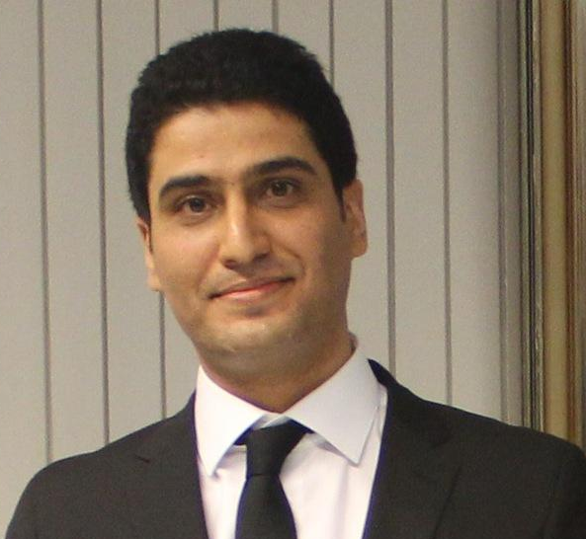 Biography
Mohammad Tavakkoli completed his Ph.D. in the Department of Chemistry and Materials Science at Aalto University in Finland in November 2017. In 2018, he was awarded the Gustav Komppa Award which is annually given by the Finnish Chemical Society to the best doctoral dissertation of the year in Finland in the field of chemistry and related disciplines. He has been working on the development of catalyst materials for a wide range of electrochemical reactions as well as electrode materials for batteries and supercapacitors. He has also devised a few facile synthesis methods to produce high-performance nanomaterials for the electrochemical energy applications. He is currently a Postdoctoral Researcher in Nanomaterials Group (NMG), Department of Applied Physics, Aalto University. His current research areas are: development and rational design of electrode materials for electrochemical energy devices; synthesis, characterization, and functionalization of functional carbon nanomaterials; and development of transparent conductive thin films for use in flexible electro-optical devices
https://www.aalto.fi/department-of-applied-physics/nanomaterials-nmg
Mohammad Tavakkoli
Tel: +358504140950
Category: (Oral presentation)
Email: mohammad.tavakkoli@aalto.fi

