Forest of structured nanowires for energy storage and production
Denis Buttard, Prof, Grenoble Alpes University CEA, France
Olivier Marconot, PhD, Sherbrook University, Quebec
Dhruv Singhal, PhD, Grenoble Alpes University CEA, France
Michael Belluzzi, PhD, Grenoble Alpes University CEA, France
Othman Lagrichi, PhD, Grenoble Alpes University CEA, France
Arnaud Morin, Dr, CEA-Grenoble, France
Olivier Bourgeois, Dr, CNRS Néel Institute, Grenoble, France
Dimitri Tainoff, Dr, CNRS Néel Institute, Grenoble, France

Abstract (300 word limit)
The storage and production of electrical energy is a major issue of the 21st century. Many methods are developed today for embedded systems in the range of small storage. In this context, the development of nanoscale 3D structures makes it possible to considerably increase the specific area of the material. By working on this surface increase but also on its reactivity we can considerably increase the performances of the devices. We have developed in our laboratory electrochemical methods for the production of ultra-dense align nanowires and nanotubes embedded in nanopourous alumina membrane with various materials like metals (Cu, Au, Ni, Pt), semiconductors (Si, Ge) or dielectrics (TiO2, polymers) for their integration into electrical devices in partnership with companies in link with industrial issue.
We will present some of our results in various fields of electricity production such as PtCu and/or PtNi nanotubes fuel cells (Figure 1), Si nanowires solar cell and thermoelectric devices. We will also present their applications for electrical storage: 3D Metal-Insulator-Metal capacitors, electrolytic capacitors, and supercapacitors. Electrochemical elaboration as well as electrochemical operation will be presented.

Image
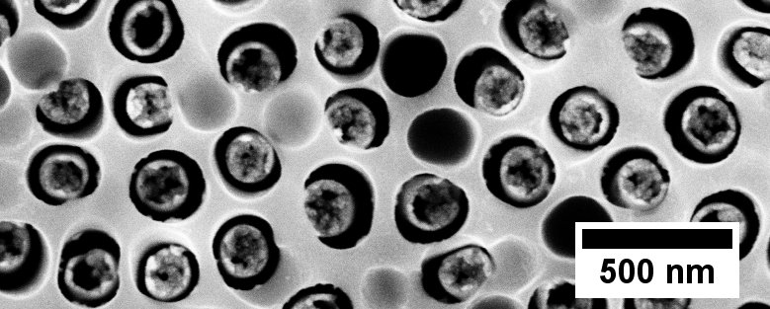
(a)


(b)
O₂

H₂

Fig. 1: As an example of our realization: PEFMC. a) Top view PtCu NTs embedded in a nanoporous alumina membrane, b) Schema of a PEFMC cross section using a PtCu forest membrane. The PEFMC operation uses the anisotropic geometry of the PtCu NT forest for transport and also the nanoporosity of each NT to increase the surface reactivity of the system.

Recent Publications (minimum 5)
- Marconot O, Morin A, Pauc N, Buttard D (2018) Vertically aligned platinum copper nanotubes as PEM fuel cell cathode: elaboration and fuel cell test. Fuel Cell (Submitted).
- Singhal D, Paterson J, Tainoff D, Richard J, Ben-Kedhim M, Gentile P, Cagnon C, Bourgault D, Buttard D, Bourgeois O (2018) Measurement of anisotropic thermal conductivity of a dense forest of nanowires using the 3ω method Review of scientific Instruments (Submitted).
- Madassamy S, Voiron F, Nguyen A P, Lefèvre A, Parat G, Buttard D, Sylvestre A Leakage Current and Reliability on Planar High-k Capacitor with Al2O3 Dielectric deposited by Thermal-ALD (2015) mrss15-2136575.
- Gorisse T, Zelsmann M, Buttard D Density multiplication of pores and their propagation in a thin layer of nanoporous alumina on silicon substrates (2015) Applied Surface Science 343 106–114.
5. Thissandier F, Dupré L, Gentile P, Brousse T, Bidan G, Buttard D, Sadki S (2014) Ultra-dense and highly doped SiNWs for micro-supercapacitorselectrodes. Electrochimica Acta 117 159– 163.

Biography (150 word limit)
Pr. Denis Buttard 49 is professor at the Grenoble Alpes University (France), researcher at the Institute Nanoscience and Cryogeny (CEA-France) and Head of the department of Physical Measurements of the University Institute of Technology. He is involved in material research for self-organised nanostructures for energy applications. He is especially involved in the realization of nanoporous alumina membranes and the confined growth of ultra-dense forest of nanowires and/or nanotubes in these membranes. Complex structures are elaborated as for example core-shell stacking for radial junction around wires. A large part of his work deals also on the structural characterization of these structures by x-rays diffraction and reflectivity methods and electron or near field microscopy techniques. He is author or co-author of 53 articles in international revues and more than 80 communications..
Email: denis.buttard@cea.fr

Notes/Comments:

