Electrochemical deposition of artificial recognition unit for gluten epitope selective determination
Zofia Iskierko, PhD, Department of Biotechnology, University of Verona, Strada Le Grazie 15, 37134 Verona, Italy
Piyush S. Sharma, PhD, Institute of Physical Chemistry, Polish Academy of Sciences, Kasprzaka 44/52, 01-224 Warsaw, Poland
Prof. Alessandra Maria Bossi, Department of Biotechnology, University of Verona, Strada Le Grazie 15, 37134 Verona, Italy
Prof. Wlodzimierz Kutner, Institute of Physical Chemistry, Polish Academy of Sciences, Kasprzaka 44/52, 01-224 Warsaw, Poland, and Faculty of Mathematics and Natural Sciences, School of Science, Cardinal Stefan Wyszynski University in Warsaw, Woycickiego 1/3, 01-815 Warsaw, Poland

Abstract
Gluten, that chemically corresponds to storage proteins deposited in the starchy endosperm cells of the developing grain, is the allergen that triggers autoimmuno reactions in people suffering of celiac sprue (CS). It is estimated that CS affects the 1-2 % of the European population with direct costs on the healthcare estimated about 3 bn Euros/year.¹ The only effective therapy is strict dietary abstinence from gluten, in fact, even a small contamination of food with gluten can cause serious adverse reactions from digestive system. Food considered as “gluten-free”, thus safe for CS suffering people, should contain less than 20 mg/kg of gluten.
Molecularly Imprinted Polymers (MIPs) are artificially made receptors² with the ability to bind reversibly and to recognize the target analytes. The fabrication of MIPs against small molecules or peptides is now straightforward, whereas imprinting of large molecular structures, such as proteins, still poses challenges^{3,4} A possible solution is to imprint just defined epitopes instead of the whole protein.⁵
In the present study, a toxic gluten epitope, PQQPFPQQ, was chosen as a template for imprinting. The MIP film was prepared by electrochemical polymerization of bis(bithiophene) derivatives, bearing either cytosine or carboxylic acid substituent, in the presence of the template and a cross-linker (Figure 1a). After deposition, the template was extracted from the polymer film. Subsequently, the film composition was characterized by X-ray photoelectron spectroscopy (XPS) as well as its morphology and thickness were studied by atomic force microscopy (AFM).
Performance of this chemical sensor was tested in laboratory conditions (Figure 1b). Extended-gate field-effect transistor (EG-FET) sensor signals were measured towards aqueous solution of the PQQPFPQQ analyte, as well as its interferences with 1 or 2 mismatched amino acids. Secondly, sensor response were measured towards PQQPFPQQ analyte in gluten digested with pepsin in pH ≈ 2. Finally, analytical parameters of the devised chemosensor were evaluated.

The present research was supported by the European Union’s Horizon 2020 research and innovation programme under the Marie Sklodowska-Curie grant agreement No 752438 (GEMS).

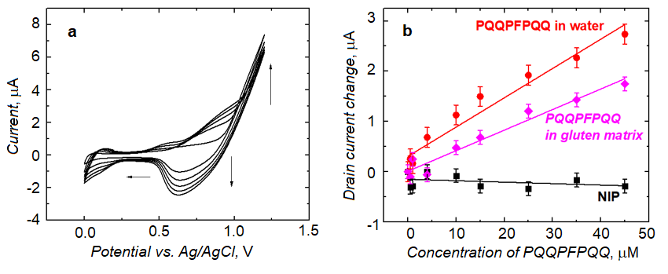
Figure 1. (a) The current-potential curves for MIP-PQQPFPQQ film deposition by potentiodynamic electropolymerization on the 1-mm diameter Pt disk electrode in 0.1 mM solution of PQQPFPQQ template, with functional and cross-linking monomers mixture, and 0.1 M (TBA)ClO₄ in the acetonitrile-to-toluene solvent mixture of the 1 : 9 volume ratio. The potential scan rate was 50 mV s⁻¹.; (b) Calibration curves determined for gluten epitope PQQPFPQQ analyte using molecularly imprinted polymers (MIPs, red and magenta curves) or non-imprinted polymer (NIP, black curve) as recognition units and extended-gate field-effect transistors (EG-FETs) as transducers. All the measurements were performed for the gate voltage, V_{G} = 1.5 V
References
- K.H. Long, et al. (2010) “The economics of coeliac disease: a popu-lation-based study”, Aliment. Pharmacol. Ther. 32, 261;
- P. S. Sharma, et al. (2015) “Bioinspired intelligent molecularly imprinted polymers for chemosensing: A mini review.” Electrochem. Commun. 50, 81;
- M. J. Whitcombe, et al. (2014) “Size matters: challenges in imprinting macromolecules.” Prog. Polym. Sci. 39, 145;
- A. Bossi et al. (2007) “Molecularly imprinted polymers for the recognition of proteins: The state of the art. ” Biosens. Bioelectron. 22, 1131;
- A. Bossi et al. (2012) “Fingerprint imprinted polymer (FIP): Rational selection of peptide epitope templates for the determination of proteins by molecularly imprinted polymers.” Anal. Chem. 84, 4036.

 Biography (150 word limit)
Zofia Iskierko graduated in Chemistry Department of Maria Curie-Sklodowska University in Lublin, Poland, in 2008, and received her PhD degree in chemistry in Institute of Physical Chemistry of Polish Academy of Sciences (IPC, PAS) in Warsaw, Poland, in June 2017. Molecularly imprinted polymer (MIP) based chemosensors have been her main topic of researches since 2012, when she joined the Kutner’s Group at IPC PAS. Now she is the Marie Curie Fellow at the Biotechnology Department of University of Verona, Italy, where she has started her researches on gluten epitope chemosensor under prof. Alessandra Maria Bossi supervision since January 2018.
Email: zofiaewa.iskierko@univr.it

Notes/Comments:

