Polyelectrolyte Multilayer Assemblies and Brushes
on Reduced Graphene Oxide Field-Effect Transistors for Sensing Applications

E. Piccinini ^{a,b}, T. Berninger ^{a,c}, C. Bliem ^{a,c}, O. Azzaroni ª, W. Knoll ^{b.c}
ª Instituto de Investigaciones Fisicoquímicas Teóricas y Aplicadas, La Plata, Argentina
^{b} AIT Austrian Institute of Technology, Biosensor Technologies, Tulln, Austria
^{c} Center of Electrochemical Surface Technologies, Wiener Neustadt, Austria

Graphene, a two-dimensional zero band gap semiconducting material, has gained considerable interest in material science, energy storage and sensor technology, due to its remarkable electronic and mechanical properties. Its high carrier mobility and ambipolar field effect, together with a great sensitivity towards changes in environmental conditions makes graphene perfectly suitable as transducing material for the use in various types of sensors.
In this report, we first describe a novel biosensor exploiting the pH dependence of liquid gated graphene-based field-effect transistors for the enzymatic detection of urea. The channel between the interdigitated source-drain microelectrodes was non-covalently functionalized with bilayers of poly (ethylene imine) and urease using the layer-by-layer approach, providing a LoD below 1μM urea.
Next, we present a sensor based on a reduced graphene oxide field effect transistor (rGO-FET) functionalized with the cascading enzymes arginase and urease as recognition elements in a layer by layer assembly with poly (ethylene imine). The build-up of this nano-architecture was monitored by surface plasmon resonance spectroscopy. L-arginine was quantitatively detected by the change in current between source and drain electrode due to electrostatic gating effects conferred by the formation of OH⁻ ions upon enzymatic hydrolysis of the analyte L-arginine.
And finally, we will describe first results on the coupling of calcium-responsive polymer brushes to graphene field-effect transistors. The presence of Ca⁺²–ions neutralize the charge of the phosphate groups leading to a change of the Dirac point by electrostatic gating effects. A formalism using the Langmuir adsorption model and the Grahame equation is used to obtain the surface coverage from the change of the Dirac point.
 | Wolfgang Knoll earned a PhD degree in Biophysics from the University of Konstanz in 1976.  From 1991-1999 he was the laboratory director for Exotic Nanomaterials in Wako, Japan, at the Institute of Physical and Chemical Research (RIKEN).
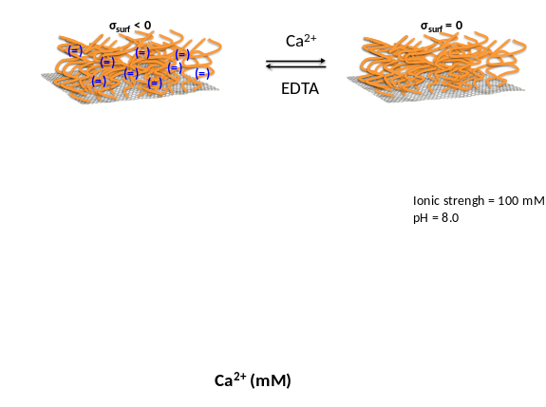Coupling calcium-responsive polymer
brushes to graphene field-effect transistors

Berninger, T.; Bliem, C.; Piccinini, E.; Azzaroni, O.; Wolfgang Knoll, W., 2018. Cascading reaction of arginase and urease on a graphene-based FET for ultrasensitive, real-time detection of arginine, Biosens. Bioelectron., submitted
Piccinini, E.; Alberti, S.; Longo, G.; Berninger T.; Breu, J.; Dostalek, J.; Azzaroni, O.; Knoll, W., 2018. Pushing the Boundaries of Interfacial Sensitivity in Graphene FET Sensors: Polyelectrolyte Multilayers Strongly Increase the Debye Screening Length, J. Phys. Chem., accepted
Piccinini, E.: Bliem, C.; Reiner-Rozman, C.; Battaglini, F.; Azzaroni, O.; Knoll, W., 2017. Enzyme-polyelectrolyte multilayer assemblies on reduced graphene oxide field-effect transistors for biosensing applications. Biosens. Bioelectron. 92, 661.
Reiner-Rozman, C., Larisika, M., Nowak, C., Knoll, W., 2015. Graphene-based liquid-gated field effect transistor for biosensing: Theory and experiments. Biosens. Bioelectron. 70, 21.
W. Choi and J. Lee, Eds., in Nanomaterials and Their Applications, CRC Press, 20

From 1993 to 2008, he was Director at the Max Planck Institute for Polymer Research in Mainz, Germany. Since April 1, 2008 he is the Scientific Managing Director of the AIT Austrian Institute of Technology. Since 2010 he is a Regular Member of the Austrian Academy of Sciences, received in 2011 an Honorary Doctorate from the University of Twente, the Netherlands, and became a member of the Academia Europaea in 2017.

