(Electro)chemical water disinfection – challenges for the 21st century
M.E. Henry Bergmann, Anhalt University, Köthen, Germany

Abstract
Whereas worldwide hundreds of millions of people do not have access to save drinking water, in developed countries current research and practice are oriented towards problems of micropolutants and disinfection by-products formed at µmol-per Liter level [1]. Another special subject of activities is the low-chemical disinfection of process waters in recirculation and cooling systems. Although direct electrochemical drinking water disinfection is applied for decades of years, conditions for avoiding overchlorination and disinfection by-products could only be clarified only in the recent yeas [2].
A new approach is the electrochemical generation of chlorine dioxide (ClO₂) at mM concentration level [3]. It is well known that ClO₂ has much lower organic by-product formation potential compared to free active chlorine [4]. The challenge is to minimize chlorite, chlorate and perchlorate is the solutions obtained. The high chlorite reactivity is often causing maxima in ClO₂ formation (Fig. 1). Highly active anodes (BDD in the given case of Fig. 1) dramatically reduce the generation of chlorine dioxide – due to parasitic reactions. Solutions for inorganic electrolysis and disinfection by-products can be found by analyzing and studying influence parameters such as temperature, electrode material, counter electrode material and cell construction. ClO₂⁻-to-ClO₂ yields of 75% are possible at the moment. Furthermore, it is discussed if combined methods may contribute to lower by-product formation. A simple variant is the combined chlorine-chlorine dioxide formation [5]. The combination of ozone and chlorine dioxide in situ is another interesting option. First own experiments have shown that all initial chlorite can be converted to chlorine dioxide. Lower temperatures in the range of 5°are preferred reaction conditions.
It can be stated that in the future improved regulations and inline analysis methods have to be applied for saver disinfection. Means of digitalization could support the process.

Image
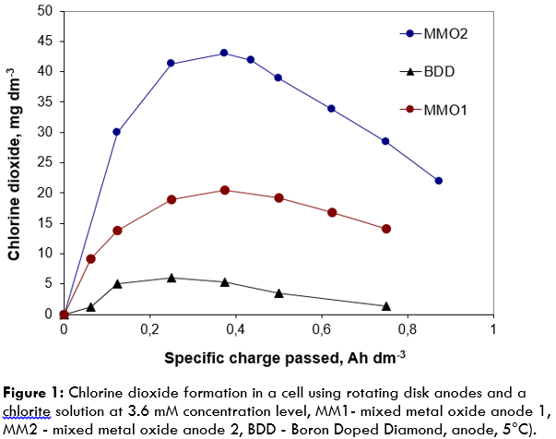
Recent Publications
- Kähkönen E, Nordström K (2008) Toward a nontoxic poison: Current trends in (European Union) biocides regulation. Integr Environ Assess Manag 4:471-477.
- Final Research Report (2012) Save Drinking Water By Using Inline Electrolysis. Supported by DVGW (10/02/08 and DBU (AZ 25386), Bad Elster, Berlin, Dresden and Köthen.
- Bergmann MEH, Koparal AS (2005) Problems of chlorine dioxide formation during electrochemical disinfection. Electrochim Acta 50:5218-5228.
- Haas CN (1990) Disinfection. Pontius FW (Ed.), Water Quality and Treatment, McGraw-Hill Inc:877-932.
- Lindner K, Lew, J, Carter B, Brauer R (2003) Avoiding chlorite: chlorine and ClO2 together to form fewer DBDs. Opflow 32:24-26.

 Biography
M.E. Henry Bergmann has his 35-years expertise in electrochemical engineering that is recently focused on methods of drinking and process water disinfection. His technological approach for small and medium-size treatment devices respects the new European Biocide Regulation and the practical needs as well - against the background of avoiding or minimizing chlorination, and the formation of hazardous by-products. New (electro)chemical technologies are suggested basing on the use of chlorine dioxide, physically or electrochemically generated ozone, and combined methods.
Email: henry.bergmann@hs-anhalt.de

Notes/Comments:

