Two-dimensional metal chalcogenides analogous NiSe2 nanosheets and its efficient electrocatalytic performance towards glucose sensing
Sakthivel Mani ª, Sukanya Ramaraj ª, Shen-Ming Chen ª,
Electroanalysis and Bioelectrochemistry Lab, Department of Chemical Engineering and Biotechnology, National Taipei University of Technology, Taipei 10608, Taiwan

Abstract (300 word limit)
Recently, 2D layered transition-metal dichalcogenide materials have received great consideration because of their unique electronic properties, large surface area and high electrocatalyticactivity. In this connection, for the first time the similar nanostructured material of NiSe2 nanosheets (NiSe2-NS) has been synthesized by a facile hydrothermal method for electrocatalytic applications. Scanning Electron Microscopy (SEM), Transmission Electron Microscopy (TEM), X-ray Photoelectron Spectroscopy (XPS), Energy Dispersive X-ray analysis (EDX), X-ray diffraction spectrum (XRD) results confirmed the formation of NiSe2-NS with required stoichiometry and morphology. Electrochemical Impedance Spectroscopy (EIS) data indicate that electron transfer is facile at the NiSe2-NS modified glassy carbon electrode (GCE). It has been as an electrode modifier for glucose sensing applications. The electrochemical studies were performed for NiSe2-NS modified GCE using Cyclic Voltammetry (CV) and Amperometric i-t techniques. The results are suggesting the effective response of NiSe2-NS/GCE with a very low limit of detection (LOD) and sensitivity of 23 nM and 5.6 µA µM⁻¹cm⁻²
respectively. Moreover, the selectivity data exhibited excellent anti-interference property of NiSe2-NS/GCE towards glucose in the presence of possible interfering agents viz. Ascorbic acid, dopamine, and glucose.
Image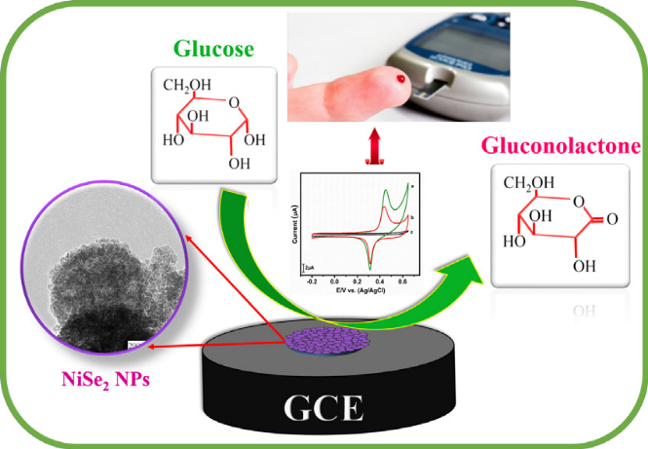

Recent Publications

1. International journal of electrochemical science 12(6):5567 – 5580 · March 2017
DOI: 10.20964/2017.06.26.
2. Journal of Colloid and Interface Science 507 · August 2017
DOI: 10.1016/j.jcis.2017.08.
3. Journal of the Taiwan Institute of Chemical Engineers · August 2017
DOI: 10.1016/j.jtice.2017.08.047


Biography (150 word limit)
Miss. Sukanya Ramaraj doing her Ph.D. in Department of chemical engineering at National Taipei University of Technology, Taiwan. She has completed her master degree in Nano science and Nanotechnology, at Bharathiar University, India. She is working in the field of electrochemical and biosensor, and dye-sensitized solar cells. She has published more than 2 papers in reputed journals and has been submitted 10 papers on SCI reputed journals.
.
Email: sukanyaram33@gmail.com

Notes/Comments:

