Tetrahedral finite element modeling of UNS S31600 stainless steel corrosion behavior under superfinish turning conditions
Y. Ech-charqy, H.Gziri, M.Essahli: University Hassan 1, Laboratory of Applied Chemistry and Environment, Laboratory of mechanic, industrial management and innovation, Settat, Morocco.

Abstract

The objective of this work is achieve an analytical predictive model to study the influence of surface topography on the corrosion resistance of UNS S31600 stainless steel in a solution of sodium chloride NaCl at 6% by weight as electrolyte, by applying the finite element method. The topography of the surface was given by the variation of the average roughness of a UNS S31600 workpiece in superfinishing turning, of which, its correlation with the corrosion resistance was examined. The analytical results show that the physico-chemical parameters of the corrosion, the polarization resistance, the rate and the corrosion potential, as well as the current density, have a very remarkable correlation with the surface roughness obtained by the superfinish turning. This is due to a very significant affinity between the depth of the plastic deformation obtained by the machining and the development of the pits on the workpiece surface.

The whole work was completed by an empirical analysis in order to validate the analytical results obtained in comparison with the experimental results.

Image
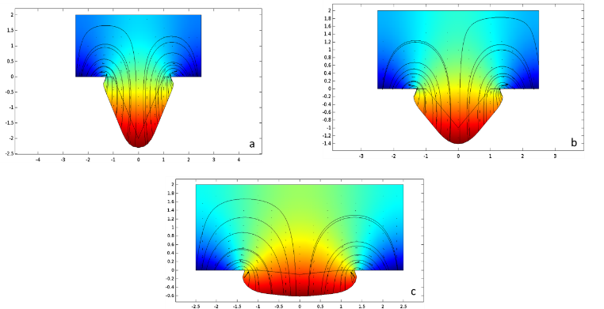
Figure: Electrolyte potential of a UNS S31600 workpiece with different average roughness values
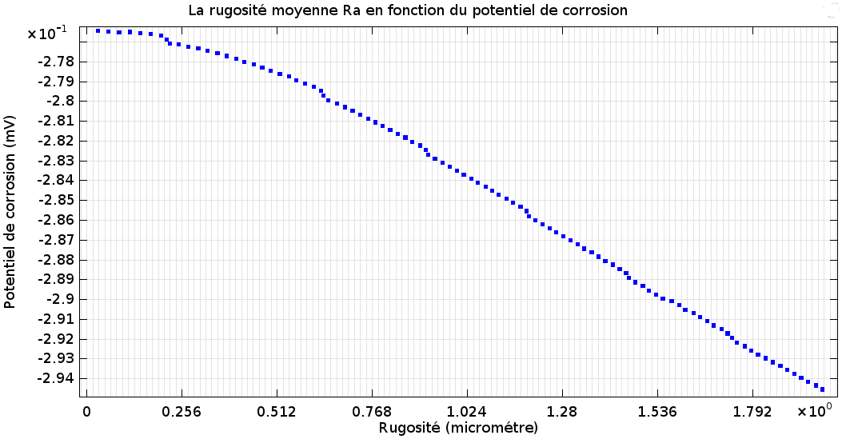
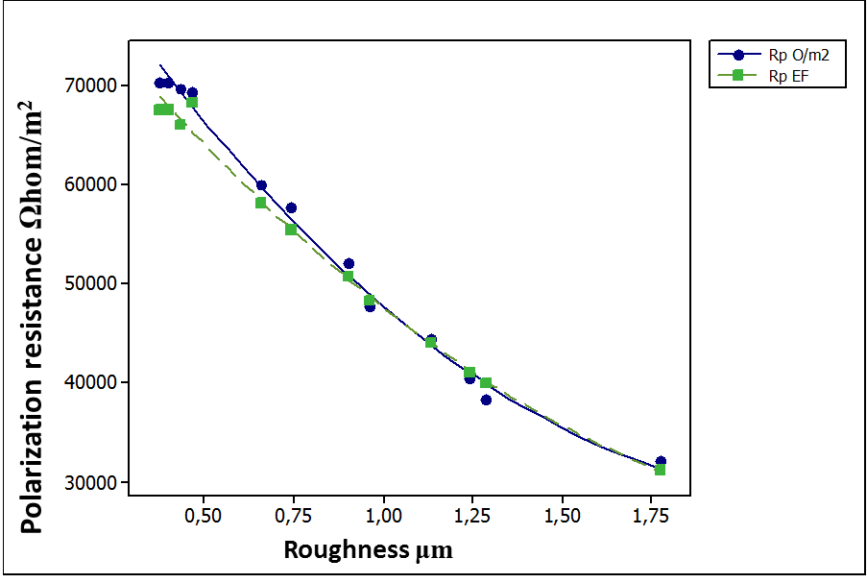
Figure: The average roughness Ra as a function of the corrosion potential Ecorr

Figure: Comparison between experimental results and finite element results of polarization resistance

Recent Publications
- S. Caruso, S. Di Renzo, D. Umbrello, A. Jayal et O. Dillon, «Finite Element Modeling of Microstructural Changes in Hard Turning,» Advanced Materials Research, vol. 223, pp. 960-968, 2011. Heilig M, Egli M (2006) Pharmacological treatment of alcohol dependence: Target symptoms and target mechanisms. Pharmacology and therapeutics 111:855-876.
- M. Prakash, S. Shekhar, A. Moon et K. Monda, «Effect of machining configuration on the corrosion of mild steel,» Journal of Materials Processing Technology, vol. 219, p. 70–83, 2015.
- S. M. Lee, W. G. Lee, Y. H. Kim et H. Jang, «Surface roughness and the corrosion resistance of 21Cr ferritic stainless steel,» Corrosion Science, vol. 63, p. 404–409, 2012.
- S. Bissey-Breton, J. Gravier et V. Vignal, «Impact of superfinish turning on surface integrity of pure copper,» Procedia Engineering, vol. 19, pp. 28-33, 2011.
- Y. ECHCHARQY, H. GZIRI et M. ESSAHLI, «Effect of machining process in superfinish turning on the corrosion behavior of UNS S31600 stainless steel in 6% NaCl solution,» Portugalia Electrochemica Acta, vol. 34, n° %13, pp. 143-155, 2016.

Biography
Younes Echcharqy is an engineer in Design and Mechanical Manufacturing, and PhD student in University Hassan the first. His Research is about the study of the surface durability according to the parameters of the machining process with mechanical and physio-chemical behavior. His papers are:
- A modified Monte Carlo method to study the performance of the roughness models; International Journal of Manufacturing Technology and Management.
- Effect of Machining Process in Superfinish Turning on the Corrosion Behavior of UNS S31600 Stainless Steel in 6% NaCl Solution; Portugaliae Electrochimica Acta.
– Détection des fissures dans les têtes des pistons en alliage de magnésium Mg-Zn (Y, Gd) par thermographie pulsée ; IEEE.
He is a trainer and Industrial advisor in mechanical manufacturing and metallic structures at the Office of Professional Training and Work Promotion in Morocco.
Email: y.echcharqy@uhp.ac.ma
Tel: +212651233883

