Effective Nanomaterials for Glucose Oxidation in an Electrochemical Energy Converter: Cogenerating Organic Electrosynthesis
Kouakou Boniface KOKOH, Professor, Université de Poitiers, IC2MP CNRS UMR 7285, FRANCE
Yaovi HOLADE, Dr., Université de Montpellier, UMR 5635, ENSCM, CNRS, UM, FRANCE
Teko W. NAPPORN, Dr., Université de Poitiers, IC2MP CNRS UMR 7285, FRANCE

Abstract
Statement Glucose is an environmentally friendly and sustainable carbohydrate that is actually a cyclized aldehyde in aqueous solution i.e. a hemiacetal. Its selective oxidation by the anomeric carbon in C1-position without any function protection is of great interest for cogeneration because the electrochemical process enables converting this highly functionalized organic molecule into electricity, heat and added-value chemicals. For this objective, we decide to synthesize effective nanomaterials towards glucose conversion at the anode and the oxygen reduction reaction (ORR) in the cathodic side of a fuel cell. The physical characterizations of the prepared materials and their electrochemical analysis at each half-cell, permitted to optimize the activity of the electrodes according to their elemental composition and structure. Furthermore, a constructed direct glucose fuel cell (DGFC) delivered an open-circuit voltage of 1.1 V in 0.5 mol L⁻¹ NaOH and an outstanding output power of 2 mW cm⁻². Complementary analytical techniques were employed to quantify the reaction processes involved in each compartment, determine the reaction products resulted from the glucose transformation and thereby, to understand reaction mechanisms of the glucose oxidation and the ORR over the synthesized electrode materials used in alkaline medium. As results, the identification of gluconate as the sole reaction product in the anodic side showed a selective 2-electron conversion of glucose, while the ORR proceeded through a 4-electron pathway over the designed cathode catalyst.

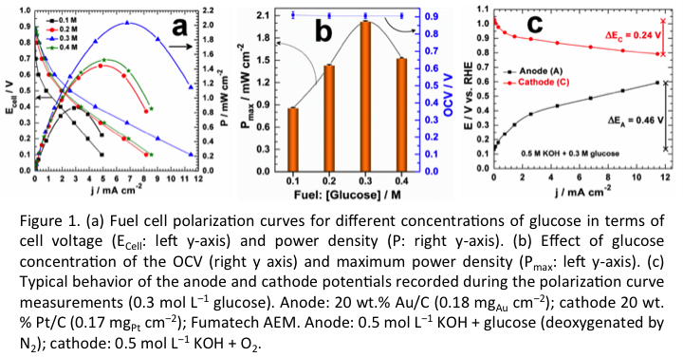
Recent Publications
- Holade Y, MacVittie K, Conlon T, Guz N, Servat K, Napporn T W, Kokoh K B, Katz E (2014) Pacemaker Activated by an Abiotic Biofuel Cell Operated in Human Serum Solution, Electroanalysis 26:2445-2457.
- Da Palma L M, Almeida T D S, Oliveira V L, Tremiliosi-Filho G, Gonzalez E R, Andrade A, Servat K, Morais C, Napporn T W, Kokoh K B (2014) Identification of Chemicals Resulted in the Selective Glycerol Conversion as Sustainable Fuel on Pd-based Anode Nanocatalysts. RSC Adv. 4:64476-64483.
- Holade Y, Da Silva R G, Servat K, Napporn T W, Canaff C, De Andrade A R, Kokoh K B (2016) Facile synthesis of highly active and durable PdM/C (M = Fe, Mn) nanocatalysts for oxygen reduction reaction in alkaline medium. Journal of Materials Chemistry A 4:8337-8349.
- Tatin A, Comminges C, Kokoh B, Costentin C, Robert M, Savéant J-M (2016) Efficient electrolyzer for CO₂ splitting in neutral water using earth-abundant materials, PNAS, 113 5526-5529.
5. Holade Y, Servat K, Napporn T W, Morais C, Berjeaud J-M, Kokoh K B (2016) Highly Selective Oxidation of Carbohydrates in an Efficient Electrochemical Energy Converter: Cogenerating Organic Electrosynthesis, ChemSusChem 9:252-263.

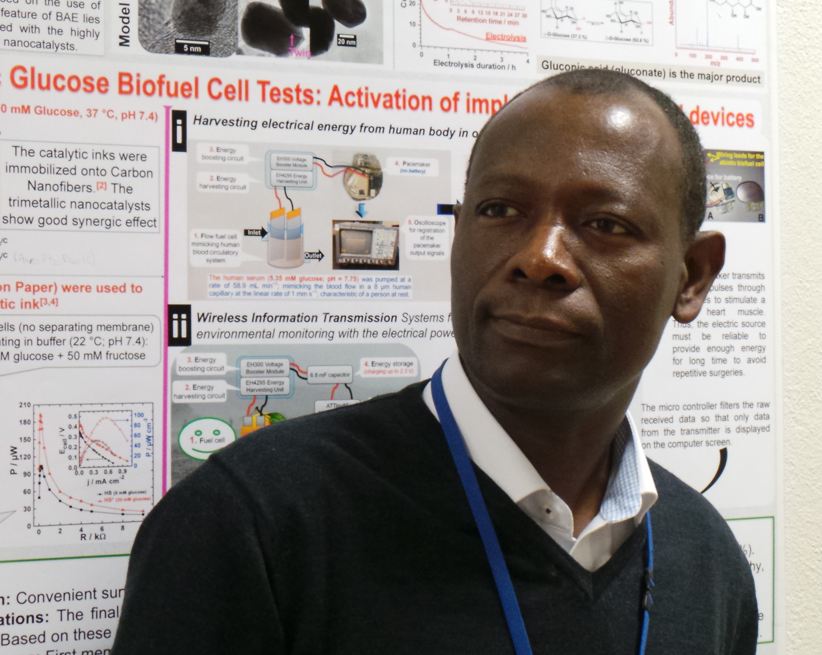 Biography (150 word limit)
Prof. K. Boniface Kokoh is developing electrocatalytic materials for sustainable energy conversion and storage. He manages an electrocatalysis group that prepares electrode nanomaterials that are suitable to each application. His research topics concern hydrogen production in a solid polymer electrolyte water electrolyzer, abiotic electrodes design for hybrid biofuel cells and the CO₂ electroreduction to platform molecules.
Email: boniface.kokoh@univ-poitiers.fr

Notes/Comments:

