Assessment of hazardous chemical parameters in drinking water treatment plant MUET Jamshoro, Sindh Pakistan

Syeda Sara Hassan, BS, PhD, USPCASW, MUET Jamshoro, Sindh, Pakistan
Aziz Ullah, BE, ME, USPCASW, MUET Jamshoro, Sindh, Pakistan

Abstract (300 word limit) Image
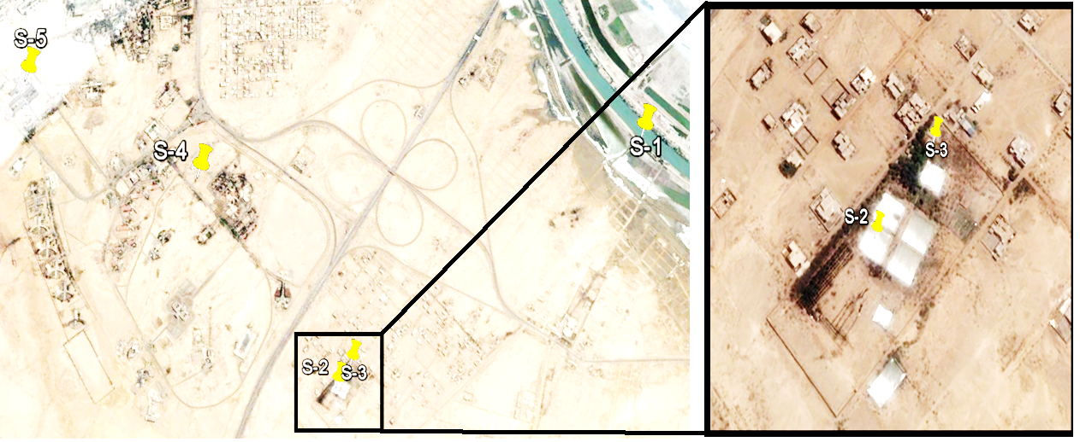
Affordable testing of safe drinking water is addressing targets SDGs goal 6 is an urgent need in a poor country like Pakistan, where my research interests lie specially poor communities in Jamshoro Sindh, is facing with intense health problems due to water pollution and this problem is intensifying day by day in our ecosystem. The main source of mehran water treatment plant and its residents is KB feeder and Indus River is originates at the right side of Kotri barrage. Larger quantities of hazardous chemicals have been released into rivers worldwide due to global rapid population growth and intensive domestic activities, as well as expanding industrial and agricultural production if they not removed by water and waste water treatment plant are most hazardous for aquatic and human beings when they enter in to the food chain and causes several health disorder in nervous system , organ , cancer, reduced growth and in severe cases, causes death and for cure thousands of dollars are used. Presently, the water quality chemical parameters of Mehran University are analyzed by using different analytical techniques. The samples were collected from June, 2016 to May, 2017. The selected locations for the study are: raw water source for Mehran i.e. KB Feeder, Mehran Water Treatment plant and Mehran University distribution system and the concentration ranged for chloride was (20-200) mgL⁻¹, alkalinity (5-95) mgL⁻¹, total hardness (50-240) mgL⁻¹, total dissolved solids (114-737) mgL⁻¹, Fluoride (0.039-0.46) mgL⁻¹, sulfate (23-76) mgL⁻¹, nitrate (0-16.12) mgL⁻¹, lead (0-22.23) µgL⁻¹, cadmium below detection limit, chromium (0.6-6) µgL⁻¹, iron (128-460) µgL⁻¹, zinc (0.575-576.25) µgL⁻¹, copper (1.14-8.2) µgL⁻¹, arsenic (3-5) µgL⁻¹, and mercury below detection limit. The observed data is compared with standards values of world health organization (W.H.O.) guidelines limits. All parameters concentration was under WHO guideline limits except iron and lead.

Figure 1: Map of MUET water treatment plant WTP), Jamshoro with
Source, total five (5) number of sampling were collected from different sites, such as S1 (KB Feeder / Intake), S2 (Sedimentation Tank Outlet), S3 (Post filtration), S4 (MUET Storage) and S5 (IWRM department).

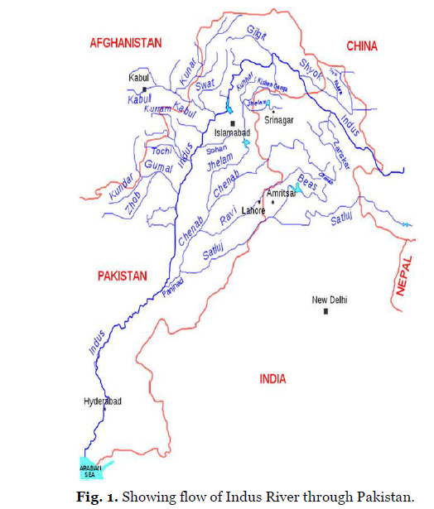
Figure 2: Map showing flow of Indus River, Pakistan

Recent Publications
- Panhwar S, Hassan SS, Mahar RB, Canlier A, Uddin S, Arain M (2017) Synthesis of L-Cysteine capped silver nanoparticles in acidic media at room temperature and detailed characterization. Journal of Inorganic and Organometallic Polymers and Materials http://doi.org/10.1007/s10904-017-0748-9.
- Hassan SS, Carlson K, Mohanty SK, Uddin S, Canlier A (2017) Ultra-rapid catalytic degradation of 4-nitrophenol with ionic liquid recoverable and reusable ibuprofen derived silver nanoparticles. Environmental Pollution https://doi.org/10.1016/j.envpol.2017.10.118.
- Arain M, Nafady A, Al-Enizi AM, Shaikh T, Ibupoto ZH, Sherazi STH, Hassan SS, Abro MI, Uddin S, Khattak MI, Kumar R (2017) Ultra-sensitive amperometric hydrazine sensing via dimethyl glyoxomat derived NiO nanostructures. Electroanalysis 29:2803-2809.
- Hassan SS, Panhwar S, Nafady A, Uddin S, Sherazi STH, Kalhoro MS, Arain M, Shah MR, Talpur MY, Al-Enizi AM (2017) Fabrication of highly sensitive and selective electrochemical sensors for detection of paracetamol by using piroxicam stabilized gold nanoparticles. Journal of Electrochemical Society 164:B427-B434.
- Hassan SS, Nafady A, Uddin S, Solangi AR, Kalhoro MS, Abro MI, Sherazi STH (2015) Ultra-trace level electrochemical sensor for methylene blue dye based on nafion stabilized ibuprofen derived gold nanoparticles. Sensors and Actuators B: Chemical 208:320–326.


Biography (150 word limit)

Dr. Syda Sara Hassan is an active and keen individual with excellent experimental expertise, adores a challenge and achieving goals. Her professional aim is to work within advanced electro analytical techniques, fabrication of nano materials and their applications to remove the hazardous metal ions as trace level from environmental, real water and industrial waste water samples using nano sensor and catalysis.

Email: sshassan.uspcasw@faculty.muet.edu.pk; ssarahassan@gmail.com
Contact no: +92 342 3432459
Date of Birth: 16th December, 1983
LinkedIn account: -------
Category: Oral (or) Poster : Oral
Gender: Female

Notes/Comments:

