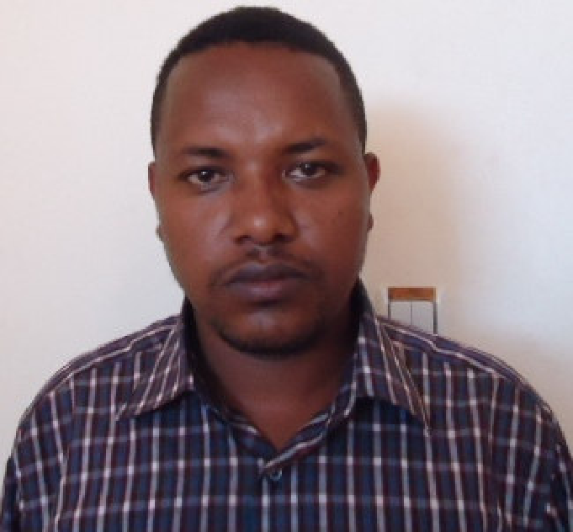
Title: Distribution and risk assessment of heavy metals in surficial sediments from Awash River Basin, Ethiopia
Dirbaba Niguse Bekele, Hongjuan Wu, Jun Wang
School of Environmental Science and Engineering, Huazhong University of Science and Technology. P．O. Box: P.o.Box: Luoyu Road 1037, Wuhan ,430074, P.R.China

Abstract: Like many parts of developing nations, rapid population growth, high urbanization rate and poor waste management practices have been observed in Awash River Basin. On the other hands, no detail and systemic study was conducted to determine the status of sediment pollution with heavy metals in the basin. 138 samples were taken 46 sites and tested for determination of heavy metals content, distribution, pollution level, possible sources of pollutants and associated ecological risk. The results indicated that the mean concentration of the elements had exceeded their respective background values except Pb and Hg. A comparison with similar studies revealed that sediments from Awash River Basin had highest average value for Cd. The mean enrichment factors of heavy metals were listed in increasing order as Hg < As < Pb< Ni< Cu< Cr< Zn <Cd. Multivariate analysis revealed that Ni and Cu had common sources while the other heavy metals were originated from different anthropogenic source. The pollution load index value of the study area was 2.94 indicating high ecological pollution. Sediment quality guidelines revealed that heavy metals like Ni, Zn and Cr were the major concern in the study area. The mean effects range medium quotient values of sampling sites varied between 0.351-2.996 indicating medium priority up to high priority sites. Potential ecological risk index of trace elements from Awash River Basin was 343.67, designating high potential toxicity response. Generally, the study indicated that surficial sediment in Awash River Basin were polluted by heavy metals and posing high ecological risks.

Biography

Dirbaba B.Niguse has completed his MSc in Environmental Science from Addis Ababa University and served as a lecturer and assistant professor at Ambo University in Ethiopia. Currently he is a PhD scholar at Huazhong University of Science and Technology, China. He has published more than five papers in reputed journals and has been serving as reviewer of African Journal of Ecology.
Presenting author details
Full name: Dirbaba Niguse Bekele
Contact number:+8613296649416
e-mail: nigusebekele@hust.edu.cn
Linked In account: niguse_21@yahoo.com
Session name: Ecology and Ecosystem
Category: Oral presentation

