CASE REPORT
PING PONG BALL THROMBUS IN LEFT ATRIUM
ANIMESH GUPTA⁽¹⁾, BEERESH⁽²⁾,C N MANJUNATH⁽³⁾
Department of Cardiology, Sri Jayadeva Institute of Cardiovascular Sciences and Research, Bangalore, Karnataka, India
ABSTRACT
Left atrial ball thrombus is a rare disorder . These ball thrombi are generally associated with mitral stenosis , and the restricted mitral orifice encloses the free floating thrombus in the LA. There is a potential for fatal systemic emboli or mitral valve orifice occlusion that may result in sudden death .We report a rare case of free – floating ball thrombus in the left atrium with mitral stenosis . A 77 year old woman with chronic mitral stenosis was admitted to our hospital for progressive dyspnea and in failure . ECG showed atrial fibrillation . Echocardiography revealed rhematic ,thickened and stenotic mitral valve with free floating ping pong ball shaped thrombus in the left atrium. During the course in hospital patient developed embolization of thrombus to distal abdominal aorta . Emergency vascular surgery was done to restore circulation in distal vessels . Unfortunately patient had on table cardiac arrest and patient cannot be revived .
INTRODUCTION
A Ball valve thrombus in the left atrium is a clot which is spherical in shape and freely mobile that intermittently occlude the mitral valve orifice. They are imprisoned in the LA because of the excess of their diameter in comparison to the mitral valve . It is a rare condition with high risk for thromboembolism and therefore portends a grave prognosis⁽¹⁾.

CASE REPORT
A 77-year-old female who was already diagnosed to be suffering from severe mitral valve disease 4 yrs ago presented with recent aggravation of symptoms since 1 month ( Paroxysmal Nocturnal Dyspnea and Orthopnoea). On examination, he was found to have congestive cardiac failure, atrial Fibrillation with controlled ventricular rate, severe mitral stenosis and moderate mitral regurgitation, severe pulmonary arterial hypertension and tricuspid regurgitation. All her peripheral pulses( both upper limb and lower limb) were well felt and she had no neurological deficits at presentation

ECG revealed atrial fibrillation with left atrial overload pattern.

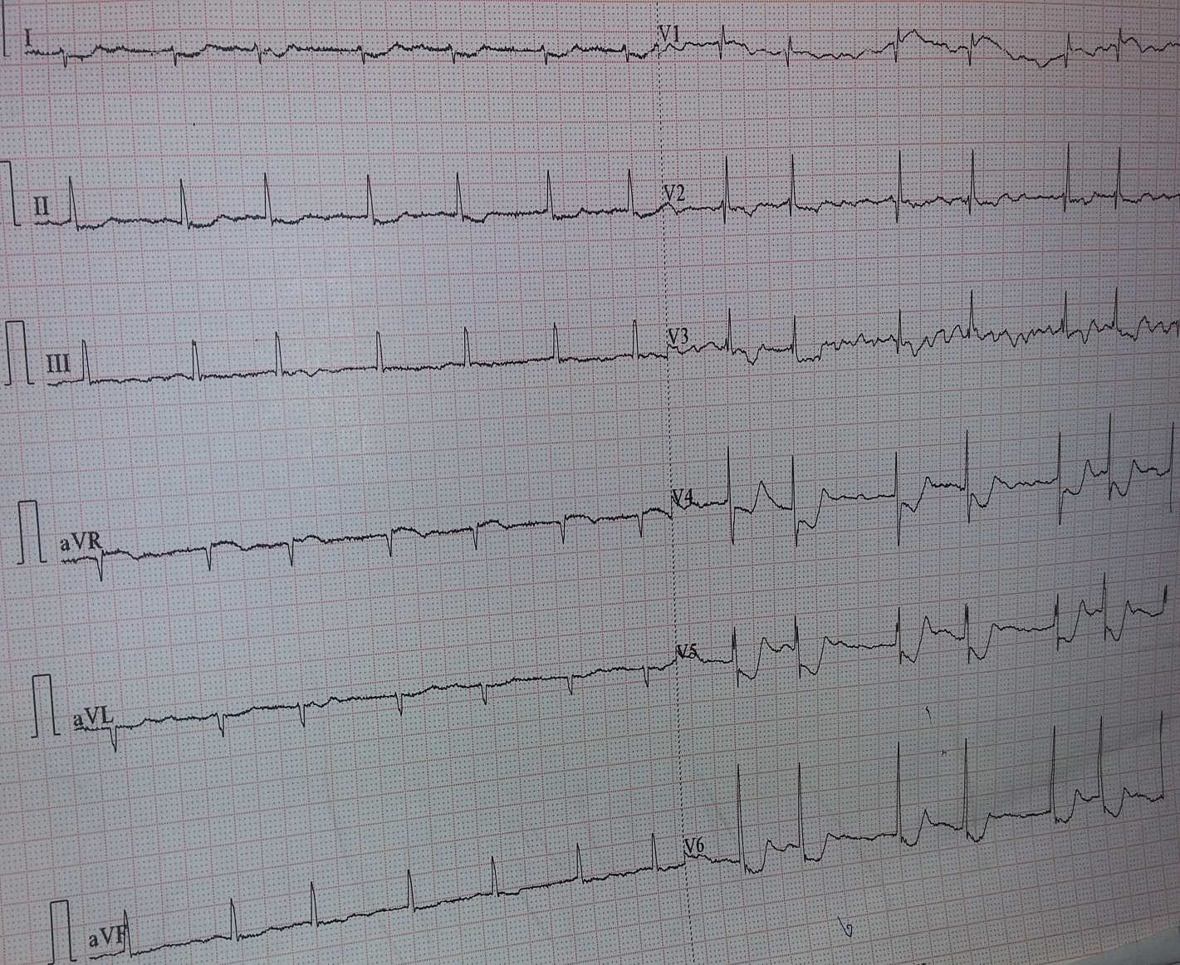

TRANSTHORACIC ECHOCARDIOGRAM confirmed the valvular lesion and revealed a large spherical freely mobile ball thrombus in the body of the left atrium which was intermittently albeit transiently occluding the left ventricular inflow.
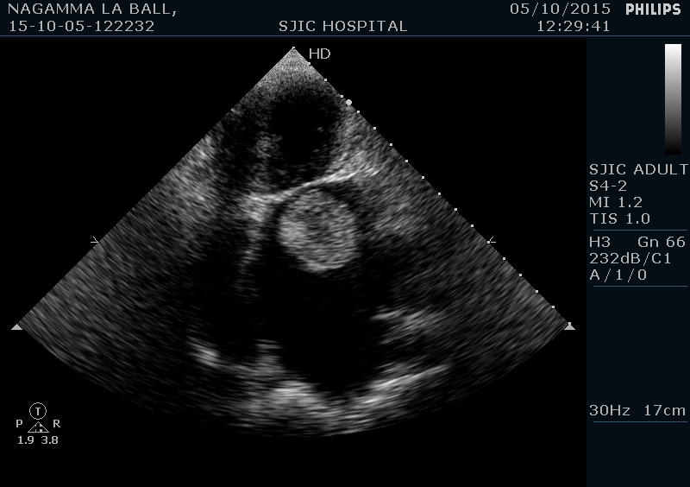

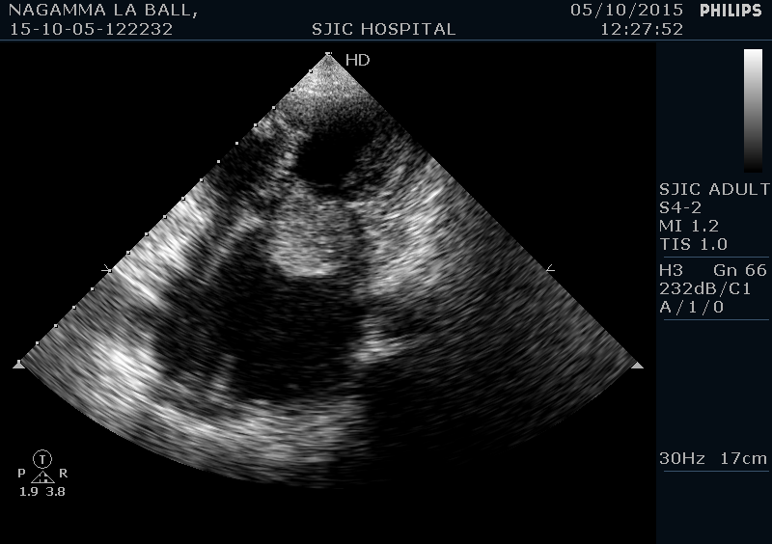

During the course in the hospital the patient had bilateral lower limb rest pain with loss of pulses of bilateral lower limb .
Urgent CT aortogram was done which reavealed thrombus just at the bifurcation of abdominal aorta.

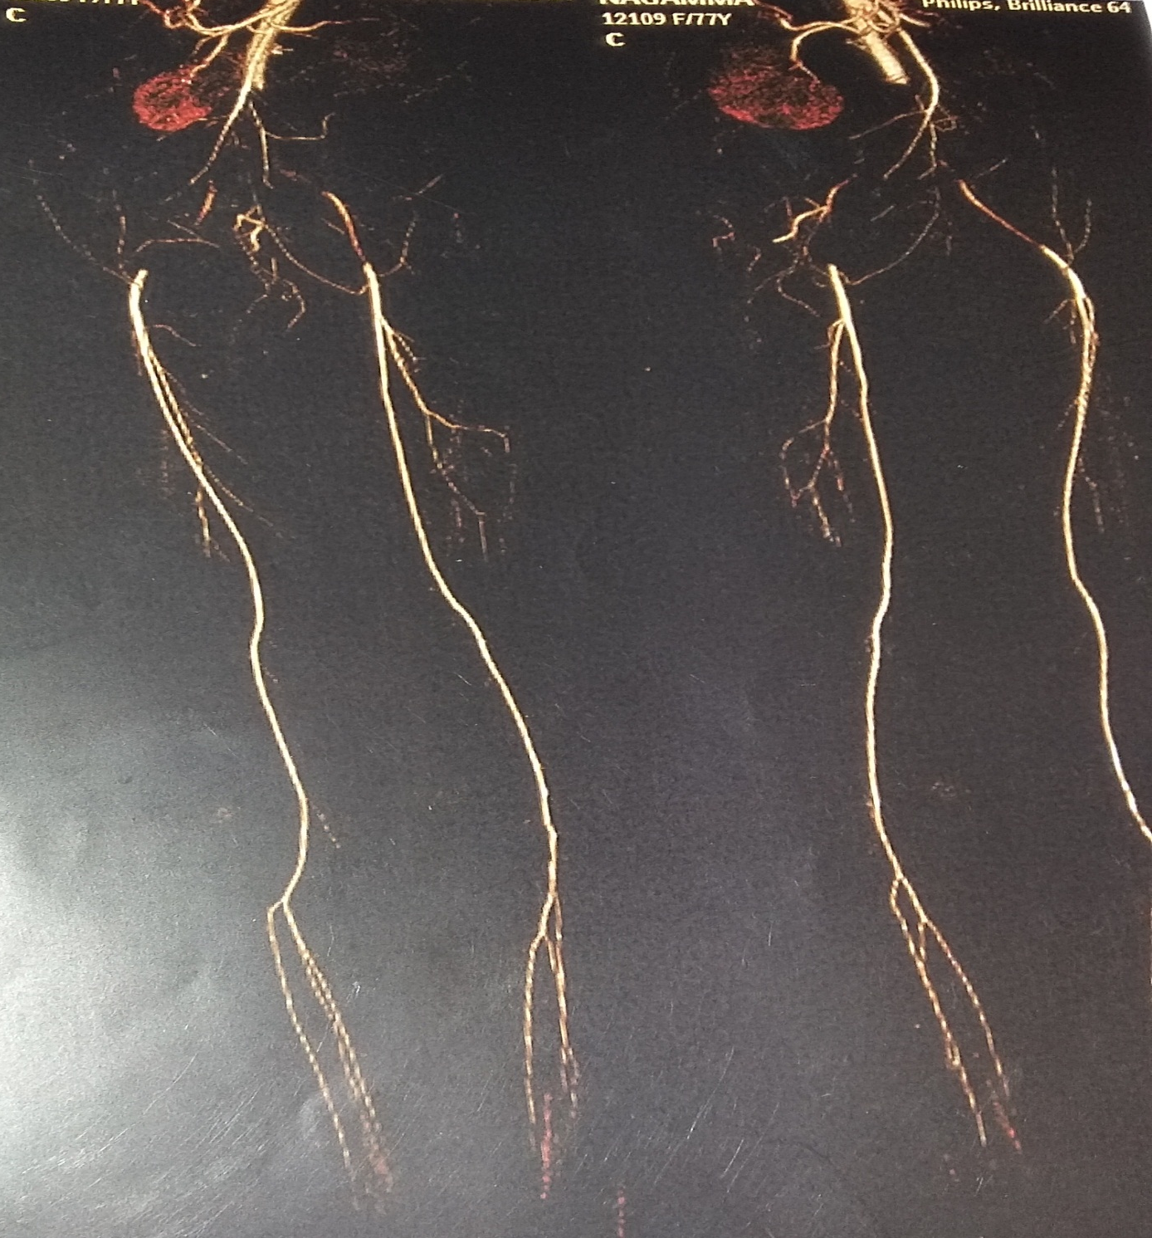
Patient was taken for emergency surgical intervention but the patient has on table cardiac arrest and patient cannot be revived.

DISCUSSION
Left Atrial ball thrombus is an infrequent pathology. It is most often associated with Rheumatic mitral stenosis. However, it has been reported without mitral stenosis also^{(2).} Majority of reports about this condition are from Japan^{(3-6).} It is surprising that there are very few reports of this entity from India where Rheumatic mitral valve disease is rampant. In a study of 490 patients in Pondicherry⁽⁷⁾ with Rheumatic mitral stenosis 169 were found to have thrombus in left atrial body or appendage but none with ball valve thrombus. Thanikachalam⁽⁸⁾ has reported a patient with ball valve thrombus with tight mitral stenosis diagnosed during a routine preoperative echocardiography. Grover has reported a single case long time ago⁽⁹⁾ . The pathogenesis of ball thrombi is obscure. Since almost all reports of ball thrombi have been in association with atrial fibrillation and its occurrence have been noted even without mitral obstruction, the role of atrial fibrillation in the pathogenesis of ball thrombi seems to be more important. Its formation may result from an initial free-floating or mural micro thrombus, with an accretion phenomenon gradually enlarging the mass like a growing snowball ^{(10).} The chronic stasis associated with atrial fibrillation should be considered an important growth factor of the ball thrombus. These large thrombi are well covered by a smooth fibrinous layer. The surface is free from rough areas. That explains the relative rarity of embolic manifestations with this pathology. The possibility of sudden death due complete mitral orifice occlusion is a dreaded complication. Further such large thrombi with organized fibrin layer on the surface are unlikely to be dissolved with anticoagulation. However, here we present a rare case of Ball valve thrombus in the left atrium with high risk for thromboembolism and therefore portends a grave prognosis. Therefore urgent interventions should be done .

REFERENCES

- Gillmer D, Campanella C. Echocardiographic diagnosis of left atrial ball-valve thrombus. A case report. S Afr Med J 1984;65:662.
- Oryoji A, Kawara T, Hara H, Aoyagi S, Kosuga K,Ohishi K. Left atrial free-floating ball thrombus in a patient without mitral valve disease. Nippon Kyobu Geka Gakkai Zasshi. 1993; 41: 699–703.
- Aoyagi S, Kosuga K, Hisatomi K, Shima H, Tanaka I, Shimadu S, Ohishi K. Four successfully operated cases of ball thrombus in the left atrium. (Article in Japanese) Kyobu Geka. 1989; 42: 97–102.
- Kaneda T, Iemura J, Michihata I, Zhang ZW, Oka H, Otaki M, et al. Two cases of a free floating ball thrombus in the left atrium. Circ J. 2002; 66: 869–71.
- Doiguchi M, Ikei S, Mizutani M, Haga K, Arai M, Yamashita S. Mitral valve stenosis associated with a floating ball thrombus in the left atrium; report of a case. Kyobu Geka. 2002; 55: 585–87.
- Misumi T, Kudo M, Ito T, Matsubara T, Kumamaru H. Floating ball thrombus in the left atrium with mitral stenosis. JPN J Thorac cardiovasc Surg. 2003; 51: 387–89.
- Srimannarayana J, Varma RS, Satheesh S, Anilkumar R, Balachandar J. Prevalence of left atrial thrombus in rheumatic mitral stenosis with atrial fibrillation and its response to anticoagulation: A transesophageal echocardiographic study. Indian Heart J. 2003; 55: 358–61.
- Thanikachalam S, Sengottuvel G, George S, Kumar MS, Sivakumar RV, Balakrishnan KR, Murthy JS. A case of Ball Valve Thrombus. Echocardiography. 1999; 16: 143–45.
- Grover A, Varma JS, Gujral JS, Wahi PL. Free floating ball thrombus in left atrium. Indian Pediatr. 1988; 25: 878–81.
- Grandmougin D, Letourneau T, Favre JP, Barral X. Paroxysmal Postural Dyspnea related to a left atrial ball thrombus. Ann Thorac Surg. 2002; 74: 1691–94.

