Temporal changes in Soil Carbon Sequestration along a Chronosequence of Pinus massoniana Plantations in Southern Sichuan – China.

Meta Francis Justine^{1,2}, Wanqin Yang^{1,2*}, Fuzhong Wu^{1,2}, Bo Tan^{1,2} and Muhammad Naeem Khan³ and Zhijie Li^{1,2}

- Key Laboratory of Ecological Forestry Engineering in Sichuan Province, Institute of Ecology & Forestry, Sichuan Agricultural University, Chengdu 611130, China
- Collaborative Innovation Center of Ecological Security in the Upper Reaches of Yangtze River, Chengdu 611130, China
- College of Forestry, Sichuan Agricultural University, Huimin Road 211, Chengdu 611130, China

Abstract

Statement of the Problem: The short term changes of soil carbon sequestration in forest plantations were not studied. In order to gain an understanding on the roles of Pinus massoniana (masson pine) plantations, in squestrating carbon, changes in soil organic carbon (SOC) and total nitrogen (TN) in two soil layers (0-30 and 30-60cm) were investigated along a chronosequence of masson pine plantations in the Upper Reaches of the Yangtze River Basin. We ascertained in what way SOC and TN contents and stocks varied with stand age and soil depth. We then look at how these variations changed in one year period and what are their influencing factors along the chronosequence. Concentrations of SOC and TN, and the stocks of SOC and TN in the sampled soil layers decreased significantly with soil depth. The SOC stock increased with forest age while the TN stock decreased, the C/N ratio increased significantly with stand age and soil depth. Soil moisture was significantly correlated with TN content and insignificant with SOC content. The percentage change in the content and stock of SOC increased with soil depth whereas the change in the TN content and stock decreased, and the change was more pronounced on the SOC and TN contents compared to their stocks. Stand age and soil depth are the dominant biotic factors manipulating the soil C and N sequestration but has no effects on their spatial changes. The traditional scientific approach of involving a single environmental factor (soil moisture) in SOC and TN contents determination and multiple factors in SOC and TN stocks determination has promoted the pronounced changes on the SOC and TN contents compared to their stocks and the C/N ratio is the abiotic factor modulating C and N sequestration. The recalcitrants compounds of C and N are neither accumulated nor lost in a relatively shorter period of time.

Findings: The traditional scientific approach of involving a single environmental factor (soil moisture) in SOC and TN contents determination and multiple factors in SOC and TN stocks determination has promoted the pronounced changes on the SOC and TN contents compared to their stocks and, the recalcitrants compounds of C and N are neither accumulated nor lost in a relatively shorter period of time.

Keywords: Pinus massoniana plantations; Stand age; Soil organic carbon; Soil total nitrogen; Soil layers; Carbon sequestration;

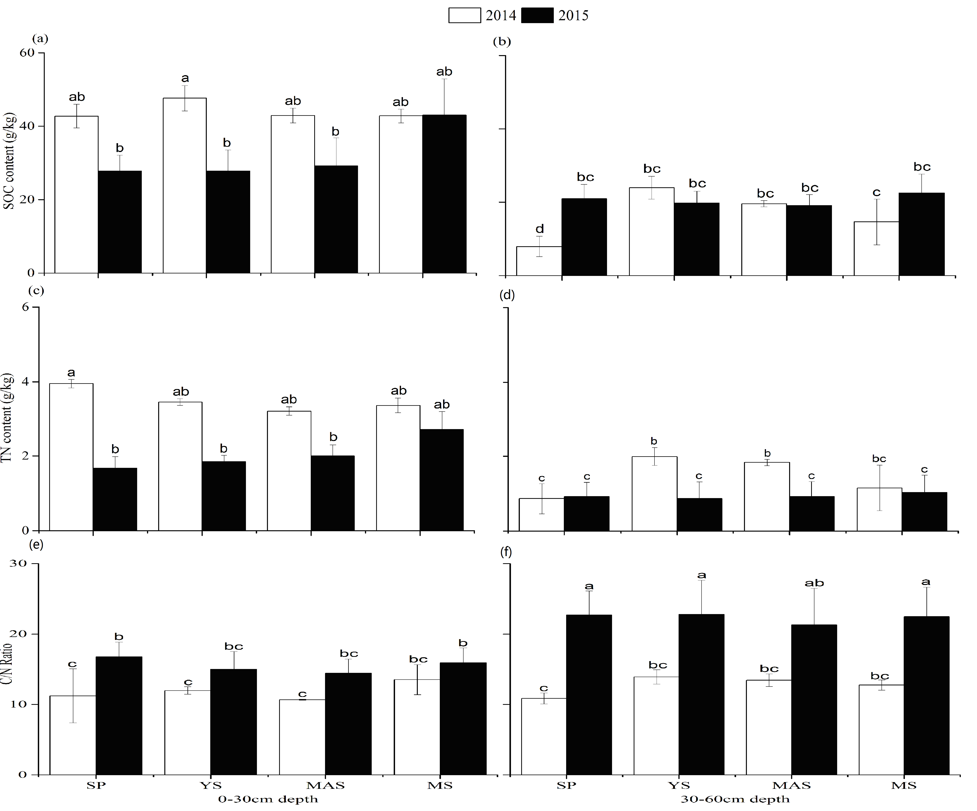

Figure 1. SOC and TN contents in soil layers of the Pinus massoniana plantations; (a-b) SOC content, (c-d) TN content; (e-f) C/N ratios. The values shown are (means and standard deviations). Different lowercase letters indicate significant (p<0.05) differences between 2014 and 2015 in the different stands within the same soil profile.

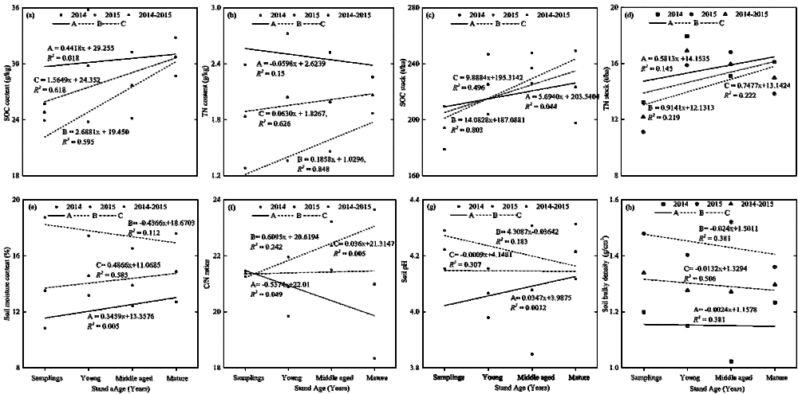
Figure S1. Relationships between stand age and the measured soil organic, physical and chemical properties along the chronosequence of Pinus massoniana plantations. Relations between; (a) SOC content with stand age; (b) TN content with stand age, (c) SOC stock with stand age; (d) TN stock with stand age, (e) Moisture content with stand age, (f) C/N ratios with stand age, (g) pH with stand age and, (h) Bulky density with stand age.

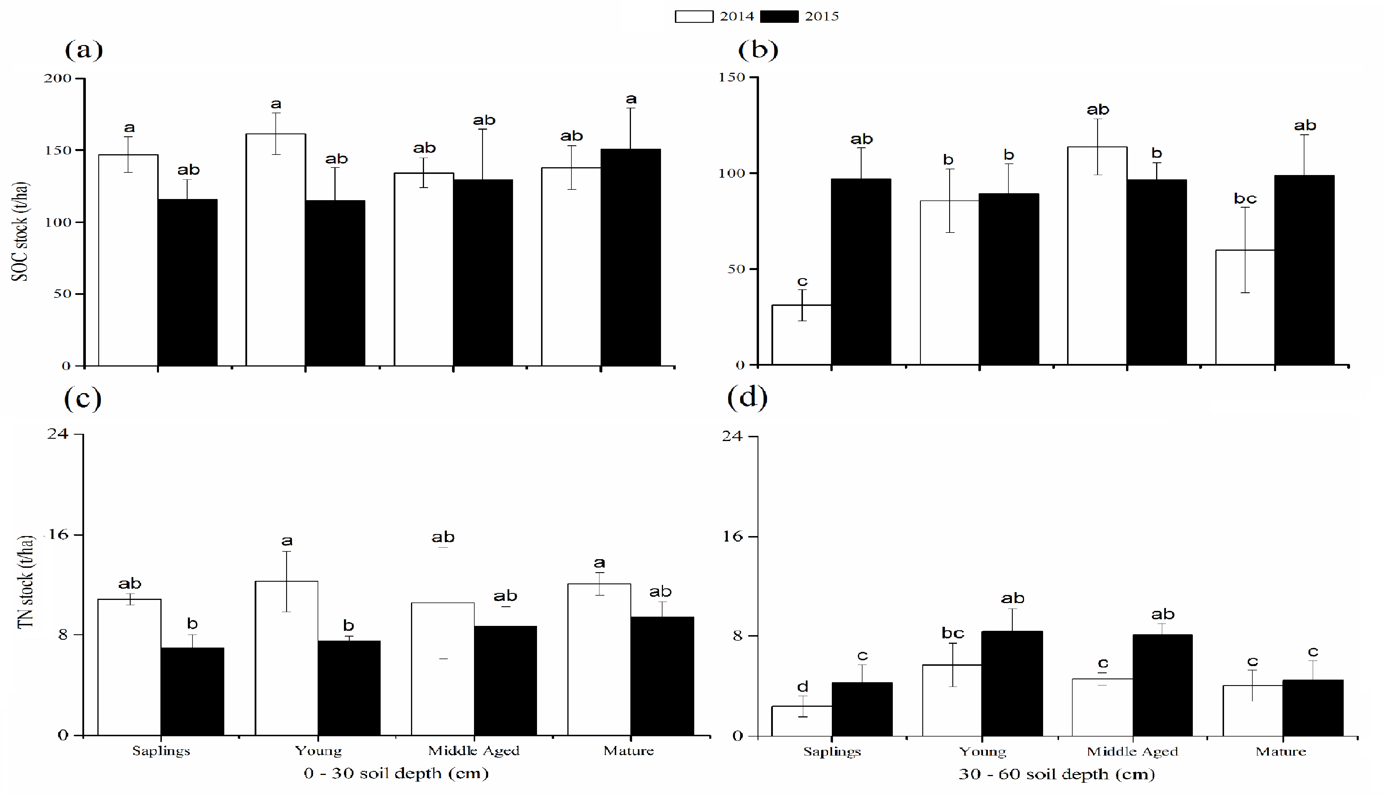

Figure 2. SOC and TN stocks in soil layers of the Pinus massoniana plantations; (a-c) SOCstock, (d-f) TN stock. The values shown are (means and standard deviations). Different lowercase letters indicate significant (p<0.05) differences between 2014 and 2015 in the different stands within the same soil profile.

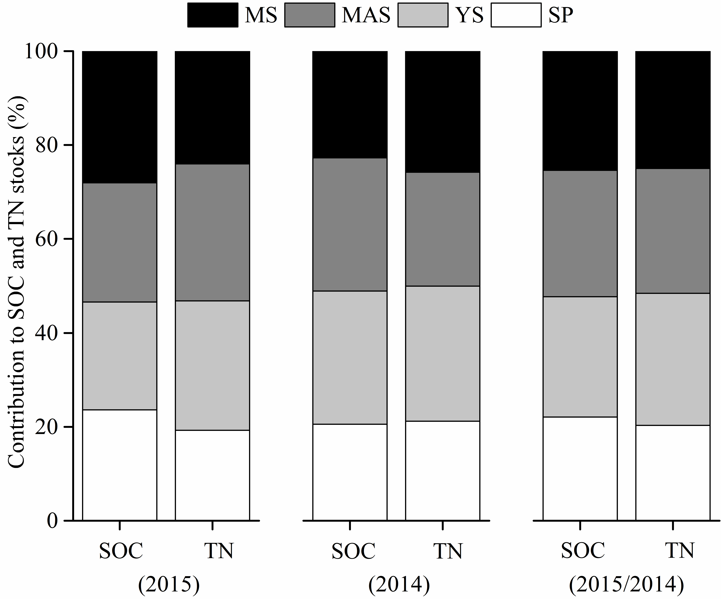

Figure S3. Percent contribution of the various stand ages to the total soil carbon and nitrogen sequestration in the Pinus massoniana plantations.

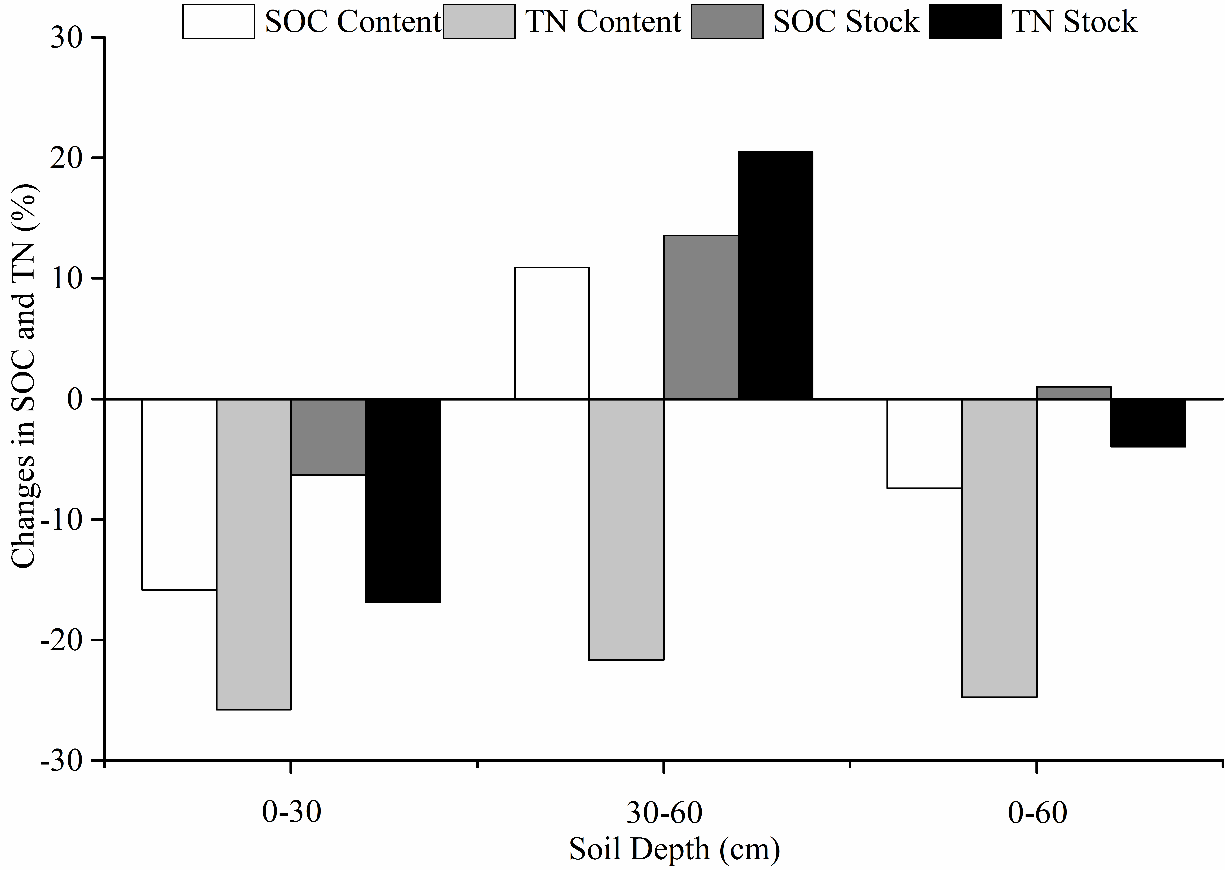

Figure 3 Changes in SOC content, SOC stock, TN content and TN stock between 2014 and 2015 in soil layers of the Pinus massoniana plantations.

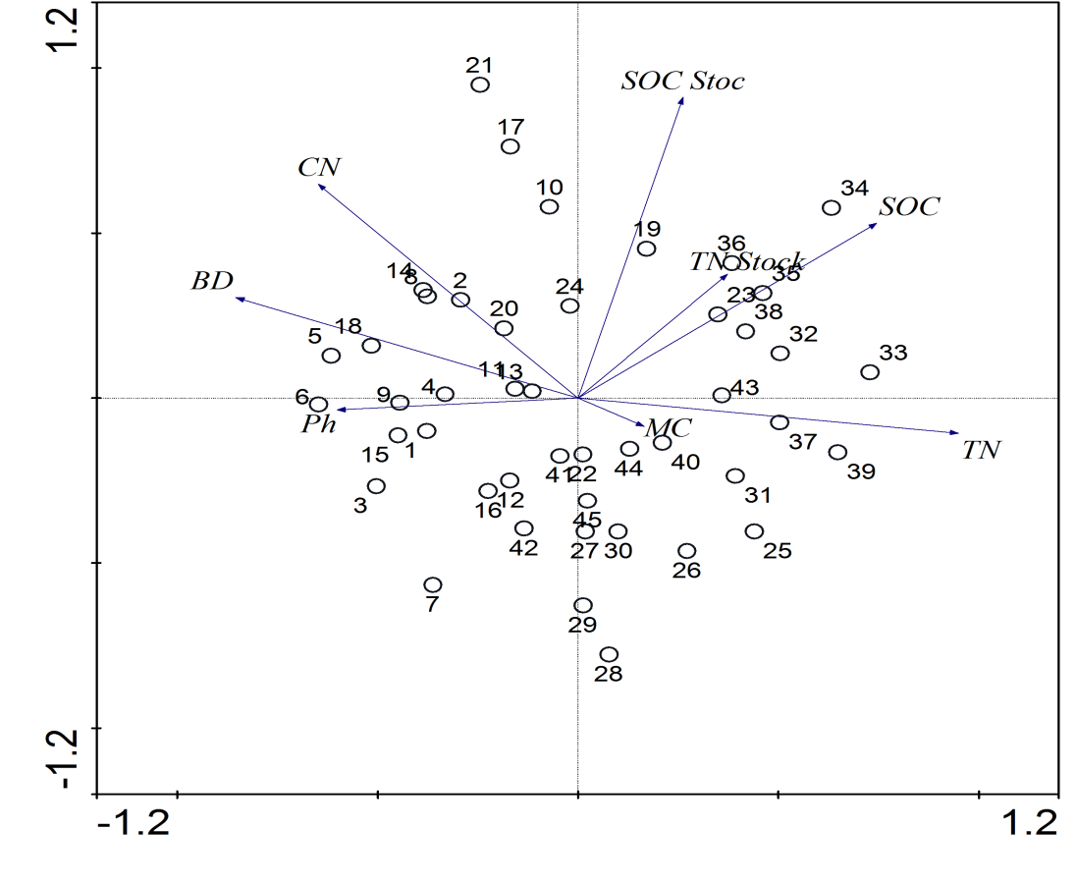

Figure 4. Bio-plot of RDA for the relationships between SOC and TN contents and stocks and the measured soil properties in the 0-60cm sampled soil profile layer in 2014 (Sites1–21) and 2015 (Sites 22–45).

Recent Publications (minimum 5)

1. Meta Francis Justine, Wanqin Yang, Fuzhong Wu and Muhammad Naeem Khan. Dynamics of Biomass and Carbon Sequestration across a Chronosequence of Masson Pine Plantations. Journal of Geophysical Research-Biogeosciences, 2017, DOI: 10.1002/2016JG003619

2. Meta Francis Justine, Wanqin Yang, Fuzhong Wu, Bo Tan, Muhammad Naeem Khan and Zhijie Li. Dissolved Organic Matter (DOM) in soils varies across a Chronosequnce of Pinus massoniana Plantations in the Upper Reaches of the Yangtze River. Ecosphere, 2017, DOI:10.1002/ecs2.1764

3. Meta Francis Justine, Wanqin Yang, Fuzhong Wu, Bo Tan, Muhammad Naeem Khan and Yeyi Zhao.Biomass Stock and Carbon Sequestration in a Chronosequence of Pinus massoniana Plantations in the Upper Reaches of the Yangtze River. Forests, 2015, 6: 3665-3682; doi:10.3390/f6103665.

4. Bin Wang, Fuzhong Wu, Sa Xiao, Wanqin Yang, Meta Francis Justine, Jiayi He and Bo Tan. Effect of Succession Gaps on the Understory water-holding capacity in an Over-mature alpine Fir Forest at the Upper Reaches of the Yangtze River. Hydrological Processes, 2015, 30: 692–703.

5. Wei He, Fuzhong Wu, Wanqin Yang, Danju Zhang, Zhenfeng Xu, Bo Tan, Yeyi Zhao & Meta Francis Justine. Gap Locations Influence the Release of Carbon, Nitrogen and Phosphorus in two Shrub Foliar Litter in an alpine Fir Forest. Scientific Reports, 2016, 6: 22014; DOI: 10.1038/srep22014.

Biography
Meta Francis Justine.
Research Assistant.
Education: September 2014 to date, Master of Science (MSc), Forest
Ecology, Institute of Ecology and Forestry, Sichuan Agricultural University, Sichuan (PR. China). 2004-2007: Diploma in Forestry (DipFor), Nyabyeya Forestry College, Masindi Uganda. 1999-2002: Uganda Certificate of Education (UCE), Aria Secondary School, Arua Uganda. Work experience: 2008-2010: Assistant Conservator of Forests, Ministry of Agriculture and Forestry, Republic of South Sudan. 2012-2014: Research Assistant and, Monitoring and evaluation focal person, Directorate of Forestry, Ministry of Agriculture and Forestry, Republic of South Sudan. Research Interests: Carbon sequestration; Elements and nutrients cycling; Climate Change and Global Warming. Awards: 10/10/2014 to date: Sichuan Government Scholarship for postgraduate studies, Sichuan (PR. China). 26/04 to 20/06/2013: Ministry of Commerce, Trade and Industry, Fujian Agriculture and Forestry University (FAFU), (PR. China). 09/03 to 30/03/2012: Ministry of Commerce, Trade and Industry, FAFU, (PR. China). 2010: Won Ministry of Gender Economic Empowerment of Women Grant for a Community Based Organization (Keliko Farmers Association Society).

Email: francismeta@yahoo.co.uk
Notes/Comments:

DETAILS OF PRESENTING AUTHOR
Full name: Meta Francis Justine.
Electronic address: francismeta@yahoo.co.uk / metafrancis9@gmail.com
Contact number: +8613982016514
Alternate contact number: N/A
Twitter account: @francismeta3
Linked In account: N/A
Track name: Land and Soil Sciences
Presentation: (Oral/ Poster): Oral

