Small Dams Mitigate Climate Change in Drylands
Govindasamy Agoramoorthy, PhD., College of Pharmacy and Health Care, Tajen University, Yanpu, Pingtung 907, Taiwan

Abstract
Statement of the Problem: India is one among the many water-starved nations of the world and it increasingly faces declining surface and groundwater resources while the usage continues to escalate aggressively in recent decades. Although the annual monsoons bring enough rain, most of the rainwater cannot be harvested and stored due to inadequate water storage facilities. The world water use has tripled since the 1950s so politicians have met this increasing water demand by building more big dams that alarmed environmentalist due to various negative side effects that range from loss of farmlands to repatriation of millions of displaced people. So, the question is, can big dams resolve all the looming water shortages and climate change consequences? What about building more eco-friendly small dams across all rivers? Can they mitigate climate change?

Findings: A small non-profit agency inn India has assisted over 1,000 villages in the semi-arid regions of Gujarat, Rajasthan and Madhya Pradesh States to build cost-effective check dams in rivers to harvest rain water for three decades. Water saved through the check dams not only transformed the infertile drylands into productive agricultural lands, but also increased ground water recharge ultimately benefiting the environment. This model has remarkable potential to be replicated in developing countries to reduce irrigation water stress and river water conflicts.

Image: A view of dried river Hiren at Borbhatod village in Rajasthan, India (above) and the hydrological transformation with full of water (below) after check dam built in 2014 (photo courtesy Sadguru Foundation)
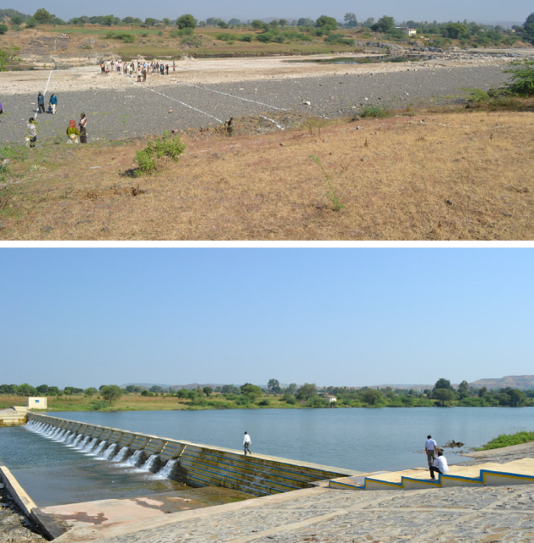

Recent Publications

- Agoramoorthy G, Chaudhary S, Chinnasamy P, Hsu MJ (2017). Harvesting river water through small dams promotes positive environmental impacts. Environmental Monitoring and Assessment 188: 645.
- Agoramoorthy G, Hsu MJ (2016) Small dams revive dry rivers and mitigate local climate change in India’s drylands. International Journal of Climate Change Strategies and Management 8:271-285.
- Selvaraj K, Pandiyan J, Yoganandan V, Agoramoorthy G (2016) India contemplates climate change concerns after floods ravaged the coastal city of Chennai. Ocean & Coastal Management 129:10-14.
- Chinnasamy P, Agoramoorthy G (2016) India’s Groundwater Storage Trends Influenced by Tube Well Intensification. Ground Water 54:727-732.
- Agoramoorthy G, Hsu MJ (2015) Community-organized irrigated agriculture mitigates local food insecurity in India’s drylands. Agroecology and Sustainable Food Systems 39:1003-1021.


Bio graphy (150 word limit)

Govindasamy Agoramoorthy is Distinguished Research Professor at Tajen University, Taiwan. His research ranges from environment to sustainable development. He has carried out research in Asia, Africa, and South America for over 30 years. He serves in the editorial board of Journal for Nature Conservation (Elsevier) and Associate Editor of Frontiers in Environmental Science. Between 1989 and 1993, he served as Visiting Scientist at Smithsonian Institution (Washington, DC). He also serves as Tata Visiting Chair in India. Professor Agoramoorthy authored 25 books, 80 book chapters, and 250 research papers published in peer-reviewed journals with impact factor. Email: agoram@tajen.edu.tw
DETAILS OF PRESENTING AUTHOR:
Full name: Govindasamy Agoramoorthy
Electronic address: College of Pharmacy and Health Care, Tajen University, Yanpu, Pingtung 907, Taiwan
Contact number: 88675253623
Twitter account: nil
Linked In account: nil
Track name: Hydrological Science
Presentation: (Oral/ Poster) Oral or Poster

