PREPARATION OF NANOTECHNOLOGY AS MAGNETICALLY-RESONANT CONTRASTING MEANS DURING VISUALIZATION OF MALIGNANT TUMOUR
Andrey Belousov, Ekateryna Belousova
Laboratory of Applied Nanotechnology of Belousov
Kharkov Medical Academy of Postgraduate Education
www.nanolab.com.ua ; an.belousov2012@yandex.ua

The task was set in an experiment on animals to check possibility of the use of the before worked out and studied methodology of intravenous insert of the standardized form water solution magnetite of nanoparticles (preparation of ICNB) for contrasting of malignant tumour at MRI research. The main purpose – to change the indexes of relaxation of T1 and T2 in area of malignant tumour during realization MRI by means nanoparticles of ICNB. In investigation on animals (Vistar rats) was proof that magnetite of nanoparticles (ICNB) are contrast means for malignant tumour visualization. Was been shown that magnetite of nanoparticles have contrast effect when performing magnetic resonance imaging (MRI) (Fig. 1, 2). Was established, that after intravenous inject preparation of nanotechnology (ICNB) the magnetite of nanoparticles have selective accumulate in tumour and alter brightness of picture in 24- hours (Fig. 2, 3). On 4-th day investigation was established significant decries of dynamic brightness of the picture of tumour and muscles (Fig. 4). This fact is connected with elimination the ICNB out of rat’s organism.
Tissue of muscula Fig. 2. МRI study the brightness of image rat with the adenocarcinoma of mammary gland and tissue of muscular on the first minutes after intravenous insert of ICNB (800 conventional sign - tumour; 700 conventional sign - tissue of muscular).r
Fig. 2. МRI study the brightness of image rat with the adenocarcinoma of mammary gland and tissue of muscular on the first minutes after intravenous insert of ICNB (800 conventional sign - tumour; 700 conventional sign - tissue of muscular).

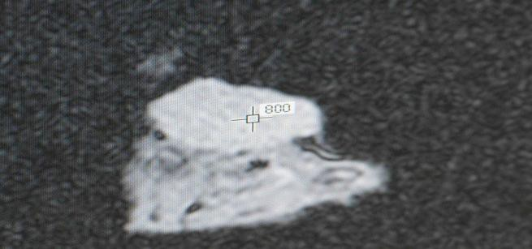
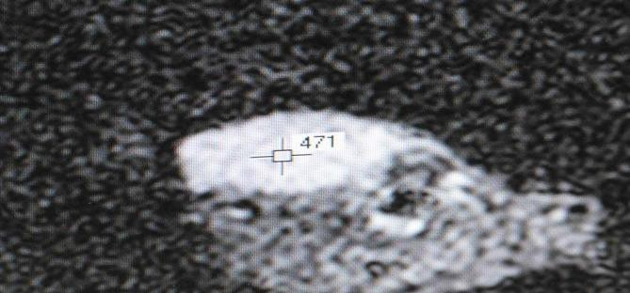
Fig. 1. Initial MRI study the brightness of image the rat’s adenocarcinoma of mammary gland and tissue of muscular (471 conventional sign – tumour; 243 conventional sign – tissue of muscular).

800
700
Adenocarcinoma of mammary gland
243
471
Adenocarcinoma of mammary gland
Tissue of muscula Fig. 2. МRI study the brightness of image rat with the adenocarcinoma of mammary gland and tissue of muscular on the first minutes after intravenous insert of ICNB (800 conventional sign - tumour; 700 conventional sign - tissue of muscular).r
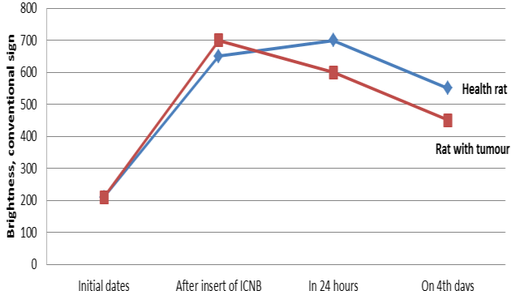
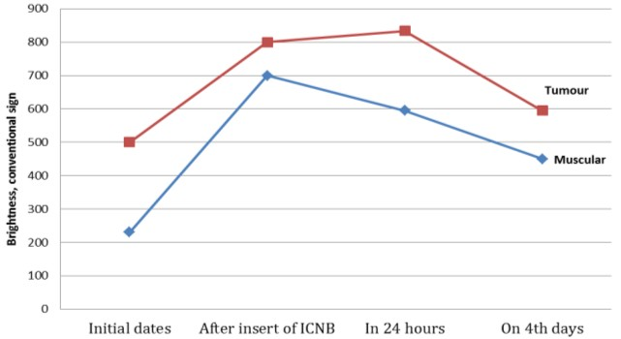
Stages of investigation

Fig. 4. Dynamic of change brightness of image rats muscles in both groups on various stages for MRI studies after intravenous insert ICNB preparation.
Fig.3. Dynamic of change magnetite of nanoparticles concentration in rat’s tumour and muscular after intravenous insert ICNB preparation on various stages for MRI studies.

Stages of investigation

