Highly Efficient Protocol for Click Labeling of Biomolecules Using a Recyclable Cu2O nanowire-catalyst

Arwa Makki^{1,2}, Dinesh Sawant^{1 *}

¹ King Abdullah University of Science and Technology KAUST, Biological & Organometallic Catalysis Laboratories, Biochemistry Department BOC; KAUST Catalysis Center, KCC
Thuwal 23955-690, Kingdom of Saudi Arabia
² Department of Biochemistry, Faculty of Science, Center for Science and Medical Research, University of Jeddah, Jeddah 80203, Saudi Arabia

Abstract
Copper catalysed azide–alkyne cyclo-addition (CuAAC) reactions have found widespread application in chemistry and life science for the modification of ligands, polymers, supramolecular compound of challenging architecture, peptides, proteins or DNA. In vivo and in vitro modifications of biological molecules are a particularly active field for the development of the bio-orthogonal AAC reaction. Recently, several metal-free click reactions were developed, since the toxicity of the required copper concentrations prevents its use in combination with living cells. ^{[1]} Here we present the use of ultra-thin Cu₂O layers on Cu nanowires as AAC catalysts, which are active at ppm concentrations of Cu⁺ in water at room temperature. Based on this observation we developed a new heterogeneous CuAAC protocol for the bio-conjugation of biomolecules in vitro and in vivo. Combination with the incorporation of unnatural amino acid into proteins such as p-Azido- or p-Ethynyl-phenylalanine (pAzF, pEynF) this protocol allows the efficient site-selective modification of proteins on living cells.

References:
- Liu, C. C. & Schultz, P. G. Adding New Chemistries to the Genetic Code. Annu. Rev. Biochem. 79, 413–444 (2010).

Image
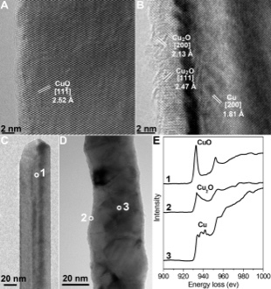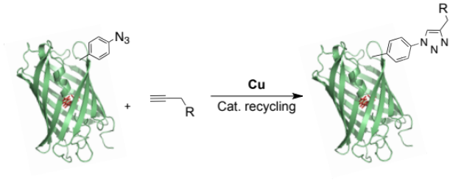
Figure 1: Cu-catalyzed click reaction for site-specific
bio-conjugation by using recyclable catalyst
Figure2: general procedure for the preparation of Cu/Cu₂O nanowires
Figure 3: HRTEM/TEM images of individual (A), (C) CuO and (B), (D) Cu/Cu₂O; (E) EELS spectra.

Biography
Highly innovative and result oriented research scientist with a broad-based research knowledge within biochemistry and biocatalysts. Strong experience in protein expression and application in catalysis chemistry using new technologies. Ability to successfully meet scientific challenges and execute multiple tasks both individually and within teams. Effective in communication of scientific content to a variety of audiences. Seek to contribute to a dynamic research team and lead projects with further develop my research experience, science skills, and project development. My ultimate goal is to bridge the gap between academic learning and research development and design to effectively serve the progress of biochemistry thorough Green chemistryevaluation: measurement, description and judgment. It allows for value-pluralism. This approach is responsive to all stakeholders and has a different way of focusing.
Email: amakki@uj.edu.sa.com

